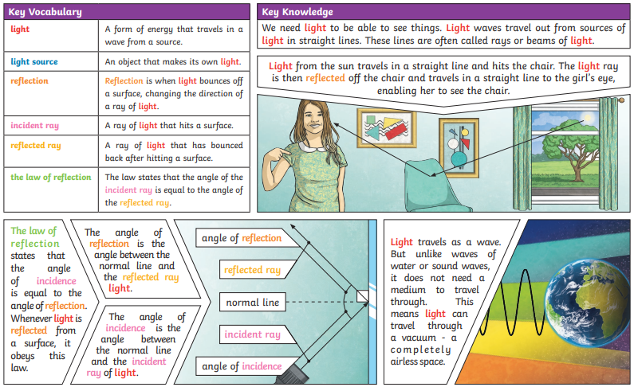

**Light**

**Travels**

**Straight lines**

**Reflect**

**Reflection**

**Object**

**Shadows**

**Light source**

**Mirrors**

**Periscope**

**Rainbow**

**Filters**

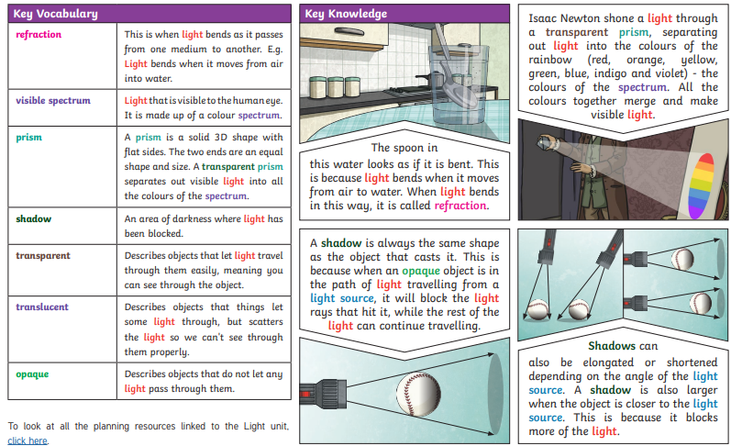

**Key Questions:**

**Can you explain how we see?**

**Can you explain how light travels?**

**Can you explain how light reflects off an object into our eyes?**

**Can you explain how shadows are formed?**

**Can you explain why a shadow is the same shape as the object that cast it?**