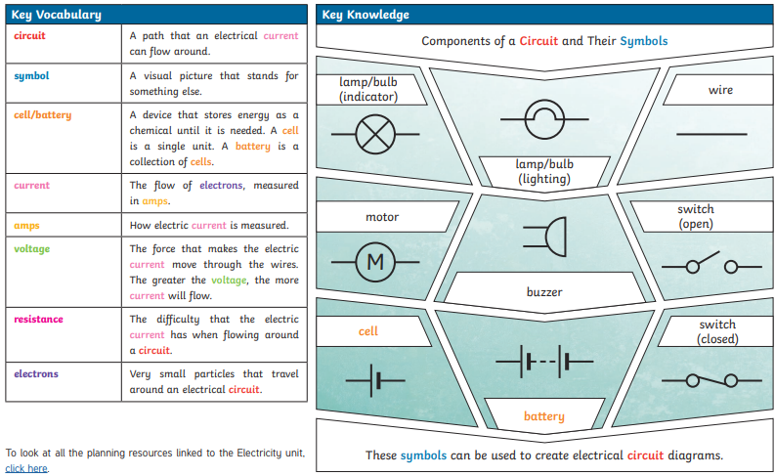

**Key Questions:**

**Can you name the basic parts of a series circuit?**

**Can you draw a series circuit diagram?**

**What effect does adding/removing components have on a circuit?**

**Electrical safety**

**Cell**

**Wires**

**Bulb**

**Switch**

**Buzzer**

**Motor**

**Voltage**

**Brightness**

**Volume**

**Series circuit**

**Variables**

**Accuracy**

**Prediction**

**Comparative tests**

