Key Vocabulary
local area | Nearby.
national | Within the same country.
resort | A popular place for holidays.
tourist | Someone who travels or visits a place for pleasure.
feature | An interesting or important part.
physical  feature | A feature that has been formed by nature.
human  feature | A feature that has been made or changed by humans.
pier | A structure built out into the water for people to walk on.
promenade | A public place for walking for pleasure.
Visiting Places
People visit lots of different places. They might visit a local area, travel a bit further and go on a national trip, or take a longer holiday somewhere else in the world. Many tourists like to visit a seaside resort.
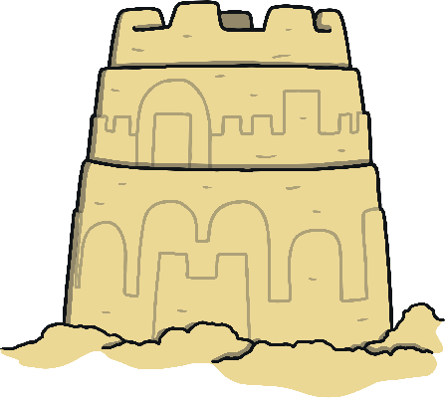
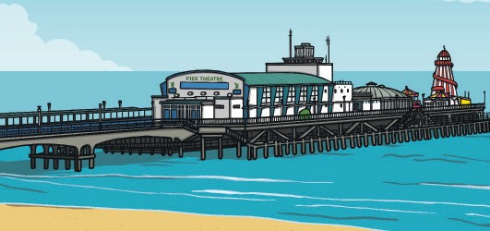
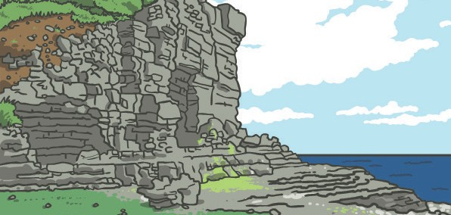
Key Questions:
- Can I say what I like about where I live and compare this to a seaside town?
- Can I say what I dislike about where I live and compare this to a seaside town?
- Can I describe some features of an island?
- Can I describe a seaside location using geographical words?
There is always plenty to do at the seaside, like building sandcastles, paddling in the sea and donkey rides.

Physical Features of the Seaside

A seaside resort has many physical features. Features such as the beach, the sea, cliffs and caves have been made naturally. This means they were made by nature.

Human Features of the Seaside
Human features found at the seaside might include the pier, the promenade, a lighthouse and a fairground. These features are all man-made.

Key Vocabulary
United  Kingdom  (UK) | England, Scotland, Wales and Northern Ireland.
Victorian | When Queen Victoria ruled (from 1837-1901).
sea  bathing | Swimming in the sea.
attractions | Things to see and do.
bay | Part of the coast where the land curves in and is surrounded by the sea on three sides.
Harbour | A place where ships or boats moor (tie-up).
climate | Weather.
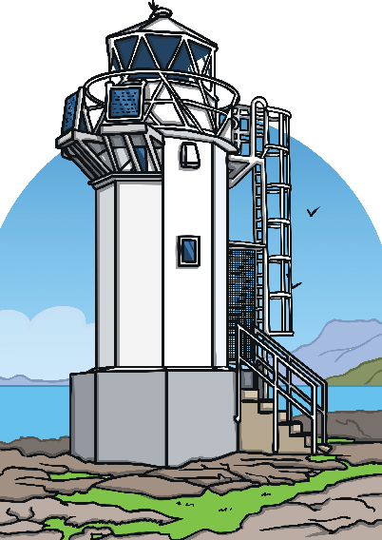
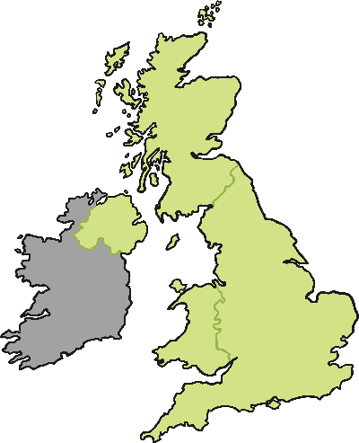
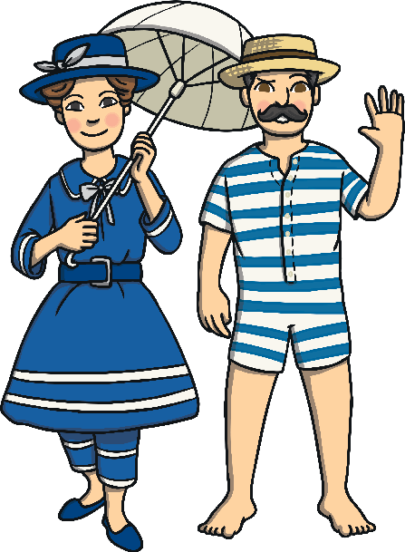
In the past, beaches were much cleaner because there was less litter.
Seaside Towns
Seaside resorts have plenty of restaurants and cafes for tourists to visit. There are also huts selling snacks, such as ice-creams, drinks and fish and chips.
The UK is made up of the large island of Great Britain, Northern Ireland and many smaller islands.
Seaside Towns
Seaside towns have plenty of attractions for tourists.
The bay and beaches are some of the physical features that visitors can enjoy.
The harbour is used for boat trips, fishing and seal spotting tours.
Visiting Beaches
The coastline around the UK is where you can find seaside resorts.
There are lots of islands around the world that people visit for their holidays. Some have a warmer climate than others.
There are lots of seaside resorts in the United Kingdom that have been popular for many years. In Victorian times, people would travel to the seaside to enjoy activities, such as a puppet show, walk along the promenade or to go sea bathing. The Victorians believed that the sea air was good for you and that sea bathing would make you healthy.

Seaside Holidays in the Past

