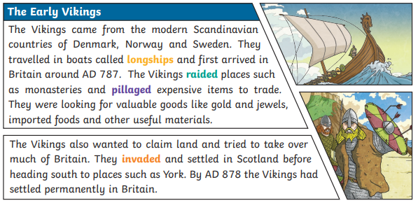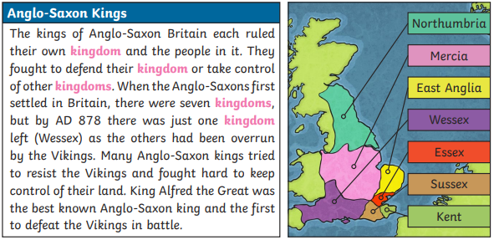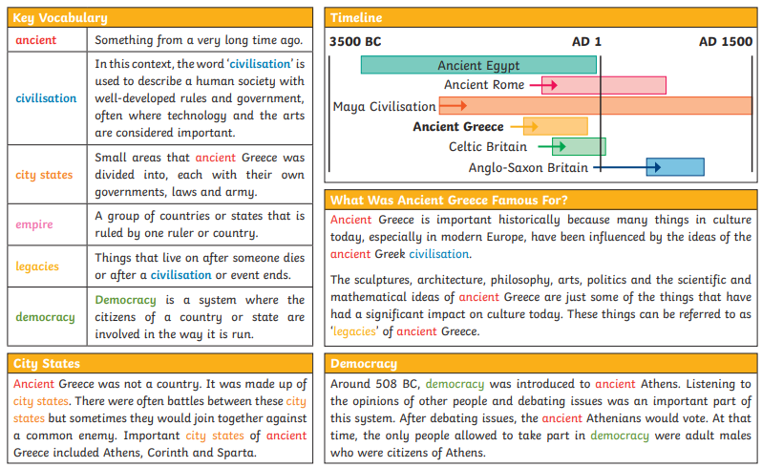

**Key Questions:**

**Can you explain where the Anglo Saxons and Vikings fit on a timeline?**

**Can you explain how the two civilisations came to settle in Great Brittain?**

**Can you explain the influences that both civilisations had on modern day Britain?**

**Can you explain who won what in the battle for Brittain?**

**Longboat**

**Chieftain**

**Raid**

**Settlement**

**Danelaw**

**Monastery**

**Treaty**

**Realm Rune**

**Angles**

**Bretwalda**

**Invade**

**Jutes**

**Kingdom**

**Old English**

**Raiders**

**Saxons**

**Scots**

**Settlements**

