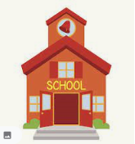
1
Year 3 classes
Cedar: Mrs. Hall
Pine: Mrs. Pritchard
Mrs DiTullio, Miss Weldon, Mrs Ashton, Mrs Parker

Year 3 Homework

Spellings
Your child will bring a spelling list home every Friday and will be tested on these the following Friday. We ask that you learn these at home – you can easily learn two words a night to make it easier.

Reading
Reading will also form a key part of the Year 3 homework. Please encourage your child to keep reading for enjoyment and we suggest at least 10 minutes reading every day. We would be grateful if you could make sure their reading book is sent in to school every day!

Times Tables
If you would like to help your child at home please encourage them to learn their times tables. Every child has had their log in for Times Table Rockstars and they are capable of logging in to this independently.

Welcome Back!!
Welcome back to a new half term - we hope you all have had a safe time at home last term. All the staff have been really looking forward to welcoming you back and it was great to see so many of you on the Monday 8th March.


Year 3 Newsletter

Home time!
We ask that you remain to be socially distanced whilst queueing to collect your child. The Year 3 staff will dismiss the children one at a time once they have seen you. Can we also please remind parents and carers that face coverings should we worn on the school grounds – this is to protect you, your child and our staff.


School foxes
We are lucky enough to have a family of foxes living on our school field at the minute! Year 3 have thoroughly enjoyed watching the videos that we have captured of them being busy during the night!
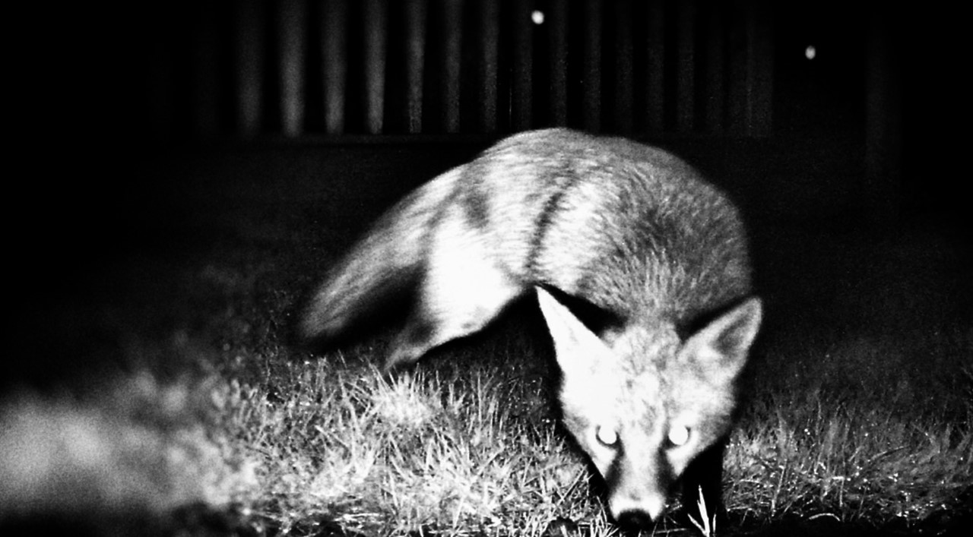
Snack

In Key Stage 2, children are asked to bring their own healthy snack to school as it is no longer provided as it was it Key Stage 1. Please also remember to bring your water bottle every day.

Reminder: School closes on Thursday 1st April 2021
School reopens for the Summer Term on Monday 19th April 2021
Y3 Spring Curriculum

Theme
In the Spring Term, we will be continuing with our topic The Maya before moving on to look at Railway Revolution. We will be investigating how the coming of the railways changed how people lived and worked and how these changes are still evident today.

English
In English we will be completing work based on books by Dick King-Smith and we will be starting with ‘Hodgeheg’. We will be writing both fiction and non-fiction from this text. At home, it would be useful if the children could continue to work on their weekly spellings and practise writing in day to day activities (e.g. writing shopping lists or keeping a simple diary).

Maths
This term in Maths we will be continuing to look at addition and subtraction methods before moving onto multiplication and division. At home, we would encourage children to help with daily tasks around the home that help with their number recognition and counting skills. For example; cooking, timing, counting and finding 1 more or 1 less.

Science
In science, we will be investigating Light and Shadows. We will be looking at light sources and how shadows are created and how they change through the day.

P.E
P.E. Will be on a Friday. Our current guidelines say that you should come to school in your P.E kit to avoid bringing bags in unnecessarily. As we are in the colder months, please ensure your child wears long trousers and jumpers and sensible shoes (NOT pumps).

Outdoor Learning
Our outdoor learning will continue over the next term. We will send out more information with your child each week.

Google Classroom

Given the uncertain nature of the current climate, we would appreciate it if you could spend some time with your child to ensure they still have access to Google Classroom at home. Each child has already brought home their usernames and passwords alongside some basic log in instructions. To access, go to:
id.sims.co.uk

If you have any difficulties, please let one of the year three staff know and we can help to iron out any issues.

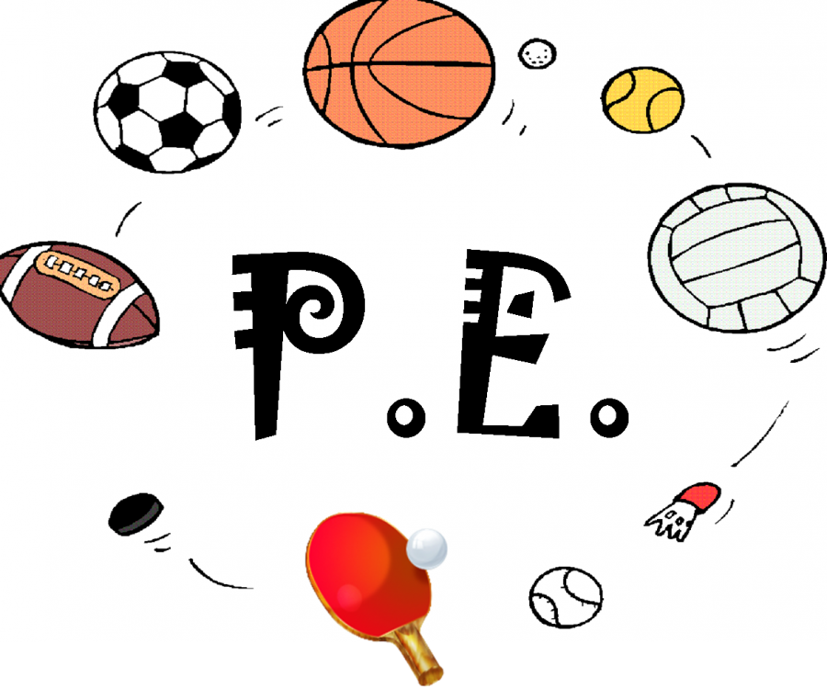
PE lessons
PE lessons will be on Fridays. All children must come into school wearing their PE kits.

and appropriate trainers.

If you have anything you wish to discuss with the Year 3 staff please make an appointment. You could also see staff after school when collecting your child but please ensure you wear a face covering.

Website:
www.greenbank.rochdale.sch.uk
Phone
01706 647923
Email:
office@greenbank.rochdale.sch.uk
Contact
Information

