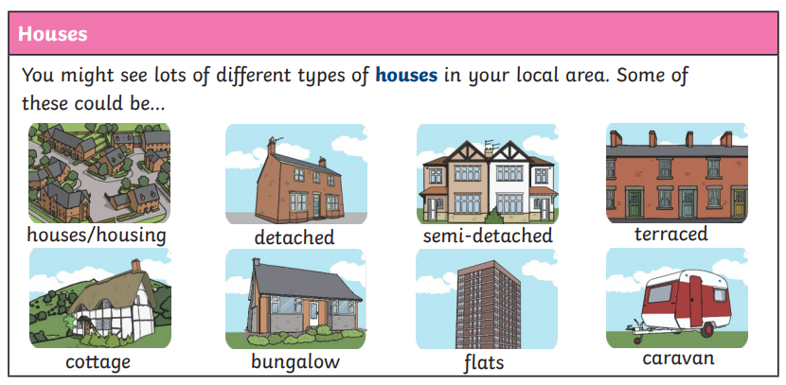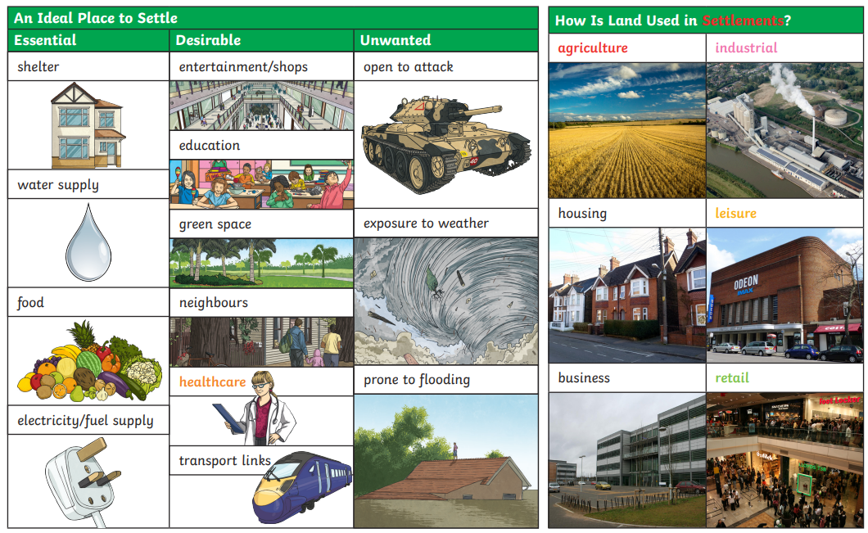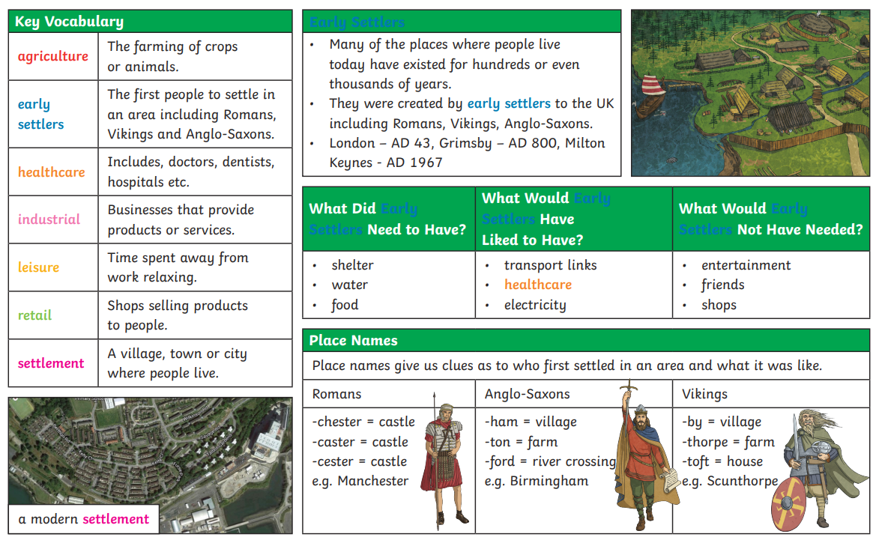

Why do people choose to live in a city?

What is your view on deforestation to build more settlements?

How has Rochdale changed over the last 200 years?

What’s the difference between a town and a city?