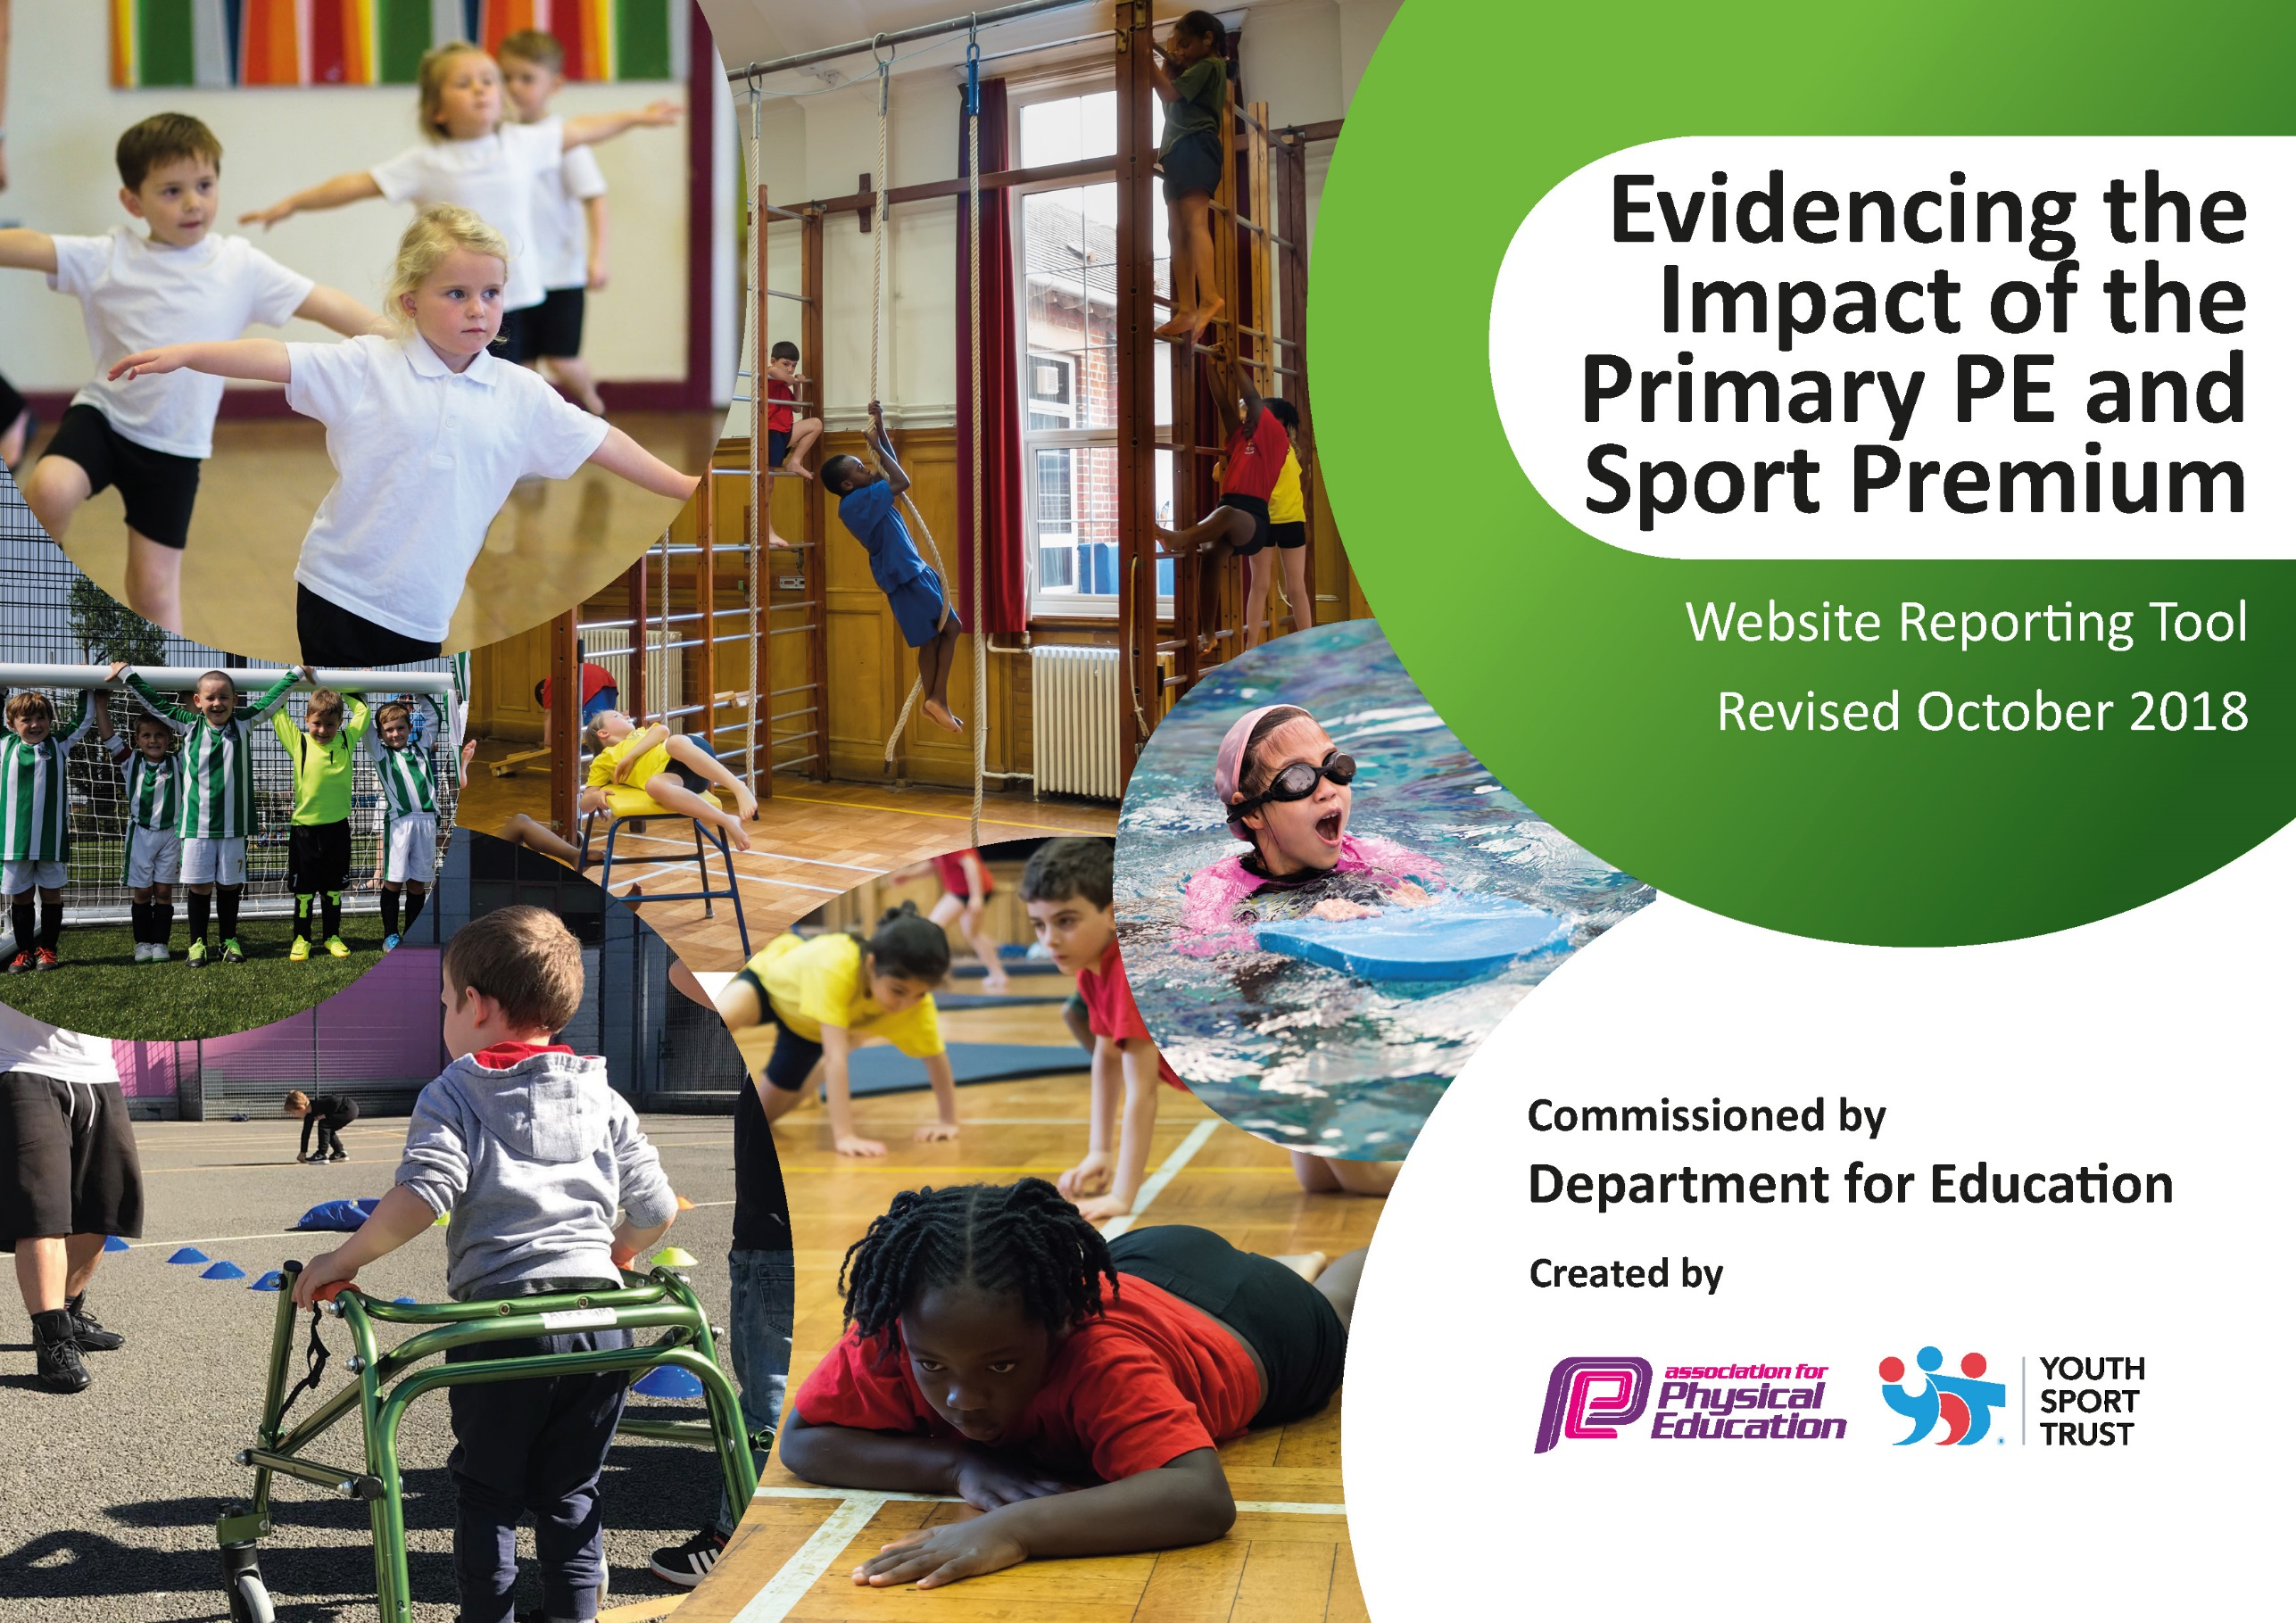
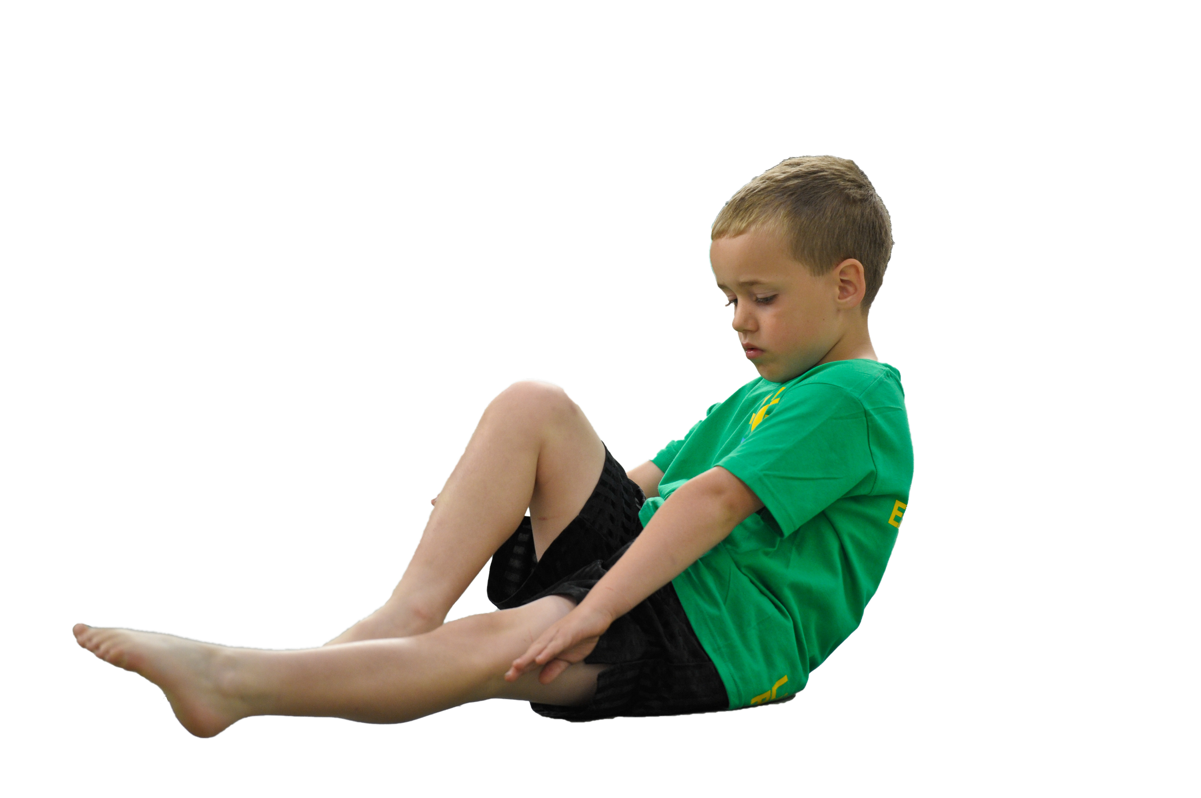
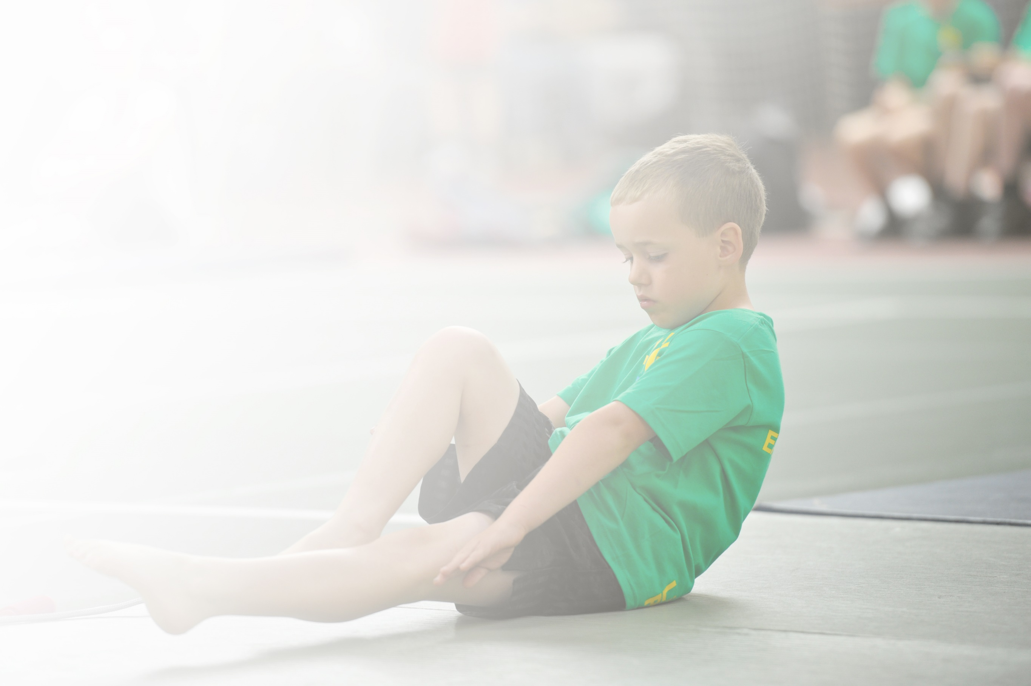
Schools must use the funding to make additional and sustainable improvements to the quality of Physical Education, Sport and Physical Activity (PESPA) they offer. This means that you should use the Primary PE and Sport Premium to:

- Develop or add to the PESPA activities that your school already offer
- Build capacity and capability within the school to ensure that improvements made now will benefit pupils joining the school in future years

Please visit gov.uk for the revised DfE guidance including the 5 key indicators across which schools should demonstrate an improvement. This document will help you to review your provision and to report
your spend. DfE encourages schools to use this template as an effective way of meeting the reporting requirements of the Primary PE and Sport Premium.

We recommend you start by reflecting on the impact of current provision and reviewing the previous
spend. Under the Ofsted Schools Inspection Framework, inspectors will assess how effectively leaders use the Primary PE and Sport Premium and measure its impact on outcomes for pupils, and how effectively governors hold them to account for this.

Schools are required to publish details of how they spend this funding as well as on the impact it has on pupils’ PE and sport participation and attainment by the end of the summer term or by 31 July 2019 at the
latest.
We recommend regularly updating the table and publishing it
on your website throughout the year, as evidence of your
ongoing review into how you are using the money to
secure maximum, sustainable impact. To see an
example of how to complete the table please
click HERE.

Support for review and reflection - considering the 5 key indicators from DfE, what development needs are a priority for your setting and your students now and why? Use the space below to reflect on previous spend, identify current need and priorities for the future.

Key achievements to date: | Areas for further improvement and baseline evidence of need:
All year groups have full participation in all aspects of PE  All year groups are assessed consistently and the data from that is then used to inform the next years planning.  Wide opportunity for after school clubs and out of school participation, for example sailing club.  IPLCN competitions including adventurous activities (e.g. Archery, Orienteering).  All children take part in numerous adventurous activities throughout the year (starting with Reception doing Climbing, Minisplash etc)  Weekly F.R.E.S.H club for children to promote healthy lifestyles. | To provide more competitive and non-competitive sporting activities for KS1 and LKS2 children.  Developments of progression of skills in swimming (Transferring the skills they learn about water safety in the mini splash sessions at Hollingsworth Lake to the swimming pool during their Year 4 lessons. We are also considering having a 6 week programme for Year 5 children to build on their skills they learn in Year 4).  More club participation for all children (in particular KS2).  Further development of Fresh club  Consider employment of another Sports Development Officer

Meeting national curriculum requirements for swimming and water safety | Please complete all of the below:
What percentage of your current Year 6 cohort swim competently, confidently and proficiently over a distance of at least 25 metres?  N.B. Even though your children may swim in another year please report on their attainment on leaving  primary school. | 31%
What percentage of your current Year 6 cohort use a range of strokes effectively [for example, front crawl, backstroke and breaststroke]? | 0%
What percentage of your current Year 6 cohort perform safe self-rescue in different water-based situations? | 0%
Schools can choose to use the Primary PE and Sport Premium to provide additional provision for swimming but this must be for activity over and above the national curriculum requirements. Have you used it in this way? | No

Action Plan and Budget Tracking
Capture your intended annual spend against the 5 key indicators. Clarify the success criteria and evidence of impact that you intend to measure to evaluate for students today and for the future.

Academic Year: 2018/19 | Total fund allocated: £19,663 | Date Updated:18/07/19
Key indicator 1: The engagement of all pupils in regular physical activity – Chief Medical Officer guidelines recommend that primary school children undertake at least 30 minutes of physical activity a day in school |  |  |  | Percentage of total allocation:
 |  |  |  | 100%
School focus with clarity on intended impact on pupils: | Actions to achieve: | Funding allocated: | Evidence and impact: | Sustainability and suggested next steps:
A qualified Sports Co-ordinator employed on a full time basis to plan and deliver high quality curricular PE provision for the children across the school in –  • Netball •Dance • Gymnastics • Games • Hockey •Badminton •Lacrosse  Ensure that EYFS are engaging with high quality physical activity.  Provided opportunities for all children to access high quality extra-curricular sports provision and competitions/tournaments.  Ensured that opportunities are given to Pupil Premium children to access extracurricular provision | Sports Co-ordinator to be timetabled to work with all classes for one session per week providing a broad experience of a wide range of sports and activities which develop key skills and ensure that all children are physically active and enjoying their activities.  Sports Co-ordinator now allocating one lesson a week to each of the EYFS classes, to ensure they are receiving the same physical exercise as the other year groups, due to the small percentage of children arriving below the expected standard. EYFS children are also accessing a range of adventurous activities, including canoeing, ‘mini-splash’ (at Hollingworth Lake), climbing.  Relevant equipment purchased to enable staff to deliver high quality extra-curricular activities and opportunities to compete in competitions through the IPLCN cluster, especially in Athletics. | £19,663  £1,966 (10%)  £830.39 | All children are more physically active and have been provided with a broad range of experience in sports.  Our Sports Co-ordinator has targeted and engaged those children who were more reluctant to join in with activities and physical exercise.  All children in EYFS are now receiving the same provision from the Sports Co-ordinator as the other year groups, who is delivering a curriculum that has developed children’s skills and techniques through a multi-skills approach, ready for them to move into KS1&2.  They have provided high quality teaching in which the children have engaged in both traditional and alternative sports.  This has helped towards increasing pupil participation in competitive sport both within and beyond the school day.  This has enabled and encouraged our Pupil Premium children to take part in extra-curricular sports based activities which they may otherwise have been unable to do. This has increased interest in sport and healthy lifestyles | With continued funding, this high quality provision will continue.  As above.  A high proportion of our children access the wide range of extracurricular activities on offer at school. This includes the opportunity to take part in competitions beyond school.
Key indicator 2: The profile of PESSPA being raised across the school as a tool for whole school improvement |  |  |  | Percentage of total allocation:
 |  |  |  | 0%
School focus with clarity on intended impact on pupils: | Actions to achieve: | Funding allocated: | Evidence and impact: | Sustainability and suggested next steps:
Individual sporting achievements to be celebrated in school assemblies | Celebration Assemblies held to recognise the sporting achievements of our children. | N/A | Children enjoy seeing their achievements celebrated in school and this acts as a huge motivation for them. | Trophy cabinet to celebrate achievements and allows parents/carers and visitors to celebrate with us.

Key indicator 3: Increased confidence, knowledge and skills of all staff in teaching PE and sport |  |  |  | Percentage of total allocation:
 |  |  |  | 5%
School focus with clarity on intended  impact on pupils: | Actions to achieve: | Funding  allocated: | Evidence and impact: | Sustainability and suggested  next steps:
Some areas of expertise amongst our staff members eg Misbaul (Year 6 teacher), Faye (Year 5 teacher), Outdoor team, James (Business Manager).  Sports Diversity Week – All staff are encouraged to take part and are given opportunities to teach a wide range of sports, or support other members of staff teaching to give everyone a wide range of experience in a number of different sports and activities. | These members of staff are regularly involved in the participation of PE, from after school clubs, to taking children to tournaments, to discussing skills and rules of a number of sport (e.g. Cricket).  As above. | £600  (to coaches and enhancements for Sports Diversity Week) | Children involved in a wide variety of sports, led and supported by a number of different teachers/staff members.  As above. | Continue to involve a variety of staff members in tournaments and sporting activities to build their knowledge and experience.  As above.
Key indicator 4: Broader experience of a range of sports and activities offered to all pupils |  |  |  | Percentage of total allocation:
 |  |  |  | 100%
School focus with clarity on intended  impact on pupils: | Actions to achieve: | Funding  allocated: | Evidence and impact: | Sustainability and suggested  next steps:
Sports Co-Ordinator to provide a wide range of sports and activities for all children throughout the year – both curricular and extra-curricular.  A wide range of extra-curricular clubs/activities to be provided for children.  Sports and Diversity Week – A week dedicated to a wide range of sports, including disability sports to give the children a broader experience in the type of sport they take part in, including Rowing, Boccia, Kabaddi, Curling, etc. | Each class timetabled to receive high quality curricular provision of a wide range of sporting and dance activities.  Extra-curricular activities provided for children each week both after school and during Intervention time within school in a wide range of sports – Boys Football, Girls Football, Netball, Karate.  Give children the opportunity to try out new sports they have never heard of, or have never had the chance to take part in before. | See above | All children are more physically active and have been provided with a broad range of experience in variety of sports.  All children have been taught by qualified sports coaches who have delivered a curriculum that has developed children’s skills and techniques through a multi sports approach.  They have provided high quality teaching in which the children have engaged in both traditional and alternative sports.  This has all helped towards increasing pupil participation in competitive sport both within and beyond the school day.  All children participating in a wide range of sports for a full week, encouraging them to take these skills and ideas for physical activity home and to the playground.  Allows children to experience new sports, in the hope they may enjoy some of the activities and remember the skills they are taught for the whole of their time in education and beyond. | With continued funding this high quality provision will continue.  A high proportion of our children access the wide range of extra-curricular activities on offer at school. This includes the opportunity to take part in competitions beyond school as part of the IPLCN PE cluster, which will hopefully continue.  A two-year plan (1st year looking at Diverse Sports and disabilities, and the 2nd looking more at healthy lifestyles and physical exercise) to continue.
Key indicator 5: Increased participation in competitive sport |  |  |  | Percentage of total allocation:
 |  |  |  | N/A%
School focus with clarity on intended  impact on pupils: | Actions to achieve: | Funding  allocated: | Evidence and impact: | Sustainability and suggested  next steps:
Ensure that our children have the opportunity to participate in a wide range of competitions in a variety of sports throughout the year.  Ensure that children are able to be transported to competitive sports events. | Membership of the IPLCN PE Cluster who organise a range of competitions throughout the year.  Membership of the Rochdale Borough Sports & Games Partnership, enabling access to borough-wide sports competitions.  School mini-buses reserved exclusively for transport of children to a variety of sports events throughout the year. | Costs are negligible | Relevant equipment purchased to enable staff to deliver high quality extra-curricular activities and the opportunity to compete in competitions in –  • Boys Football, Girls Football, Netball, Athletics, Cricket & Multi-Sports.  Membership of the clusters has enabled our children at access a wide range of competitions throughout the year. | A high proportion of our children access the wide range of extra-curricular activities on offer at school. This includes the opportunity to take part in competitions beyond school.  Through the time and goodwill of our staff this will continue in the future.

October 19

