How to log-in to Mathsflex
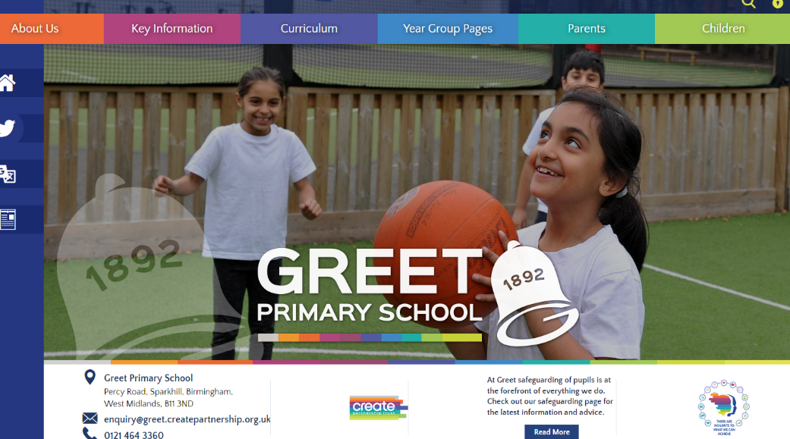

- On the Greet Website click on children and then Mathsflex.
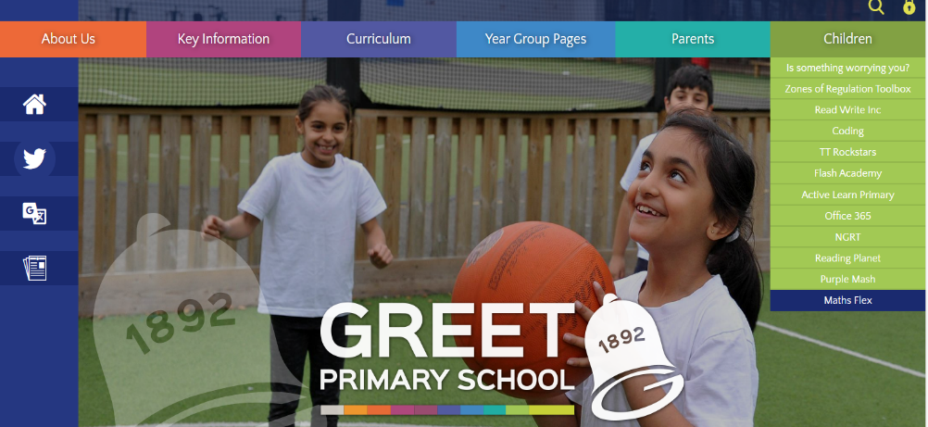

- Follow the link to the Mathsflex page.
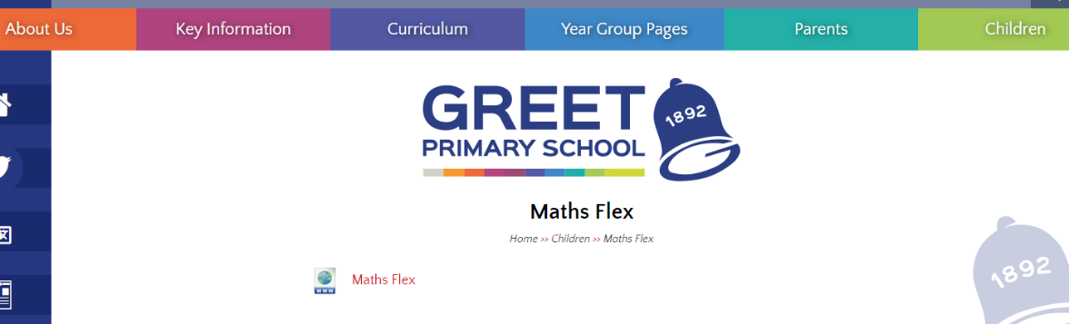

- Log-in to the Active Learn site
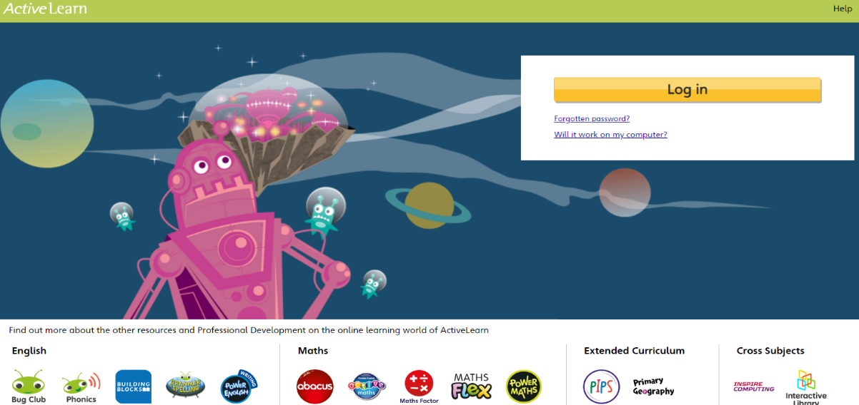

- Enter the children username (same as the one for bug club/TT Rockstars) and their password (for most children this is two of the same 4-letter words followed by .1 e.g. snowsnow.1)

- Then enter the school code which is GREE
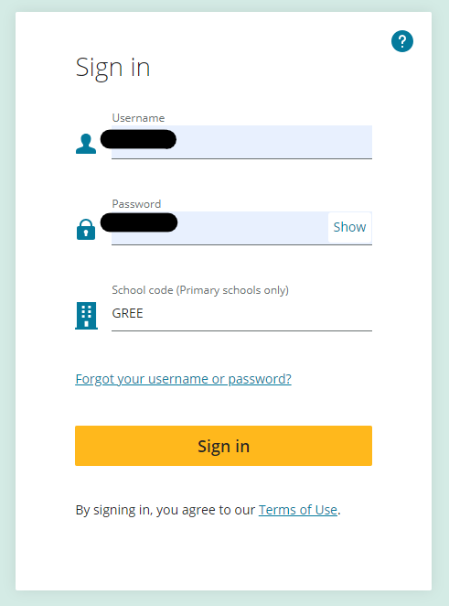

- On the Active Learn site click on Mathsflex

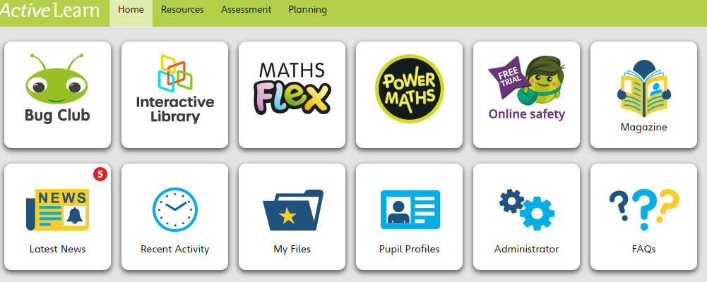

- Click on My Stuff and then My Work
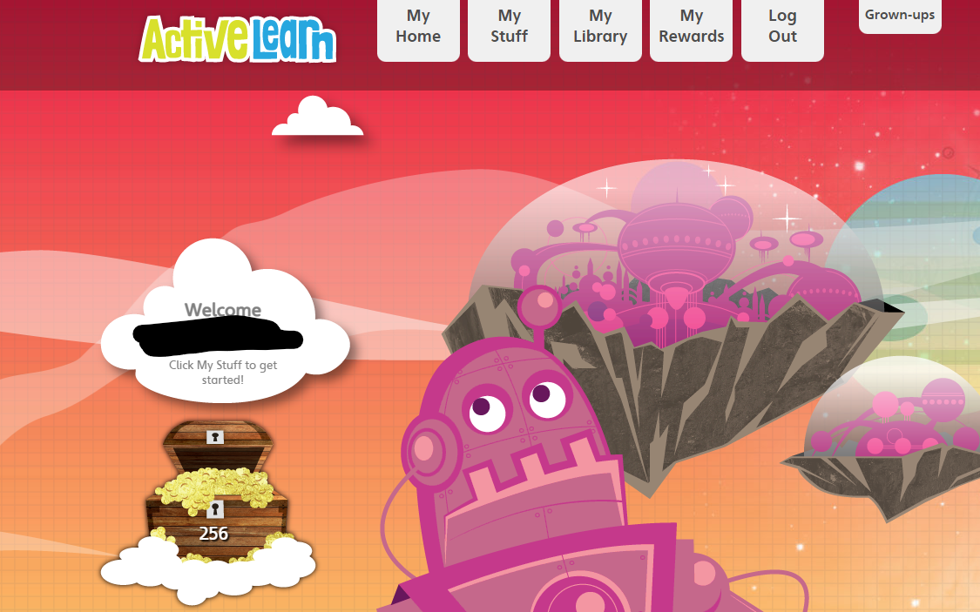

- Finally click on ‘Let’s go’ and enjoy!
