**Grove Academy**

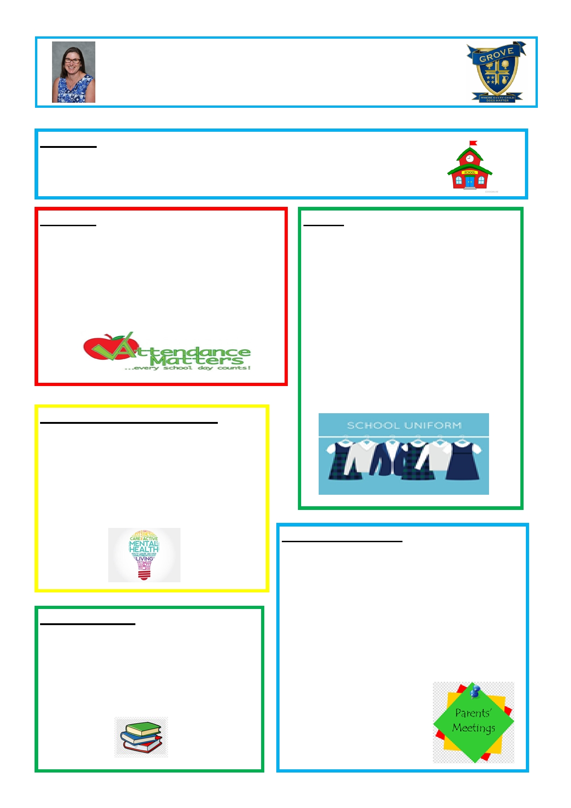

**Academy Principal's Newsletter—January 2020**

**Site Update**

The roof project is on track and should be finished by March 2020.

New vanity units were installed in the pupil toilets at October half-term—these are

looking very smart!

**Attendance**

Attendance and punctuality remain a huge focus

for Grove Academy, especially after the winter

illness bugs swept through the school causing the

attendance to plummet. Our attendance is

currently 94.3%, which is significantly below the

national attendance target of 96%. We will be striving to rapidly improve this.

**Mental Health Support Team (MHST)**

We are thrilled to have this team working with

us. When pupils are referred the team carry

out an initial assessment, then work with pupils

to provide targeted support, they have great

strategies to share! Please speak to your

child's teacher if you think they would benefit

from a referral.

**Uniform**

Thank you for your support with our new

uniform, I'm sure you will agree that pupils

look incredibly smart, and visitors to our

school always comment on this. There are a few pupils who are not yet in full new PE kit

(purple 'Grove' T-shirt, navy sports shorts

NOT cycling shorts or leggings). A reminder

that from February half-term, the whole school is required to be wearing the new uniform. Please also label this with their name.

**Parent meeting feedback**

Thanks to the parents who attended this meeting

on 10th December. Some of the ideas suggested by

parents were:

**New Reading Books**

We have recently spent over £10,000 on new books to be used for reading in school and for home readers. Miss Simpson is getting these

organised and pupils should start to bring

•

•

•

More text messages / letters to inform about

school activity, especially before we make a change (such as the change to lunchtimes)

More opportunities to come into school and

work alongside children to find out what they

are learning, especially in maths

More fund-raising

these home. Please support all of our

fundraising to pay for these books.

We are aiming to address these

issues so look out for

invitations to work with us.

**Grove Academy**

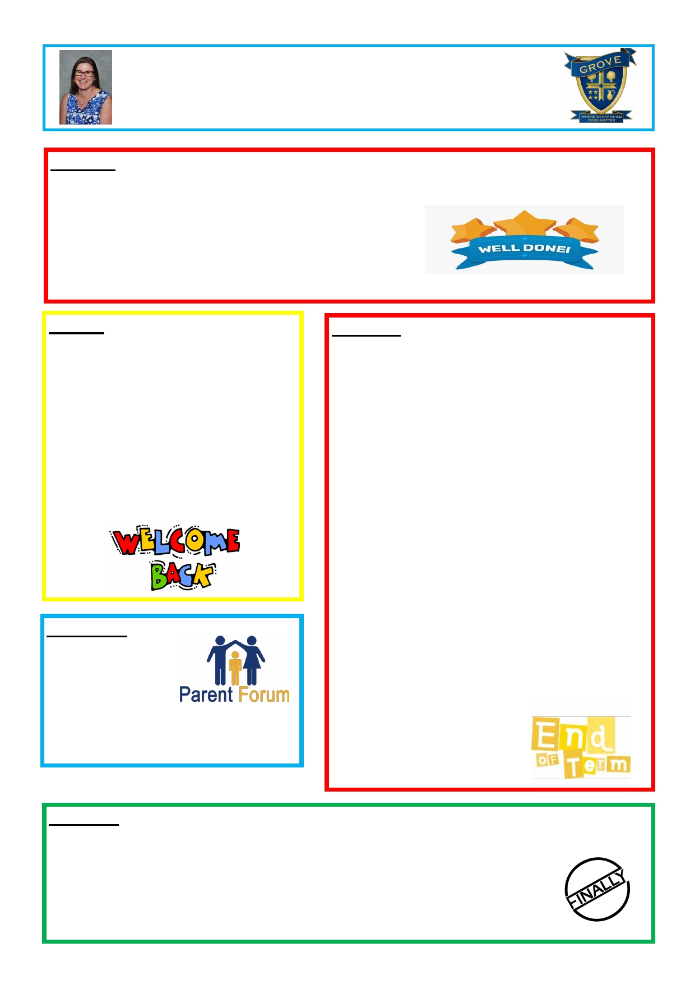

**Academy Principal's Newsletter—January 2020**

**Well done!**

The children make me proud every day with their super behaviour around school. They have also made

me so proud when they have taken part in activities outside

school, showcasing their talents. These include:

• High fives netball tournament

• Football tournament at Power League

• City Choir concert at Victoria Hall

• Local Democracy Day

**This term**

We will continuing to work on improving

the teaching of reading, writing and maths, and ensuring that we are teaching a broad and balanced curriculum. We are hoping

to invite parents in to workshops to see

how we help pupils to remember their new

knowledge in science, history and

geography. We will also be organising small group phonics teaching for those pupils who need this extra support.

**Parent Forum**

Thanks to our Parents'

Forum for their

support, it is invaluable.

If you would like to join them, please pop a

note in your child's

diary and we'll be in touch.

**And Finally!**

**End of term**

I was so proud watching our Year 5 pupils in their super

performance of 'Bah Humbug'. They did so well,

learning all of those lines. A special shout-out to those

pupils who had to take on new roles at short notice,

due to illness. Our Christmas Fayre was a huge

success; we raised over £1300 for the school fund,

which we will be using to fund our new reading books.

Congratulations to our raffle prize winners and once

again thank you for supporting this event and for your

generous donations. Christmas dinner was delicious

and well received. Thank you to our kitchen staff who

make feeding 430 pupils look so easy! For the first time

at Grove we held a Community Carol Concert, which

was a lovely way to end the term, putting a little bit of

Christmas in the air! It was a real honour to present 2

Community Hero awards at this concert. We award these for pupils who have shown community spirit.

Joshua (Y3) received his for fundraising for the

counselling service Dove, and Tierre (Y6) received his

for spending his own time translating some key

phrases to help pupils who had

arrived at our school not speaking

English. What gorgeously kind and generous pupils we have at Grove.

I hope that you all enjoyed some relaxing time with your families over Christmas. Thanks, as always, for your continued support.

From all of the staff at here at Grove, we look forward to working together in 2020 for another magical, successful year for our children.