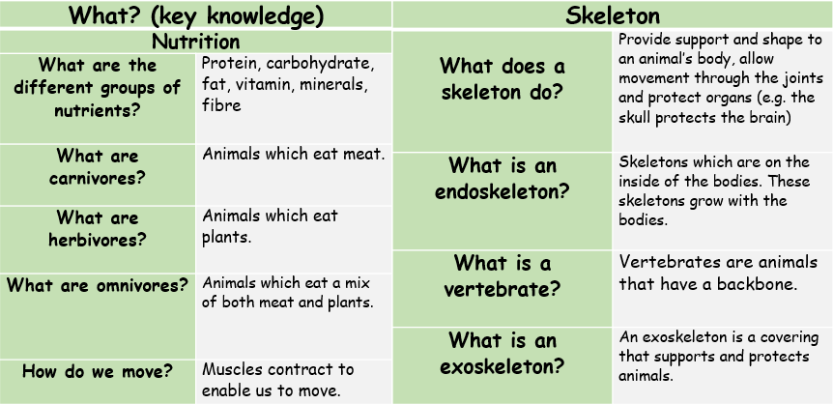
Summer 2 – Animals including Humans: Biology
Influential Scientist:
Marie Curie
bones | the hard parts inside your body which form your skeleton
contract | to make smaller by drawing together; shrink or make tighter
endoskeleton | the internal (inside) skeleton of an animal
exoskeleton | the protective structure covering the outside of some animals
joints | where two or more bones meet
muscles | something inside your body which connects two bones; used in movement
organs | a part of your body that has a purpose in keeping us alive
skeleton | the framework of bones in your body
tendons | a strong cord inside bodies which joins a muscle to a bone
vertebrate | a creature which has a spine
nutrition | getting the food necessary for health and growth
minerals | something which gives goodness to the body
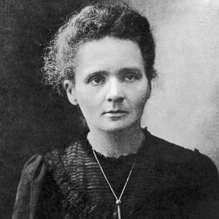
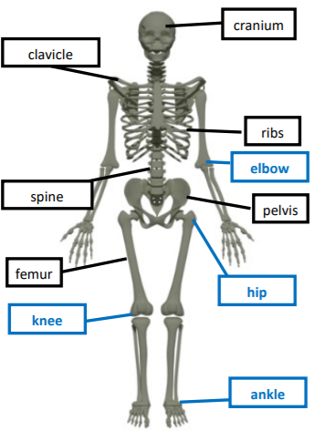
Marie Curie used the work of Wilhelm Roentgen to improve the use of X-Ray machines to help us to see inside our bodies.
Forces, Levers and Pulleys: Physics

