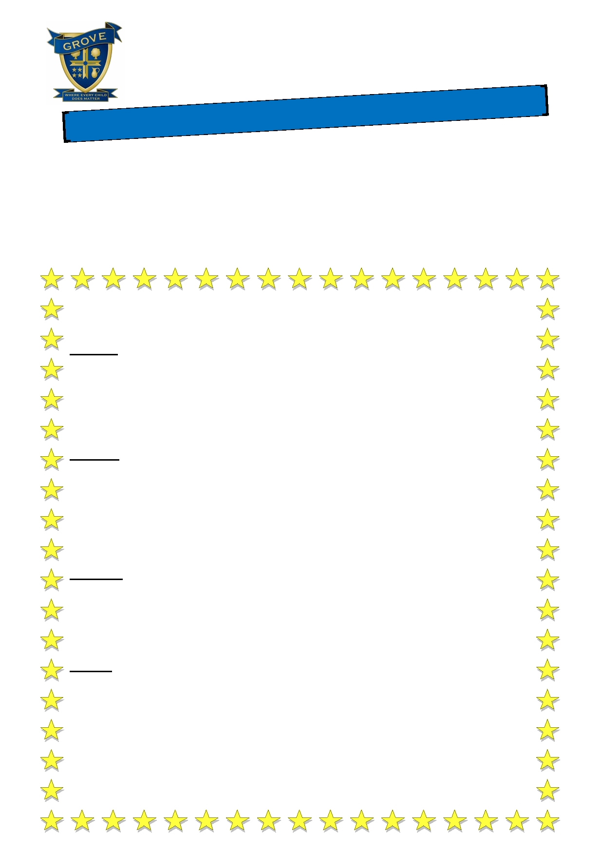
Grove Academy
Attendance Newsletter
2017/2018

A is for Attendance!

Welcome to our school newsletter dedicated to school attendance.

Attendance at Grove Academy as at 25th May 2018 stood at 94.85%,
2.65% below our whole school target.
With your continued support we are sure that we shall achieve our school target of 97.5%
Thank you to all of our parents/carers who have continued to support our school attendance.

Celebrate! The following children received certificates for 100% attendance at school for
Summer Term 1.

Gryffindor — Lauren A, Amira A, Oliver A, Sham, Emma A, Harun A, Caine A, Soureya B, Ellie-Mae B,
Rosie B, Daniel B-G, Dalton B, Liala C, Ruben C, Lily C, Layla C, Edward C, Oscar C, Chloe C, Ellie D-E,
Finlay D, Charlie F, Callum F, Maddison F, Amelia G, Trinity G, Kayla H, Kamran H, Reece H, Varin I,
George J, Scarlett K, Reece L, Zachary L, Nadine L, Christabel M, Igor M, Jacob M, Paige M, Bartosz M, Shahram M, Phoebe M, Dylan M, Louis M, Daisie-M M, Ryan P , Finlay R, Abigail R, Erin R, Tawana S,
Sophie S, Demi-Leigh S, Peyton S, Leo S, Tamana S, Lakshay S, Leon S, Joseph S, Tommy S, Birhat S,
Deniel T, Harry T, Chloe W, Finley W, Emily W

Hufflepuff — Minnah A, Ayisha A, Theo A-B, Demi A, Maisie A, Musa A, Sumaiya A, Rawan A, Roxie A,
Salaam A, Heidi A, Tiffany A, Hannah B, Rayan B, Kyle B, Logan B O'M, Karina B, Isabel B, Jayden B, Olivia C, Owen C, Harry C, Lacey C, Ole D-M, Kelsey D, Katie F, Steph G, Leyla H, Liam H, Lily-Ann H, Samuel H, Jack H, Edie-Mae H, Hollie H-K, Alfie H, Ruby H, Idris I, Ella I, Alfie J, Matilda K, William K,
Lillie-Jo L-C, Isabelle L, Aidan L, Joel L, Alyana M, Lily-May M, Emily M, Isla M, Tion G-G, Trae G-G, Emily M, Isaac M, Emaan N, Sophie-Anne O, Harvey P-W, Libby P, Yousha PR, Freya R, Layton R,
Malk S, Mia S, Manpreet K, Logan S, Curtis S, Maisie T, Charlotte T, Sophie W, Alexandra W,
Isabelle W, Raheem Y-V, Abdullah Z

Ravenclaw — Jack A, Ben A, Azaan A, Saros A, Tylese A, Lily-Rose A, Ethan B, Thomas B-H, Kyle B,
Harry B, Reily C, Emily D, Maddison D, Milka E, Sharmaine F, Poppy F, Ben G, Alex H, Caitlin H,
Melika H-A, Lewis H, Ali Murtaza-H, Anisah K, Mischa L, Rhys L, Mollie L-M, Finlay M, Aatif M,
Maxwell M, James O'D, William O, Alfie P, Nile P, Aroona R, Holly R, Nashra R, Zhear R, Antoni R,
Lewis R, Nyasha S, Layton S, Emmanuel S, Ruby S, Brooke S, Ellyssia-Mae F, Rhys S, Luca S, Jereal T,
Libby W, Fran W, Sadie W, Talulah W, Paige W, Isma Y, Damilola Y

Slytherin — Adam A-I, Ahmed A, Joseph A, Sam A, Charlie A, Keira B, Garry B, Ethan B, Zak B, Alfie C, Emily C, Kyle D, Amy-Leigh D, Safira D, Kyran D, Kyle E, Saoirse E, Leila E, Claudiu F, Corey F, Jessica F,
Olivia F, Samuel F, Grayson G, Tia G, Alex H, Bradley H, Khizer H, Henry H, Lily H, Chloe H, Lucy H,
Alfie H, Ethan H, Madeline H, Isaac H, Rhys H, Oliver H, Vina I, Archie J, Jack J, Matthew J,
Evangelien K, Amjad M, Isaac M, Missi-Jaye M, Melissa N, Kane N, Junior P, Noah P, Mahmoona R,
Ta-Ha S, Thomas S, James S, Nicolas T, Joshua V, Ellie W, Macey-Mai W, Sophie W, Zoya Z

Class attendance for Summer Term 1 - Well done Hufflepuff AC

Huff AC Raven JW Slyth HC

98.4% 98% 97.2%

Huff JW

96.5%

Huff RM Raven LS Slyth HJ Gryff LD Huf AB Raven SC

95.7% 95.6% 95.5% 95.3% 95.2% 95.1%

Raven MF Gryff GJ Slyth CB Gryff RC Slyth RL Gryff CD

95.1% 94.7% 94% 93.3% 93.2% 92.7%

There will be a surprise reward in the summer term for every child who achieves 98%-100% or more for this academic year.

