14th February 2019

Dear Parents and Carers

For those of you who use our Before & After School Clubs, you will have probably met our new club manager, Peter Lockett. Peter has been spending his first few weeks meeting the children, staff and parents and carers and getting feedback about the clubs.

The clubs have been running since 2016 and can accommodate up to 70 children, 35 at each school in each session and we offer a walking bus to and from Grove from each of the infant academies for up to 12 children each morning and afternoon.

In order to make improvements to our club rooms, keep costs down and to ensure we offer the best for our children, we are planning a few changes to our clubs which will come into effect after the Easter holidays.

- Both clubs will open from 7:30am for Breakfast which will be £3.50 per child per session.
- Both clubs will stay open until 5:45pm each day which will be £9.00 per child per session.
- All places will need to be booked and paid for in advance on ParentPay.

You will be able to book and pay for places up to one term in advance. If places are not filled earlier, you will be able to book and pay for spaces up to the Thursday of the week before you require care club.

We are sure you will appreciate, these prices are extremely competitive and we want to ensure the children have a lovely place to stay and play before and after the school day.

We are aware that these changes may impact on parents’ budgets, so we are starting them immediately after the Easter break. This will allow for a smooth transition from our current system.

If you have any questions or queries about these charges, we will be holding drop-in sessions at Hamilton Academy from 5:45pm to 6:00pm on Tuesday 26th February 2019 and at Northwood Broom Academy from 5:45pm to 6:00pm on Thursday 28th February 2019.

We are asking all parent/carers who wish to continue to use the clubs, to read the enclosed Before & After School Club policy, and for you to return the registration form so that we can ensure we have accurate up to date information.

Please return the registration form by 28th February 2019, either by sending into school or dropping off with the care club staff.


Yours sincerely

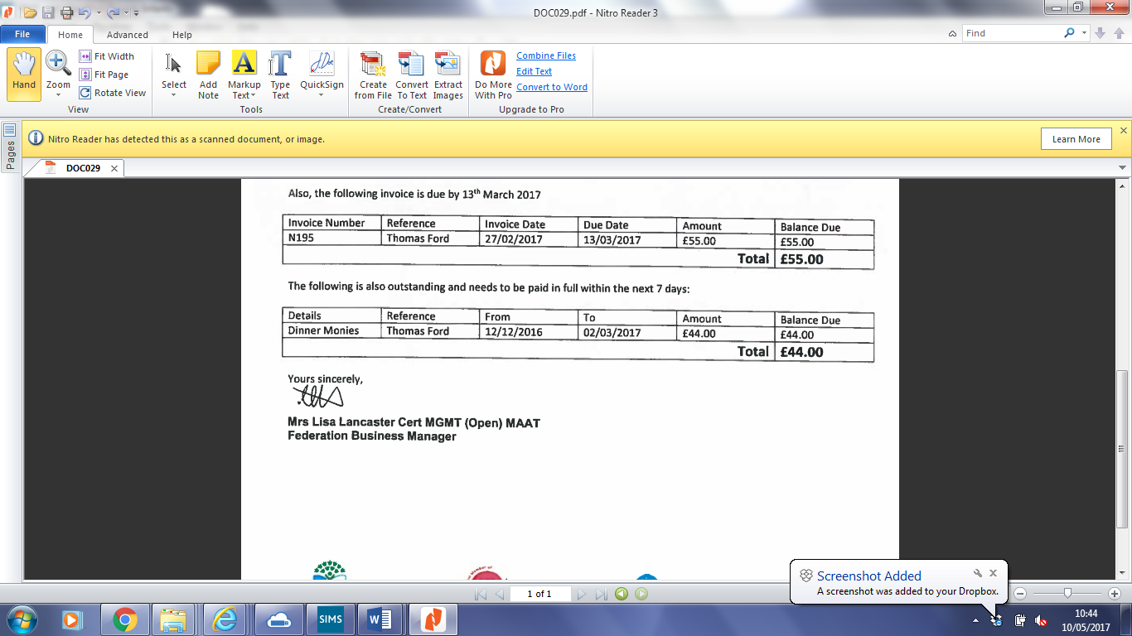
Mrs Lisa Lancaster Mrs S Carrigan
Executive Business Manager Academy Principal
ESPRIT Multi Academy Trust Grove Academy

