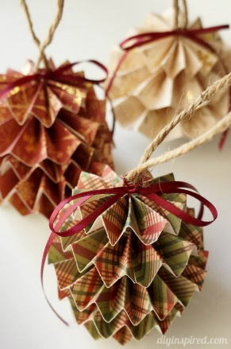
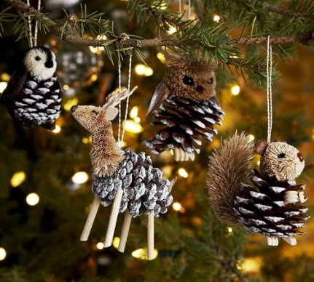
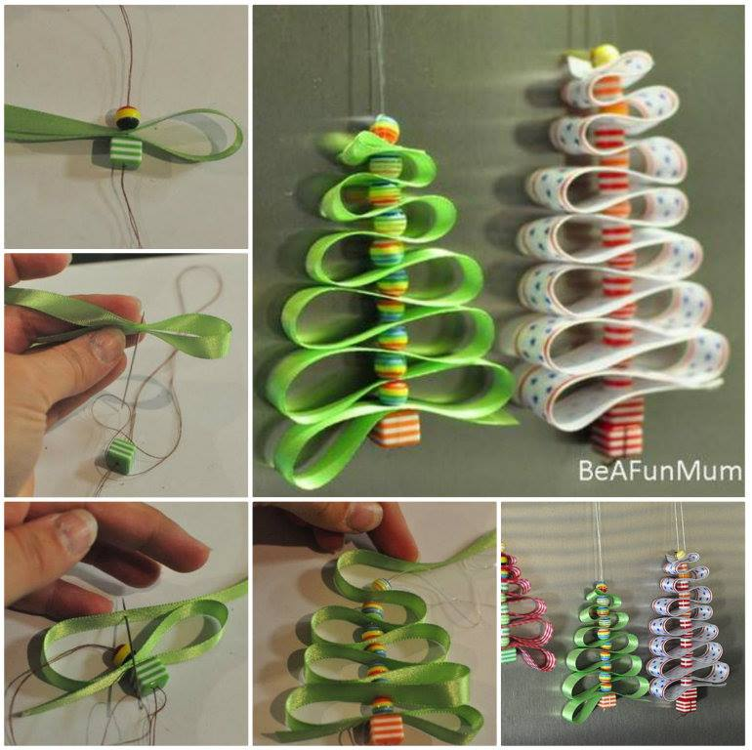
CHRISTMAS creative COMPETITION
We would like you to make a Christmas tree decoration with your child, which will be sold at our Christmas Fayre on Wednesday 11th December to raise money for our academy funds.
To make it even more fun, any decorations sent into our academy will be entered into a Year Group competition and judged.
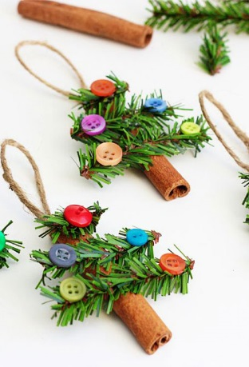
The best decorations will win a small prize!
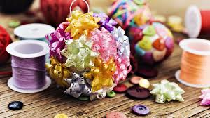
There are lots of ideas on the internet of DIY decorations: You can make your decorations out of anything. How about salt dough, pine cones, buttons, polystyrene, ribbon, cinnamon sticks, sponge, glitter or bows? Let your imagination run wild!
Please bring in your creations by Friday 6th December 2019.

