Our ref. SCa.JP

29th April 2019

Dear Parents/Carers,

Re. School Closure

Grove Academy has been selected as a Polling Station for the forthcoming European Elections which are taking place THURSDAY MAY 23rd, 2019 and in order that we can ensure the health and safety of our pupils and staff, we will be closing the school for this day.

As per our holiday arrangements shared previously, school will be closed on FRIDAY May 24th and re-open after half term on MONDAY 3rd JUNE, 2019.

Thank you for your continued support.

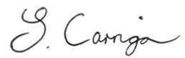
Yours faithfully,

Mrs S Carrigan
Academy Principal

