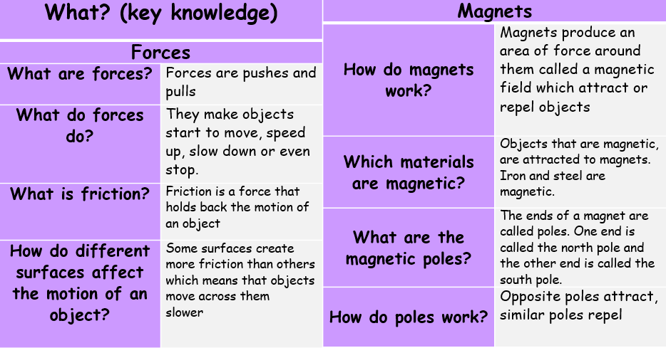
Forces and Magnets: Physics
attract | causes an object to move towards another object
friction | a force between two surfaces that are sliding, or trying to slide, across each other
force | the pulling or pushing effect that something has on something else
gravity | the force which causes things to drop to the ground
magnet | a piece of iron which attracts magnetic materials towards it
motion | changing position or moving from one place to another
opposite | something which is completely different in a particular way
pull | move something towards you
push | move something away from you
surface | the flat top part of something or the outside of it
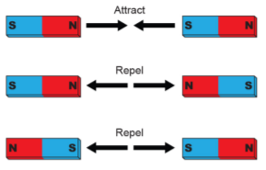
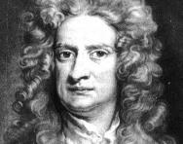
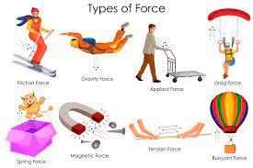
Influential Scientist:
Isaac Newton
The famous story of an apple falling to the ground from a tree illustrates how Newton's work on gravity was inspired by things he observed in the world around him.
Forces, Levers and Pulleys: Physics

