We are delighted to be able to offer your Year 6 child the opportunity to attend Birches Head Academy for the last few weeks of this term. We are very grateful to BHA, with whom we have worked very closely over the last couple of weeks, to risk assess and organise this provision.
Your child will be taught initially by Grove staff, and we are hoping that there will be some opportunity for them to also be taught for some lessons by BHA staff. We are able to use an area of the school that is not used by any other students or staff at BHA, with our own access, access to outdoors from the classrooms, and our own toilets, so it really is ideal! This will be a great transition for your child. The Year 6 pupils who have been attending Grove Academy for the last couple of weeks have settled in well to the new environment and systems and have enjoyed getting back to some sort of normal so we are confident that pupils will feel the same when they are working at BHA.
Mrs. Dixon, principal at Birches Head Academy says:
I am delighted that we will be welcoming your child to Birches Head Academy. We are very much looking forward to meeting the children properly and working with them to learn what makes them truly special. It gives us a unique opportunity to support their transition to us in September. I hope you will take up this great opportunity.

Please bear with us on the first few days, as ensuring a one-way system of entry and exit that does not overlap with any current BHA students in school has taken some organising, and we ask you to be patient with us as we evaluate the arrangements. Our aim, as always, is to ensure the safety and wellbeing of your children.
Our provision will be continually assessed due to:
- Local and national Government directives
- Numbers of children that we need to provide childcare for
- The health of our team
As many of you are aware we have been offering daily provision (including wrap around care) for ‘critical’ key worker children throughout the lockdown period. This provision will continue. Therefore, this handbook will share with you the arrangements for relocating some Year 6 children to Birches Head Academy. Pupils who are not transitioning to BHA will continue to be educated at Grove Academy.

Entrance to school | - Pupils should assemble on the Front Yard, where they will be met by Grove Academy staff. They should wait on a number in the yard until all pupils have arrived. They will then be taken into school.  - Parents who drive should park on the visitor car park and walk their child down to the Front Yard. Please do not wait by the Front Yard as it is likely to be very busy.  - When dropping off and collecting your child we are asking parents to follow a one-way system so that social distancing measures can be put into place. The map below shows the school and the one-way systems. The blue arrows show the route for arrival and the red arrows the route for collection. There will be members of Grove staff along the route to direct you, please respect them as they are helping to ensure social distancing for the safety of all.  - Pupils will attend for 2 days per week – your child will be allocated either a Monday and Tuesday, OR a Wednesday and Thursday – see bubble information below.  - Times of day will be APPROXIMATELY 09:50am – 2:00pm  - Strictly one parent/carer (18+) only MUST accompany their child to and from school, no siblings unless absolutely necessary (if siblings accompany they must remain alongside the adult). NO PUPIL, REGARDLESS OF AGE SHOULD WALK TO OR FROM SCHOOL ON THEIR OWN.  - Follow the arrows on the paths which show the one-way system  - Pupils will enter school and sit on designated seats  - If children arrive late they WILL NOT be admitted.  - Dogs are not permitted on the premises.
Groupings | - Pupils will be in a small bubble and stay in that bubble group for the whole day, not mixing with any other bubble  - Each bubble group will have 2 members of staff who will stay with the children in that bubble at all times.  - Children will access outdoor provision as much as possible.
BASC | No BASC provision is available for the Y6 pupils working at BHA

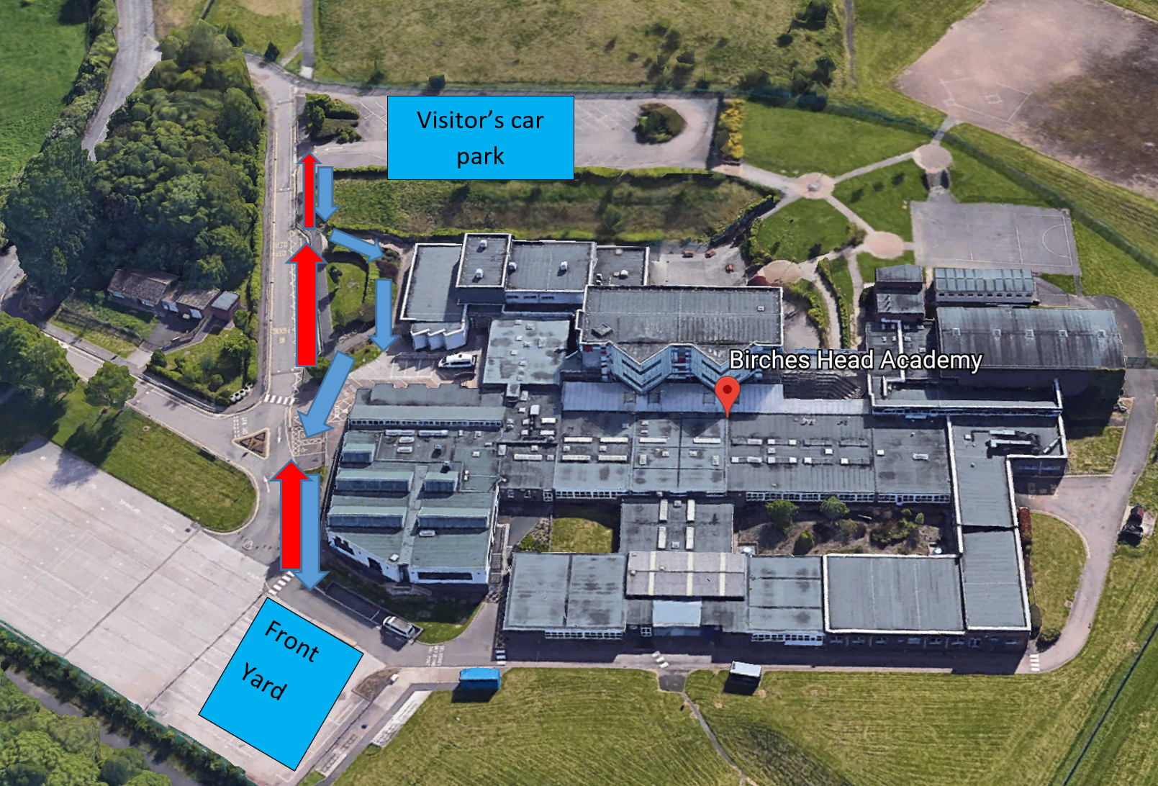
TIMETABLE & ARRANGEMENTS

 | Location in school | pupils | Days | Number of pupils | Staff (T and TSA) first aid | Toilets to be used by pupils | entrance | SLT to supervise gate entry | Time of entry | Time of exit
Bubble BHA1 | BHA  Maths 3 | Y6 | Monday, Tuesday | Max 12  Currently 10 | Miss Walker and Mrs. Sheldon | BHA pupil toilets | From the front yard | See rota | 9.50 | 1.50
Bubble BHA2 | BHA  Maths 3 | Y6 | Wednesday, Thursday | Max 12  Currently 12 | Mr. Price and Mrs. Damjanovic | BHA pupil toilets | From the front yard | See rota | 9.50 | 1.50
Bubble BHA3 | BHA  Maths 2 | Y6 | Monday, Tuesday | Max 12  Currently 11 | Miss Bentley and Mrs. Worthington | BHA pupil toilets | From the front yard | See rota | 10.00 | 2.00
Bubble BHA4 | BHA  Maths 2 | Y6 | Wednesday, Thursday | Max 12  Currently 11 | Miss Craddock and Miss Willett | BHA pupil toilets | From the front yard | See rota | 10.00 | 2.00
Bubble BHA5 | BHA  Maths 1 | Y6 | Monday, Tuesday | Max 12  Currently 10 | Mrs. Clowes and Mr. Hill | BHA pupil toilets | From the front yard | See rota | 9.50 | 1.50

WHAT YOU NEED TO KNOW
Clothing | - Pupils to wear sensible, comfortable clothes and trainers, no make-up  - Clothes to be clean on every day  - We advise children remove their clothes as soon as they return home, place them in the washing machine and shower or bathe.
General | - Pupils to bring a water bottle every day, CLEARLY LABELLED with their name.  - Please send your child to school with a pack of tissues which they can leave in their tray.  - If needed, suncream to be applied BEFORE attending school, then to be reapplied by child as needed during the day.  - If your child uses an inhaler, this must be brought to school every day with them, and kept in their bag.  - All children, regardless of year group, must be dropped off and collected by an adult.  - If your child arrives wearing a mask and / or gloves, they must remove it and place in a plastic bag before entering the building. They can then put the mask back on when they leave school and have been dismissed.
Lunch | - All children to bring a packed lunch.  - Lunches and snacks to be eaten in classrooms – no tuck will be provided or on offer from the academy
Hygiene | - All visits to the toilets supervised by an adult  - Regular handwashing modelled and observed by staff  - Enhanced cleaning of resources and environment, deep clean on a Friday  - PPE equipment will be used by staff when necessary  - If a child falls ill, they will be placed in isolation (and supervised from a safe distance).
Test and Trace | - As you are aware, the Government are implementing the Test and Trace scheme. If any of our staff are contacted through this service and told to self- isolate, it may be necessary for us to close a bubble at very short notice. This is out of our control, and we will communicate this with parents as soon as we become aware this may happen.
Communication | - Parents and carers to communicate via email or phone calls, the academy office is not open  - Parents bringing their child to Birches Head Academy are agreeing to abide by all stipulatoins within this document  - If a child becomes ill at school, they must be collected immediately. As a result of a child being ill, parents should request a test for their child by calling 119, the results of which MUST be shared with school in order for the remainder of the bubble to access a test if necessary. If you do not have your child tested, you will need to keep your child isolated at home for the next 7 days, and the rest of the household for 14 days.
Staff illness | If any staff member starts to show signs of Coronavirus, High Temperature, a new or continuous cough, change in taste or ability to smell they will need to:  - Inform SLT on site immediately  - Access a Covid 19 Test  - Self-Isolate and follow NHS advice regarding household isolation until results are known.  - The SLT member of staff will decide on the following depending on staff availability  - Is there a staff member who can cover the bubble – who has not worked in another bubble for past 14 days?  - If Yes – allocate that staff member to the bubble (Teachers can only be replaced with Senior TSA or other teacher.  - If No – Is the bubble a KEY WORKER bubble?  - If Yes – seek support from MAT or LA for alternative available staff / arrange supply staff cover (MUST not have worked at any other school setting for 14 days)  - If No – Close bubble until staff available (Up to 7 days).  The SLT member must also follow the Local outbreak control plan  ..\..\..\SOT Outbreak overview and process for educational settings (shorter version).pptx  - Informing Stoke on Trent Council’s Covid Response team on 01782 231222 or via email address Tracecovid19@stoke.gov.uk
Revised School Rules | - I will stay 2 metres away from others including my teachers  - I will regularly wash my hands throughout the day for 20 seconds  - I will tell an adult if I feel unwell  - I will not bring items into school from home, or take items home from school  - I will only use the equipment in my pack  - I will not mix with children in a different bubble in school  - I will ask an adult when I need to use the toilet, so they can keep me safe  - I will use the catch it- kill it rules (coughing and sneezing into my elbow or tissue)  - I will follow these rules at all times so that I do not get sent home and are unable to come back to school  The Children will be taught the following to support the revised rules:  - What 2 metres looks like and how to keep this distance between others  - How to thoroughly wash their hands  - What feeling unwell means  - The reasons and importance for not bringing into school items from home or taking items home from school  - The reason and importance of why they can only use their own equipment in their packs  - The reasons and importance of why they are not able to mix with children in different bubbles when in school  - The importance of asking an adult when they wish to use the toilet  - What is meant by the catch it- kill it rule  - Why they will not be allowed back in to school if they do not apply the rules

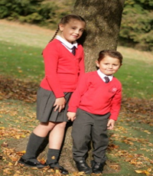  No Uniform | 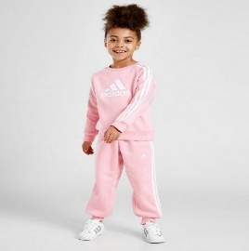  PE Clothes | 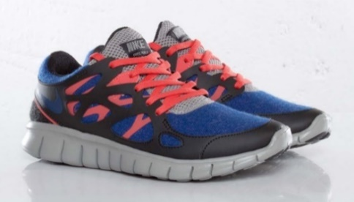  Trainers
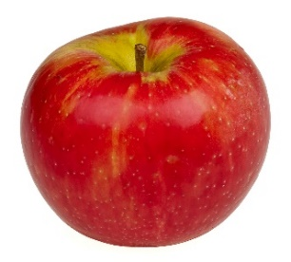  Snacks | 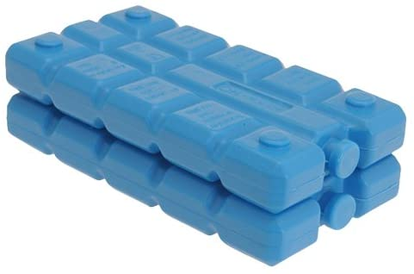  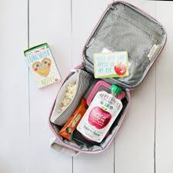  Lunch & Ice Pack | Sun Hats
Sun Cream | 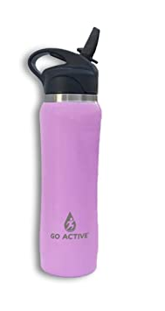  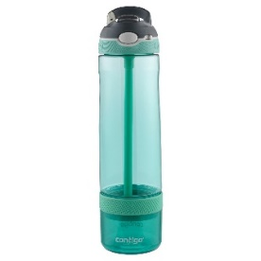  Sports Water Bottle | 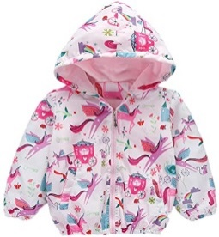  Coat
Tissues

PARENT AGREEMENT:
I AGREE THAT FOR MY CHILD TO ATTEND BIRCHES HEAD ACADEMY I MUST FOLLOW THE GUIDANCE BELOW:

- Update school immediately if a member of my household becomes ill and will arrange to be tested by calling 119. I will update school with the result as soon as it is available. I understand that if I refuse a test, I will follow the self-isolation expectations of 7 days for the infected member of my household and 14 days for all other members of the household.
- Explain clearly to my child what social distancing is and why it is important for it to take place.
- Talk to my child to explain that school may look and feel very different to what they remember and that they may be working with new teachers in new classrooms.
- Ensure my child arrives promptly and is collected promptly at the times identified above, always accompanied by an adult (over 18). (Late arrival will not be permitted as gates/doors will be locked)
- If my child is upset and not willing to enter school independently, I will take my child home. I understand that staff cannot comfort my child due to social distancing measures.
- Allow my child’s temperature to be taken if complaining of feeling ill, with a non- contact thermometer.
- Ensure my child wears their PE kit or casual wear which MUST be fresh on each day – we recommend putting clothes straight in the washing machine once returning home from school to minimise and control the spread of infection.
- Ensure my child has a shower or a bath as soon as they return home from school, again to minimise and control the spread of infection.
- Ensure my child wears trainers every day.
- Ensure my child brings a clearly labelled water bottle, sun hat and sun cream OR coat, so they can access outdoors in all weathers.
- Ensure that my child brings a packet of tissues to leave in their tray
- Ensure up to date contact details for family members are available within school and emergency contact details should children become poorly/exhibit symptoms of contracting coronavirus.
- Ensure the school is kept up to date with any decisions regarding withdrawing my child from school.
- Treat staff with respect at all times.
- Ensure I observe the one-way system and social distancing markers during arrival and dismissal
- Ensure I do not gather with other parents at the school gate.
- Ensure I do not enter the school premises without a pre-arranged appointment.
- Ensure my child brings their own packed lunch and snacks every day, in a clearly labelled lunch box and include an ICE PACK to keep the lunch cool.
- Ensure I adhere to all of the expectations outlined in this document.
A message from Grove Academy staff
Your children are precious to you and to us. The current situation we are living in has tested and will continue to test us all. As we enter this next phase of opening our school to more children, we know it will continue to be one of the most unchartered times of our personal and professional lives. Remember in the words of Winnie the Pooh ”You are braver than you believe, stronger than you seem, smarter than you think and loved more than you know.” Let the journey continue!
Stay safe and well – your support is immensely appreciated
All staff at Grove Academy xxx
PHOTOGRAPH TO USE WHEN TALKING TO YOUR CHILD
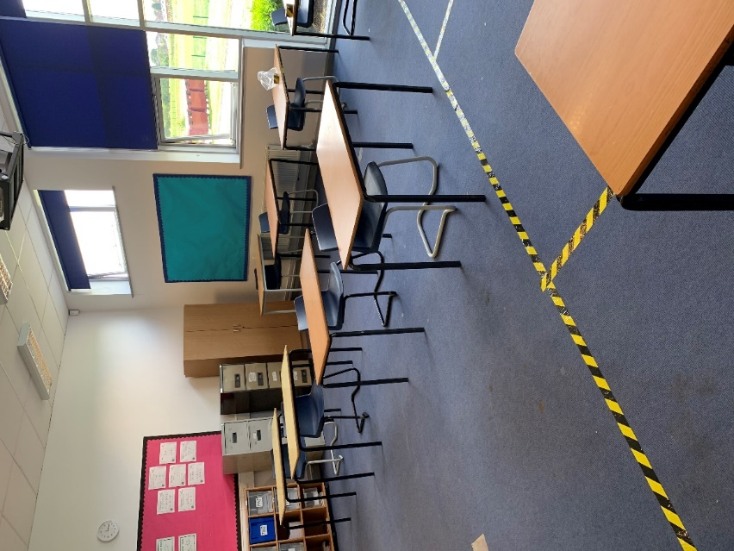
Each classroom has been cleared of any soft furnishings and tables have been set out so each child can sit at their own table with their own ‘tray of resources’. Each child will have their own tray to put their belongings in each morning when they arrive. Any resources that are not needed have been covered over or removed. If your child has not been attending Grove during lockdown, they may feel unsure about what school will look like. This will be very different to the school experience that your child knows and remembers. Therefore, please share this information so they have an understanding of what to expect when they arrive at school.

