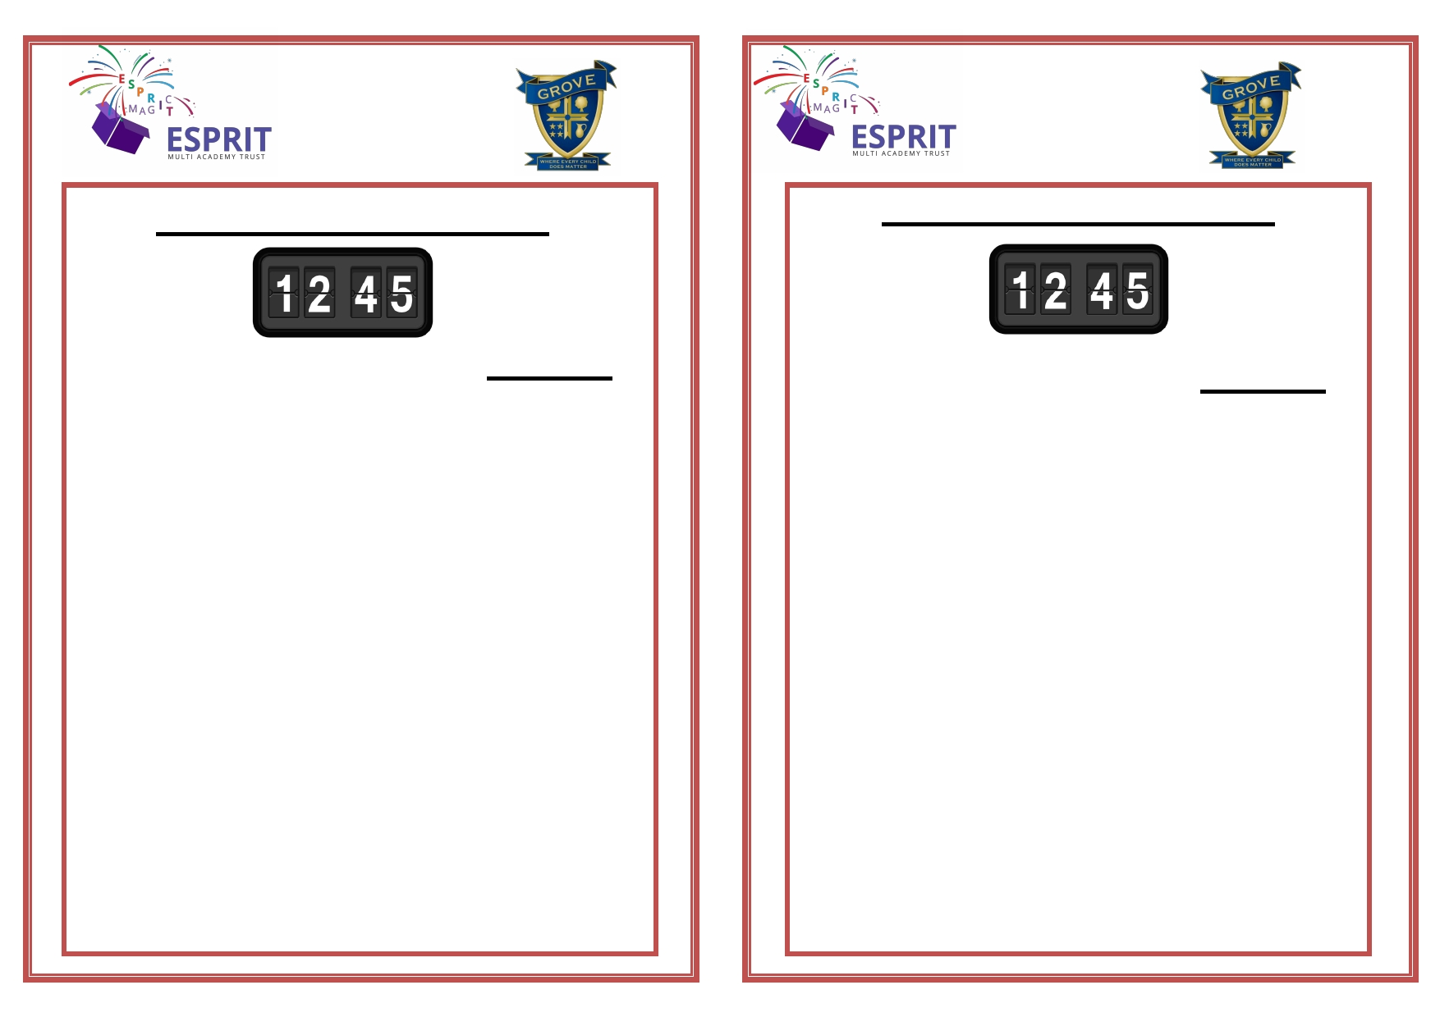
Friday 12th April Reminder
Friday 12th April Reminder

◻

◻

◻

◻

◻

Grove Academy closes at 12:45pm
on 12th April 2019 for all pupils. City Catering will be providing a
sandwich lunch on this day,
therefore there will be no hot meals served.
Payment will be as usual via
ParentPay at the cost of £2.50. Any children who are eligible for
free school meals will have a
sandwich lunch provided for them from City Catering.
Lunch will be served earlier than the
usual time, therefore there will be no tuck on this day.

◻

◻

◻

◻

◻

Grove Academy closes at 12:45pm
on 12th April 2019 for all pupils. City Catering will be providing a
sandwich lunch on this day, therefore there will be no hot meals served.
Payment will be as usual via
ParentPay at the cost of £2.50.
Any children who are eligible for free
school means will have a sandwich
lunch provided for them from City Catering.
Lunch will be served earlier than the usual time, therefore there will be no tuck on this day.

