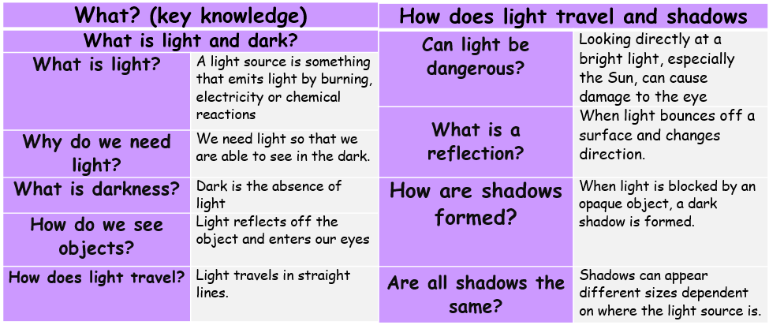
Light: Physics
angle | the direction from which you look at something
dark | the absence of light
emits | to emit a sound or light means to produce it
light | a brightness that lets you see things
opaque | if an object or substance is opaque, you cannot see through it
reflects | sent back from the surface and not pass through it
shadows | a dark shape on a surface that is made when something stands between a light and the surface
source | where something comes from
translucent | if a material is translucent, some light can pass through it
transparent | If an object or substance is transparent, you can see through it
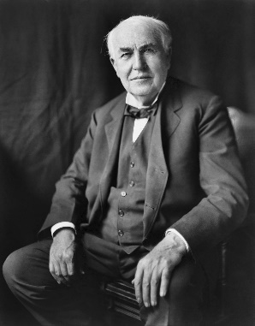
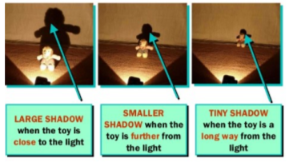
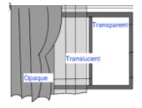
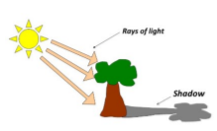
He is best known for inventing ‘domestic’ lightbulbs to go in houses
Influential Scientist:
Thomas Edison
Forces, Levers and Pulleys: Physics

