Our Ref: SC/EC

Friday, 15th November 2019

Dear Parent/Carer

As I am sure you are aware, a late notice General Election will take place on Thursday, 12th December, 2019. As in previous elections, our building is required to be used as a polling station. This decision is out of our control. The Returning Officer has the right by law to make use of any school premises for the purpose of an election and schools cannot refuse such a request.

In order that we can ensure the health and safety of our pupils, we will be closing the school to pupils for this day only. Our academy staff will be working as normal on this day, creating exciting activities for our children.

Our academy will reopen to children on Friday, 13th December, 2019.

May we thank you for your continued support.

Yours faithfully
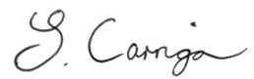

Mrs S Carrigan
Academy Principal

