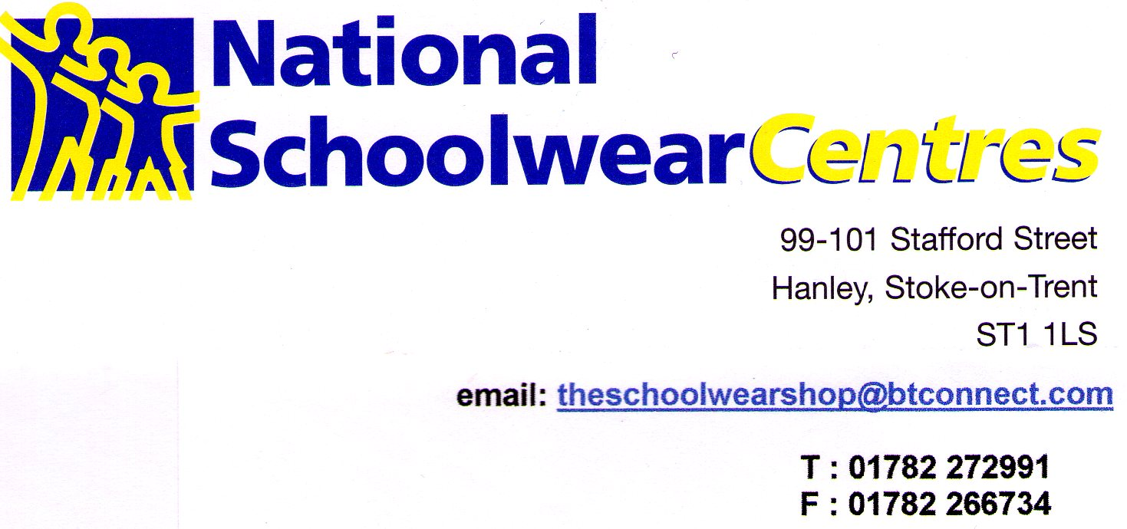

LOCKDOWN UNIFORM PROVISION

Although we are closed due to the latest lockdown rules, we will our very best to help you with all your uniform requirements.

If you need uniform please email us on theschoolwearshop@btconnect.com let us have your details including contact number. We will call you as soon as we can and arrange to fulfill any uniform requirements that you may have.

We will send you a tracking number to your mobile number so you can track the delivery.

Due to the lockdown rules our working hours will vary, so please be patient, we will do our best for you.

Thank you for your custom and support during these difficult times.

In the meantime, say safe

The staff at National Schoolwear Centres

