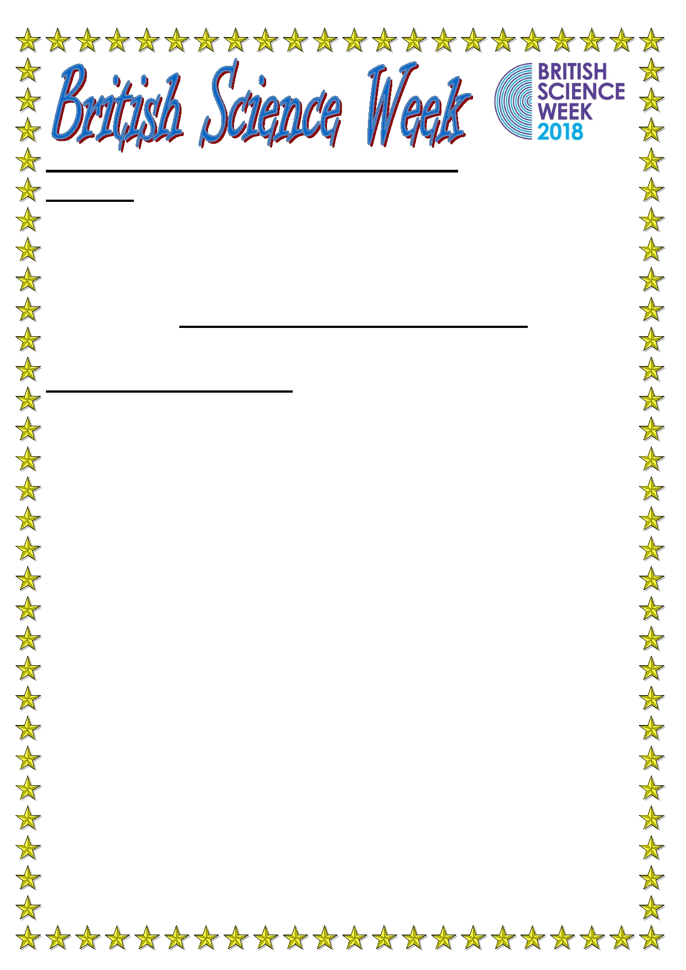
British Science Week 2018 is nearly
upon us!
Dear Parent/Carers
On Wednesday 14th and Thursday 15th March, Grove Academy will be once
again celebrating British Science Week! After last year's success parents
will again be invited to celebrate this event at our school science fair on
Thursday afternoon. You will get to enjoy the wonderful world of science
where you will be taken on a tour of activities by your own child.
2018 is the Year of the Engineer and sees us celebrate a wide range of
amazing scientists well-known for their engineer exploits!
What is British Science Week?
British Science Week (BSW) is a national ten-day programme of Science,
Technology, Engineering and Maths (STEM) events that take place all over the UK for people of all ages. The main aim of BSW at Grove Academy is to
encourage all children to explore the joys of STEM. We are aiming to raise
the profile of science within the school and local community in order to
encourage children to become inspired in considering a future career within
the STEM industry.
Special-guests will also be in attendance on Tuesday to kick off our super cel-
ebration in style as children become enthused in a wide range of scientific
enquiry. Please note, children will NOT be required to dress up. If you are
interested in attending our science week, please return the slip below by
Friday 9th March. Unfortunately, no slips will be accepted after this
date and, due to demand, entry will be limited one ticket per family.
Many thanks,
Mr Woods
Science Leader, Grove Junior Academy
__________________________________________________
I, the parent of ____________________Class (____), would like to attend
the Grove Academy Science fair on Thursday 15th March at 2.00pm.
Signed ______________________. Date____________.

