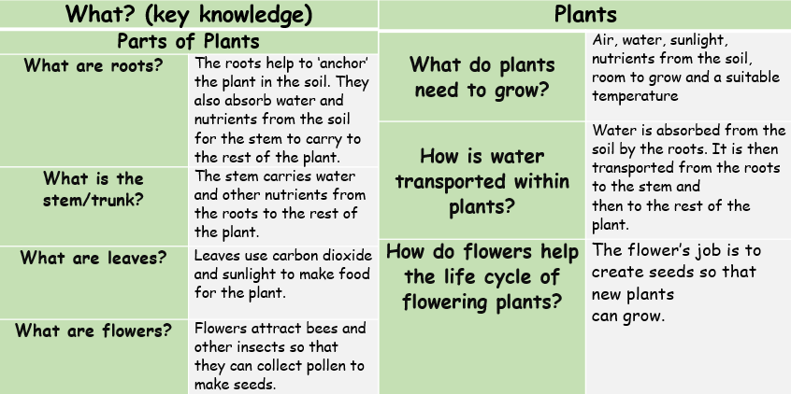
Summer 1 - Plants: Biology
Influential Scientist:
Joseph Banks
absorb | soak up or take in
deciduous | a tree that loses its leaves in the autumn every year
dispersed | scattered, separated, or spread through a large area
dissect | to carefully cut something up in order to examine it
evergreen | a tree or bush which has green leaves all year round
fertilisation | where pollen meets the ovule to form a seed
flower | brightly-coloured part of a plant
flowering | trees or plants which produce flowers
germination | when a seed starts to grow
nutrients | substances that help plants and animals to grow
ovule | a small egg
stigma | the top of the centre part of a flower which takes in pollen
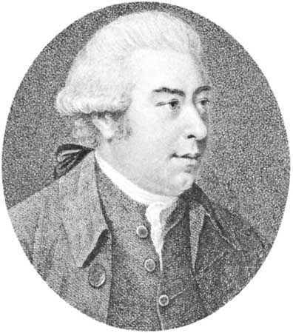
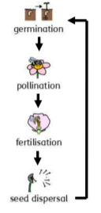
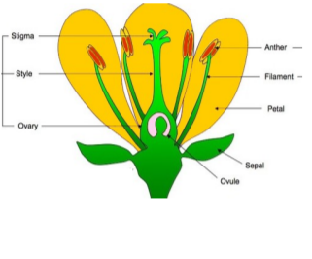
Banks took part in Captain James Cook's first great voyage from 1768 to 1771. About 80 species of plants are named after Banks.
Forces, Levers and Pulleys: Physics

