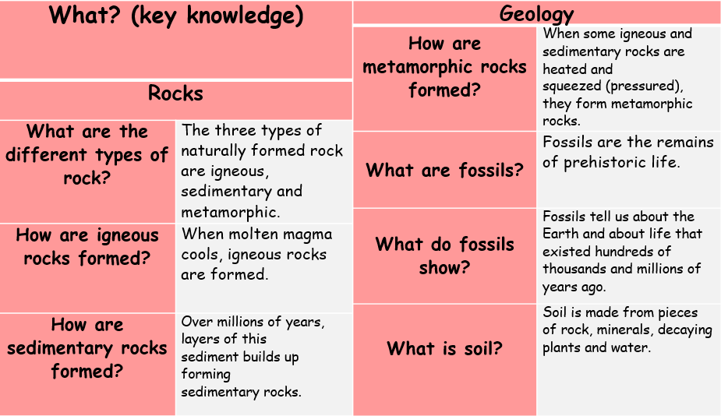
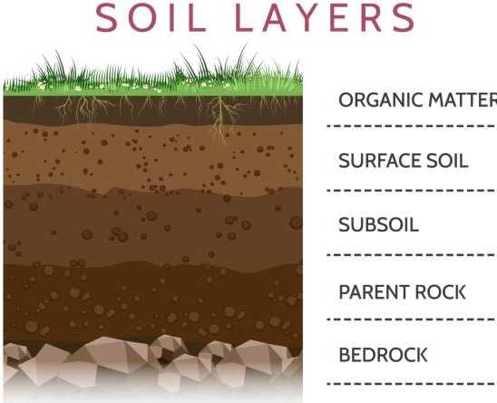
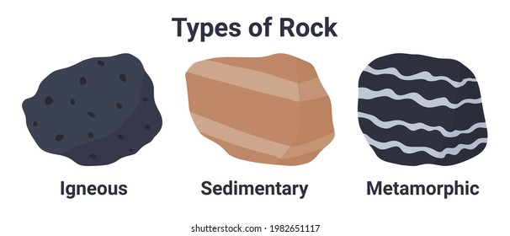
Rocks: Chemistry
Influential Scientist:
Mary Anning
bedrock | The solid rock in the ground which supports all the soil above it.
decaying | Gradually being destroyed by a natural process.
magma | Molten rock that is formed in very hot conditions inside the earth.
mineral | Something that is formed naturally in rocks and in the earth.
palaeontology | The study of fossils as a guide to the history of life on Earth.
permeable | If a substance is permeable, something such as water or gas can pass through it or soak into it.
porous | Something that is porous has many small holes in it, which water and air can pass through
sediment | Solid material that settles at the bottom of a liquid, especially earth and pieces of rock that have been carried along and then left somewhere by water, ice, or wind.
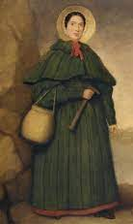

Mary Anning was a famous fossil hunter and collector from the 19th century.
Forces, Levers and Pulleys: Physics

