Our ref: SM.JP/Y6/O/lettershome/General

December 2018

Dear Parent/Carer
We are writing to share our disappointment with last year’s SATs results at Grove Academy.
In July 2018, Grove Academy results were not good enough and we want to reassure you that we are focused on ensuring rapid improvements are made before Key Stage 2 SATs and Teacher assessment in 2019.
The Principal, Executive Principal, Trustees and Governors are all very clear about the need for sustained improvement. We would like to share the following information about the school, and its plans to improve:

- We have a school improvement plan, approved by the DfE, that is focused tightly on improving educational performance and pupil progress;
- We are working closely with the infant schools to ensure Grove meets the needs of pupils on entry and pupils continue to make substantial and sustained progress throughout key stage 2;
- We have introduced formal testing in every year group to be undertaken three times per year in order to clarify gaps in learning and support planning for next steps teaching;
- We have employed a dedicated Home School Link worker and sourced additional support from the Local Authority Education Welfare service to support us in tackling attendance issues;
- Our leadership team is headed up by one of our experienced Principals within the MAT with extensive Key Stage 2 and English experience
- One of our Deputies is a Specialist Leader of Education for Mathematics;
- We are working closely with a local teaching school on a focused approach to improving reading and writing in current Y6.
In addition we will ensure that:
- Exposure to testing happens earlier;
- We use robust data analysis to identify and teach to children’s learning gaps;
- As far as possible children will have the same teacher working with them all year, however, in any school it is quite normal to have unexpected changes of staffing mid-year. We always do our upmost to limit disruption to pupils.
- There will be an even tighter focus on Teaching and Learning and we would appreciate your understanding as this will take priority above other activities, for example Watch Me Learn sessions.

We hope that this information provides you with reassurance that we are doing everything within our power to improve standards rapidly for our pupils. Some parents have already asked how they can support their children’s learning. As always we would welcome your support to ensure that your child is in school every day, and that they complete their weekly homework, including regular reading.

The team at Grove are committed to improving provision rapidly for your children and will work tirelessly to ensure that results will improve significantly this year. You can be confident that children attending Grove Academy will get the same great opportunities that the two partner infant schools currently provide. If anybody would like to discuss this further, Mrs. Carrigan, Mrs Moran and a number of governors will be present at the school fayre on Wednesday 12th December, to answer any informal questions. There will be a formal opportunity to ask questions on Thursday 13th December at 9.15 am. Please complete the reply slip below if you wish to attend so that we can organise an appropriate space for a meeting. As always we would like to thank you for your support in our continued work to raise standards.
Regards



Mrs S Moran Mrs S Carrigan
Executive Principal Academy Principal
ESPRIT Multi Academy Trust Grove Academy

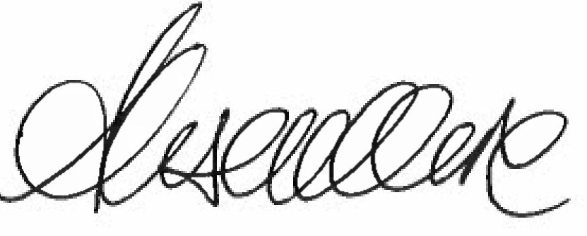


Mrs J Gaffney Mrs A Moore
Chair of Trustees Chair of Governors
ESPRIT Multi Academy Trust ESPRIT Multi Academy Trust

Parent / Carer Meeting

Thursday 13th December 2018

Name of child:___________________________________ Class:______________________________

I will be attending the formal parent / carer meeting at 9:15am.

Name of parent / carer:___________________________ Signature:__________________________

