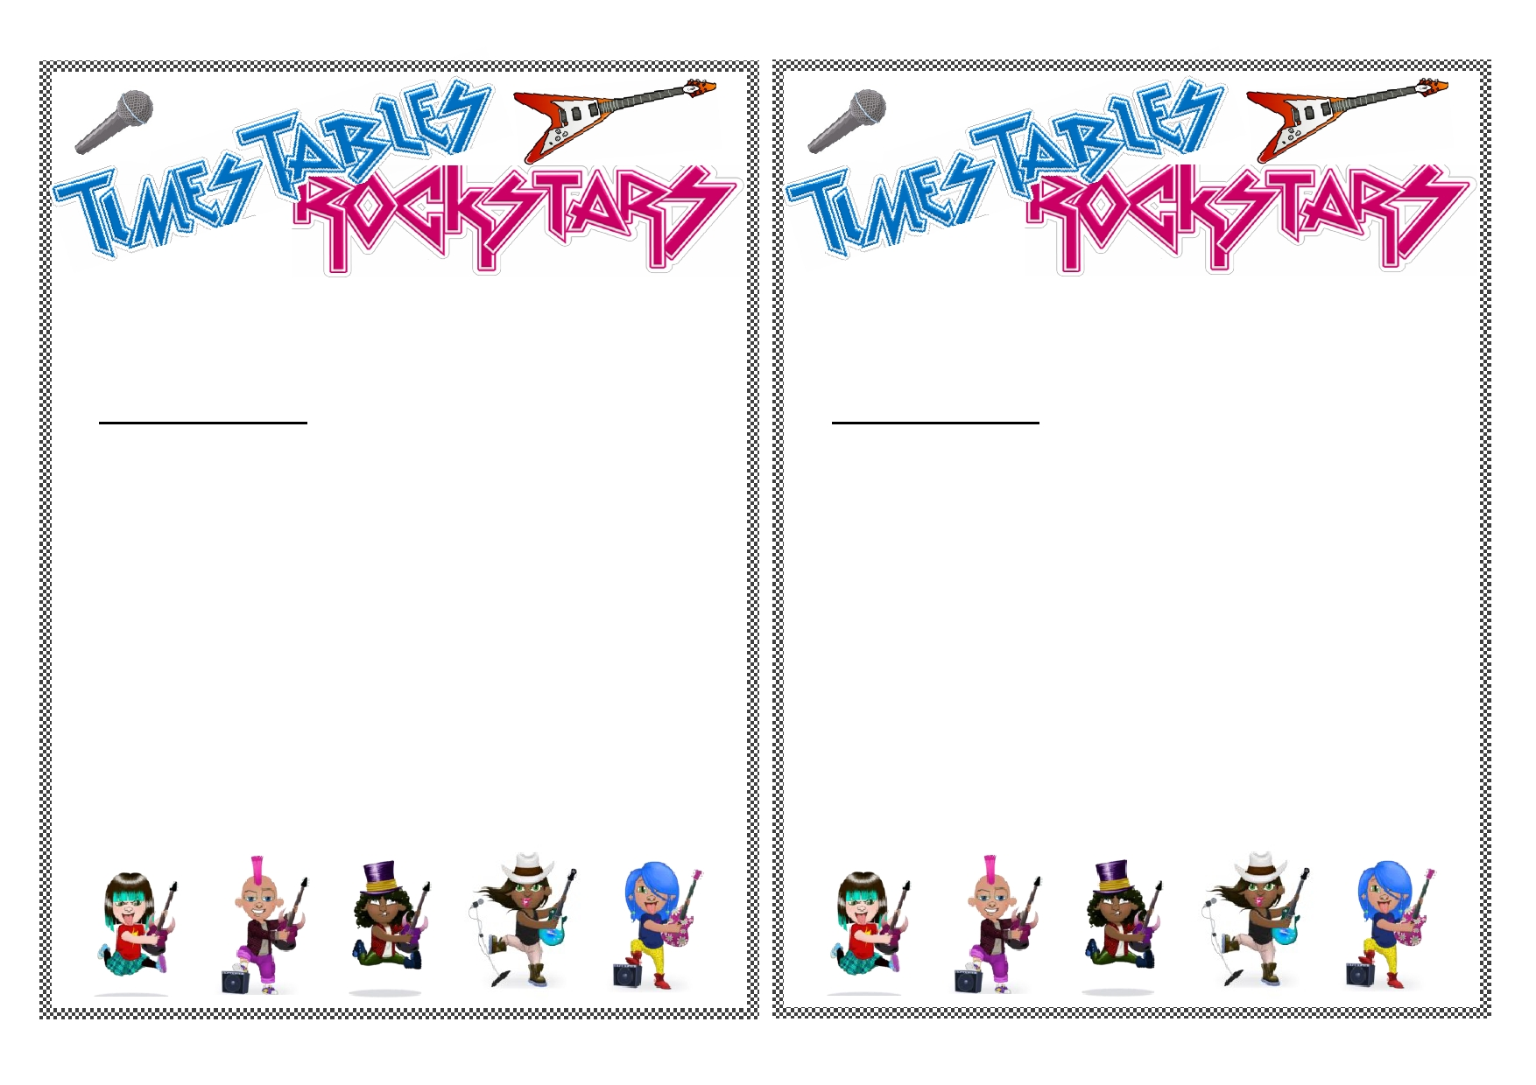
When it comes to times tables, speed AND accuracy are important - the more
facts your child remembers, the easier it is for them to do harder calculations.
Times Table Rock Stars is a fun and challenging programme designed to help
students master the times tables!
On Friday 1st March 2019,we will be celebrating the launch of Times Tables
Rock Stars at Grove Academy with special activities and fun challenges to
reinforce the importance of mental calculations and times tables in real life. Your child will also be given their own personal login to the website.
To celebrate our launch day, we would like your children to come dressed in
full rock star attire! This could include messy hair, animal print, sunglasses, or
dressing in all black.
We are really looking forward to this day and hope you can support us in
making this as memorable as possible for our children.
Many thanks,
Miss Comerford and Miss Craddock (Maths Leads - Grove Academy)
When it comes to times tables, speed AND accuracy are important - the more
facts your child remembers, the easier it is for them to do harder calculations.
Times Table Rock Stars is a fun and challenging programme designed to help
students master the times tables!
On Friday 1st March 2019,we will be celebrating the launch of Times Tables
Rock Stars at Grove Academy with special activities and fun challenges to
reinforce the importance of mental calculations and times tables in real life. Your child will also be given their own personal login to the website.
To celebrate our launch day, we would like your children to come dressed in
full rock star attire! This could include messy hair, animal print, sunglasses, or
dressing in all black.
We are really looking forward to this day and hope you can support us in
making this as memorable as possible for our children.
Many thanks,
Miss Comerford and Miss Craddock (Maths Leads - Grove Academy)

