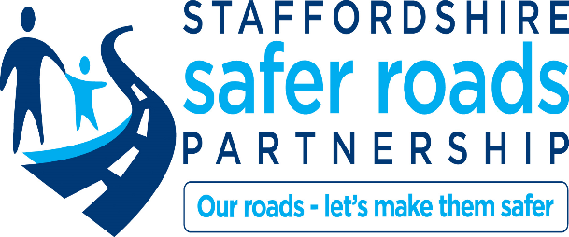
Staffordshire Road Safety Education
Postal Address Community Liaison, Staffordshire County Council
Wedgwood Building
Tipping Street
Stafford
ST16 2DH
Email: roadsafetyeducation@staffordshire.gov.uk
Telephone: 0300 111 8011
Dear Parent or Carer

STEPPING OUT: PEDESTRIAN TRAINING FOR 7 - 9 YEAR OLDS

Your child is about to take part in a basic pedestrian awareness scheme, which involves classroom work and visits to roads near to the school. At the end of the scheme, teachers will observe the children walking a route in the local area.
I hope that you will take every opportunity to reinforce the work your child will be doing in school.
If you would like further information, please contact Staffordshire County Council on 0300 111 8011.
Yours sincerely

Mary Anne Raftery Community Infrastructure Manager

