BEHAVIOUR POLICY

Date of Policy Creation: | April 2025 | Review Date: | April 2027 | Responsibility: | FGB
Head teacher | Mr Richard Walker |  | Signed: Richard Walker |  | Date: 3/11/25
Chair of Governors | Mrs Lucy Merrett  Mr Alan Tucker |  | Signed: Lucy Merrett  Alan Tucker |  | Date: 3/11/25

Policy Review

Date: | Notes:
April 2025 | 1st adoption of new policy
Sept 2025 | Update to reasonable force in line with KCSIE 2025

Linked Policies

Suspension/Exclusion Policy

Anti-Bullying Statement

Equality Information and Objectives Policy

Key Terms

SLT Senior Leadership Team

ELT Extended Leadership Team

HLTA Higher Level Teaching Assistant

CPOMS Child Protection Online Monitoring System (Our Safeguarding, Wellbeing and Pastoral Recording System that is used at Grove Road Community Primary School)

Rationale

This behaviour policy is designed to support the way in which all members of the school can live and work together in an environment in which everyone feels happy, safe and secure.
Introduction
Our positive behaviour approach is the foundation for an effective learning and teaching environment in which all members of the school community can feel respected, safe and secure. The school behaviour policy reflects how the school values and includes all the people in it.
In order to promote positive behaviour, we have adopted positive approaches to behaviour management. It is based on the following clearly defined rules and values which are known by all (pupils, staff and parents). These are displayed around school and referred to by staff constantly.
We have high expectations of all the pupils at Grove Road and will work as a team to promote this positive behaviour.
Vision and Values
We want to create a school community full of happy children who feel safe, secure and respected.
Our School rules
- Be safe
- Be respectful
- Be ready to learn
Our School values
Our PRIDE values represent our vision towards promoting key character traits to help all children become confident, independent, successful life-long learners. Our values are shared with the pupils and parents, as the PRIDE charter is displayed prominently around school.

General aims of this policy
At Grove Road, we aim to provide a happy atmosphere in which staff and parents work together for the welfare of the children, and where children adopt certain standards of behaviour and values to develop a sense of self-discipline and an acceptance of responsibility for their actions.
We encourage children to be polite, well-mannered, dependable and empathetic towards to each other in order to become good citizens. These aims are best achieved in a hardworking, positive, nurturing atmosphere in which pupils are able to give their best, both in and out of the classroom.
This demands a positive policy of encouraging socially acceptable behaviour and high standards of work, rewarding and praising wherever possible and the setting of good examples by staff and parents. Praise and encouragement should be used as much as possible.
The principle that underpins our approach to school behaviour is that:
No-one has the right to prevent another child from learning or an adult from working with everyone.

We aim to give all our children a shared sense of pride in attending Grove Road Community Primary School and to feel that it is a place where they are safe to learn without disruption.
The general standard of behaviour at Grove Road is the collective responsibility of all staff. Every time a child displays poor choices it must be challenged. It is important that we all understand what acceptable behaviour is. Equally, unacceptable behaviour and the consequences of such behaviour must also be clearly stated. We aim to listen to all children and discuss issues before sanctions are put in place. It is important that the cause of inappropriate behaviour is investigated and that plans are made to meet individual needs.
From the outset, we recognise that there is a distinction between emotionally affected behaviour (which may be caused by a specific learning need) and poor behaviour.

Overall Expectations
We expect that all adults and children within our school will treat each other calmly, positively and with respect at all times. No member of our school has the right to refuse to follow a reasonable instruction.
Specific Expectations
Staff, volunteers and governors | - To follow the reward and sanction flowchart (Appendix 1) consistently at all times  - To ensure that individual positive behaviour plans, where in place, are followed consistently and without prejudice  - To lead by example, modelling respect in all interactions  - To be consistent in dealing with pupils and all members of the school community  - To encourage the values of the school among pupils and the school community  - To ensure a positive, calm tone of voice and body language are demonstrated at all times  - To have high expectations of all pupils  - To meet the educational, social and behavioural needs of the pupils through an appropriate curriculum and individual support  - To facilitate regular communications between home and school  - To ensure that all expected behaviour is recognised in an appropriate way  - To ensure that children aren’t labelled as naughty and that the choices they make are dealt with and sanctioned  - To promote correct and smart uniform at all times  - To model and promote good manners at all times
Children | - To respect, support and care for each other, both in school and the wider community  - To actively listen to others – all adults, including support staff, parents, visitors and children – and respect their opinions  - To attend school regularly, on time, ready to learn and take part in school activities  - To take responsibility for their own actions and behaviour  - To follow school rules and demonstrate the school’s values  - To be respectful of others, regardless of difference; for example, race, gender, religion, disability, sexual orientation and age
Parents | - To be aware of and support, the school’s values and expectations  - To ensure that pupils come to school regularly, on time for the school day  - To take an active and supportive interest in their child’s work and progress  - To respect, model and support the vision and values of the school  - To ensure pupils are fully prepared for the school day  - To respect each other and school staff both in school and the wider community
Positive Behaviour Strategies and Rewards

Positive behaviour is consistently reinforced and our staff model appropriate behaviour in their interactions with each other and with the children. The fundamental rights of all of those in the school are also reinforced. Teachers and other adults adopt a positive and empathetic manner when responding to children and each other.

Verbal Praise

Verbal praise is used to reinforce positive behaviour choices in the moment, providing immediate feedback, and to encourage intrinsic motivation.

Dojo Points

To promote and celebrate positive behaviour and learning choices, children earn ClassDojo points for following school rules and demonstrating our five PRIDE values. All staff members can award these points, supporting a consistent and unified approach to reinforcing positive conduct.

Each classroom displays a visual representation of the points, while the online Dojo system keeps track of each child’s total. Upon reaching designated milestones, children can select a prize from the ClassDojo shop, available to each class every two weeks. They also have the option to save their points for a larger reward if they prefer.

All adults in school can award Dojo Points. Points may also be awarded electronically or recorded on the classroom’s tally chart, located on the inside of the door. Lunchtime staff can acknowledge positive behaviour by giving stickers, which can later be exchanged for Dojo points in class.

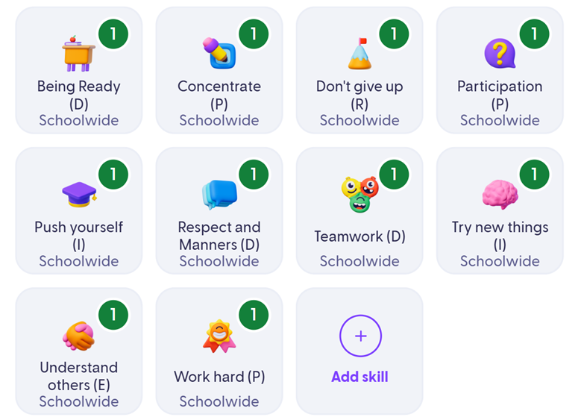

Head Teacher’s Awards

To be given to children in recognition of their success and going above and beyond. These are celebrated during our weekly Celebration Assembly.

Star of the Week and Gold Awards

In every interaction, we actively seek to celebrate, value and share the successes of our children. A weekly celebration assembly is a dedicated time for the school community to come together to acknowledge and praise achievements. Each class teacher selects one child to receive a ‘Star of the Week’ award; the children are chosen because they meet our high expectations for behaviour. Additionally, each class teacher selects one child to receive a 'Gold' award; the children are chosen because they have demonstrated particular passion or effect for a piece of learning that week.

Celebrations with parents

Postcards, positive Seesaw messages and phone calls will be made to parents to reward positive behaviour. This will be regularly but on an unplanned basis e.g., a teacher may decide to send home 4 positive Seesaw messages one week and 6 the next week depending on the situation.

PRIDE Journal

PRIDE Journals are used by children and adults to promote and celebrate responsibility, dependability and empathy in and around school and to celebrate as a whole class.

Collective Responsibility

All staff are responsible for dealing with behaviour issues with the support of ELT (Extended Leadership Team) and SLT (Senior Leadership Team). Procedures will be applied consistently and fairly at all times.

Teaching Assistants and Support Staff | Listen to all sides  Seek facts: speak to those involved AND witnesses  Deal with concern / issue by following school procedures  Pass to the class teacher if necessary
Class Teachers | Listen to all sides  Seek facts: speak to those involved AND witnesses  Deal with concern / issue by following school procedures  If serious / support is required, involve phase leader (ELT)
Phase Leaders (ELT) | Familiarise with information / facts gathered by the class teacher  Establish the reason for escalation  Seek further facts / information by having further conversations with those involved AND witnesses  Follow up on the incident / issue following school procedure  If serious / support is required, involve Deputy / Headteacher (SLT)
Deputy / Headteacher (SLT) | Familiarise with information / facts gathered by phase leaders  Establish the reason for escalation  Seek further facts / information by having further conversations with those involved AND witnesses  Follow up on the incident / issue following school procedure

Consequences for Unacceptable Behaviour

At Grove Road, we believe in supporting children to make positive behaviour choices. We recognise that, despite all our efforts to maintain a positive atmosphere, some pupils may struggle and can exhibit displays of unacceptable behaviour and have systems in place to support those who struggle. These systems are based on a relational approach balanced with acceptance of consequences to learn from mistakes and take responsibility for actions.

Step | Examples of Behaviour
Look | Non-verbal reminder given. | None
Verbal Warning | Despite gentle reminders, not meeting school rules or values  Ignoring advice given | None
Pay Back | Continuing to ignore school rules or values despite further reminders and ‘take up’ time | Miss 5 minutes of next break time. If behaviours continue further minutes will be added.
Step-Out  Record on CPOMS | Significant disruption to others’ learning  Indirect inappropriate language including discriminatory terms  Leaving the classroom without permission  Violence – without intent | Reflection time within phase, alternative classroom – minimum 5 minutes
ELT Removal  Record on CPOMS | Aggression or intimidation (threats)  Direct inappropriate language including discriminatory terms  Violence – with intent (to peers) | Go to work in an ELT Phase Leader’s classroom or with Learning Mentor – minimum 20 minutes  Parents to be informed by class teacher / HLTA
SLT Removal  Record on CPOMS | Bullying  Significant or intentional damage of property  Violence – with intent (towards staff) | Go to a member of SLT (HT/DHT) 30 minutes – can be in free time (playtimes)  Parents to be informed by class teacher / SLT via phone call home
SLT Removal (Following investigation)  Record on CPOMS | For individual or continuous serious breaches of the school expectations, an investigation will be held and parents will be informed of the process of this investigation | - Pupil may receive a fixed term suspension  - Permanent exclusion may be considered

Restorative Approach

When there have been incidents between children, key questions will be asked to find out what has happened and how the individuals involved can make things right again or repair the harm caused. When children have had a step-out or removal, a Restorative Approach will be used as the final step before a fresh start. Our aim in not necessarily to ask ‘Why?’ something has happened but to determine what has led up to an issue and resolve it positively. Everyone involved in an incident is taken to talk through a Restorative dialogue and is therefore supported in coming to understand the harm that has been caused to all parties.

The Restorative Questions:

What happened? Drawing out each person’s story one at a time, starting with the person who has caused the harm. The aim is not necessarily to come to a definitive conclusion on what has happened, but for each person to have their point of view listened to.

What were you thinking or feeling? What each person was thinking and feeling at the time, before and since.

Who has been affected? Who has been harmed / affected? Older children are encouraged to think about the wider implications of who has been affected e.g., the school community and families.

What needs to happen to put it right? What do those affect need to feel better, move on and repair and rebuild relationships.

How do you feel now? What each person is thinking or feeling now after the Restorative dialogue.

What do you need to do next time? What alternative options could the child who caused the harm have next time, instead of the action they chose?

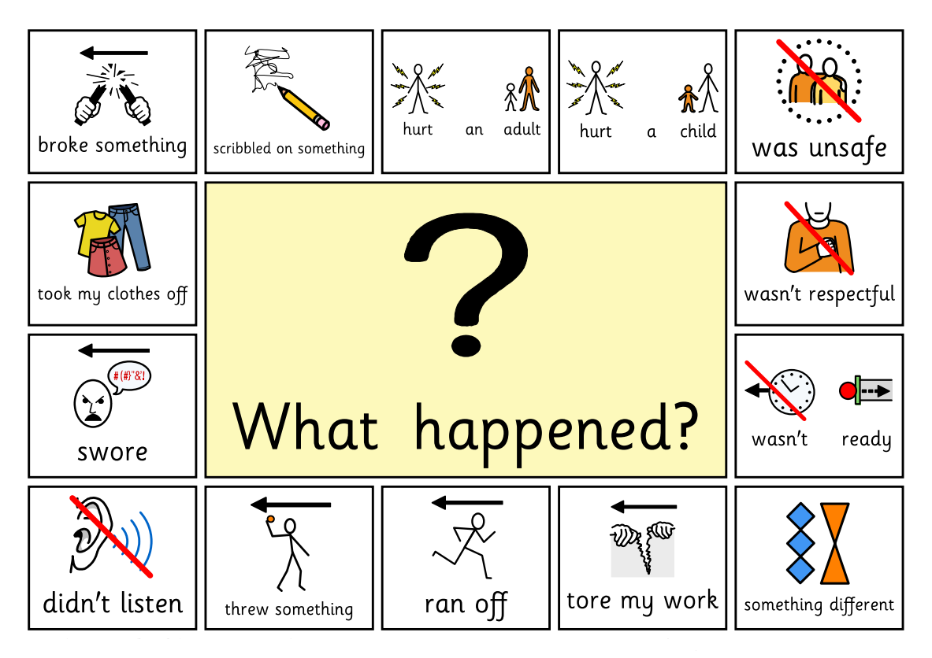
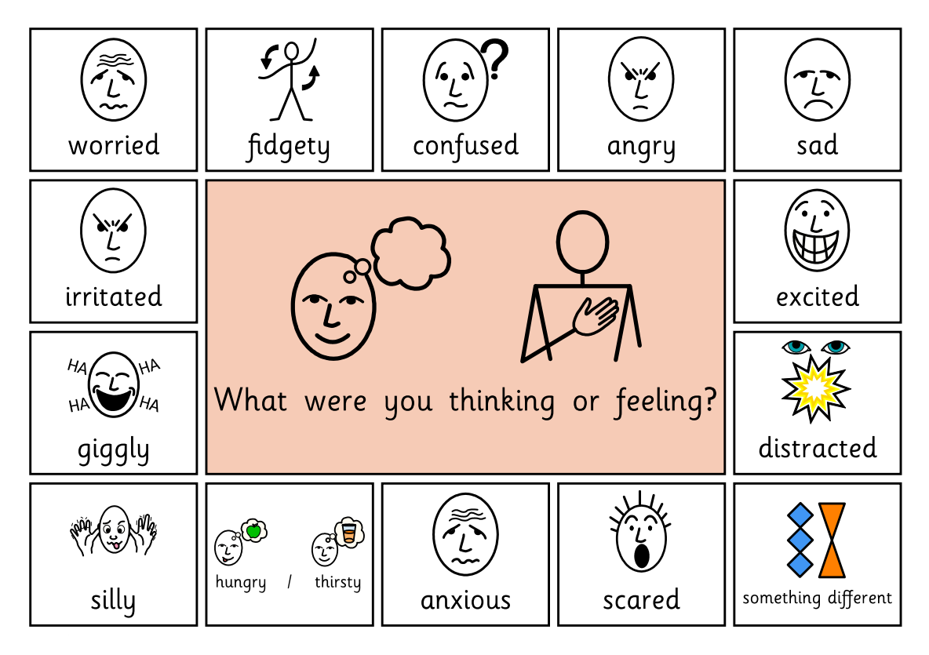
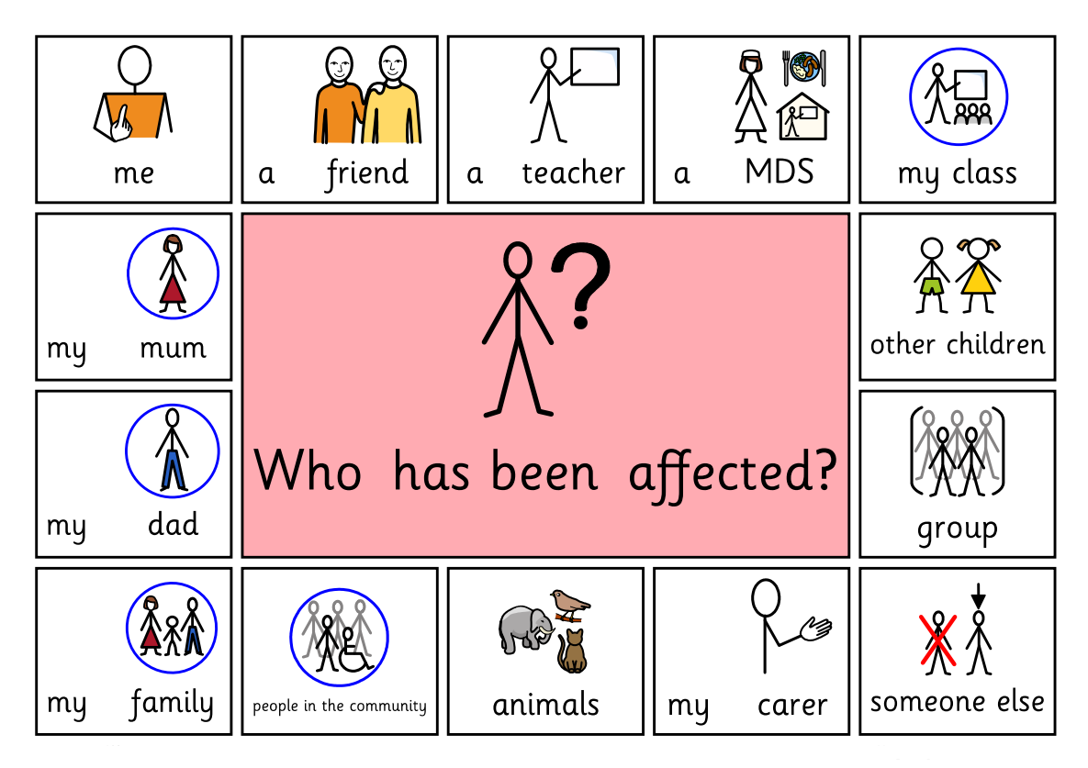
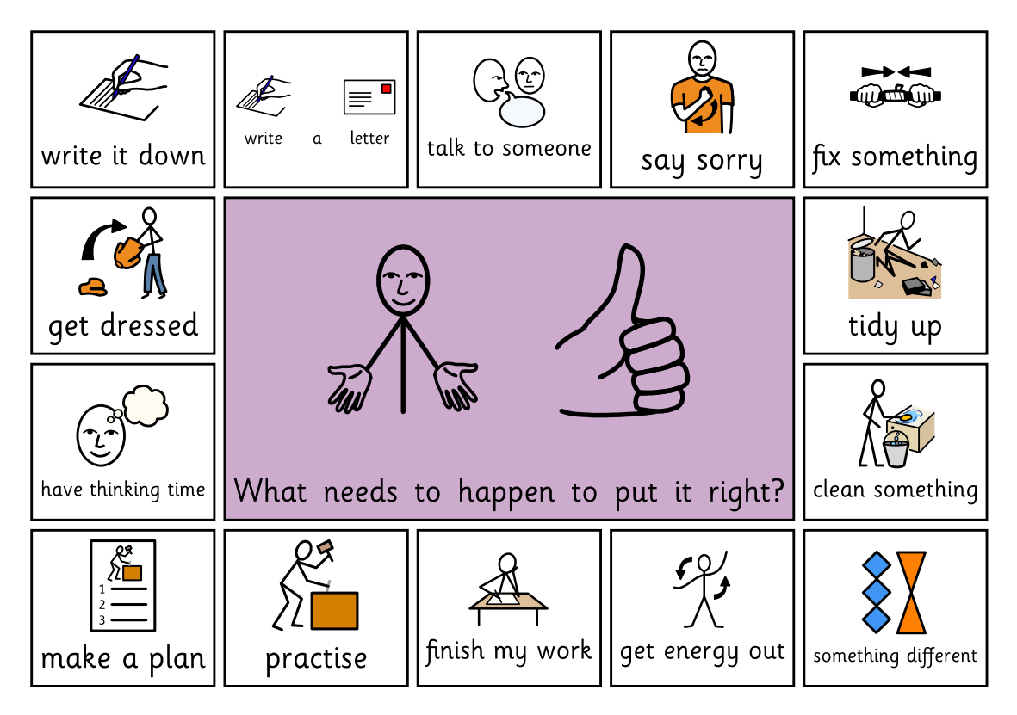
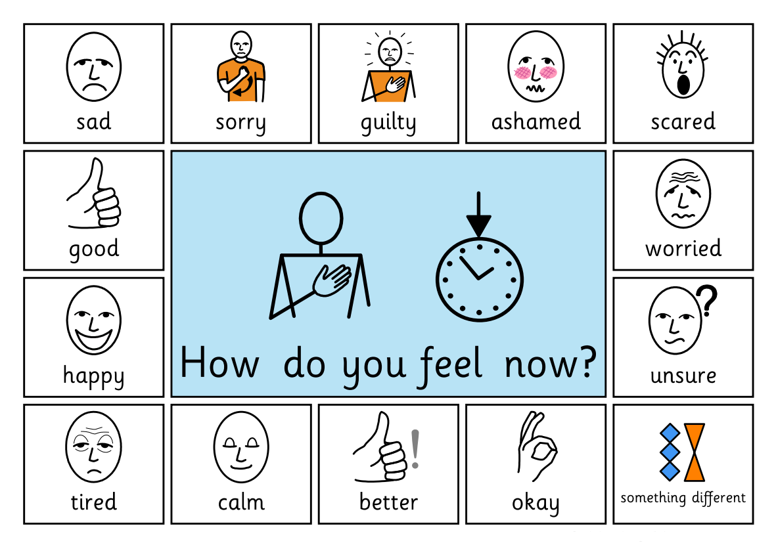
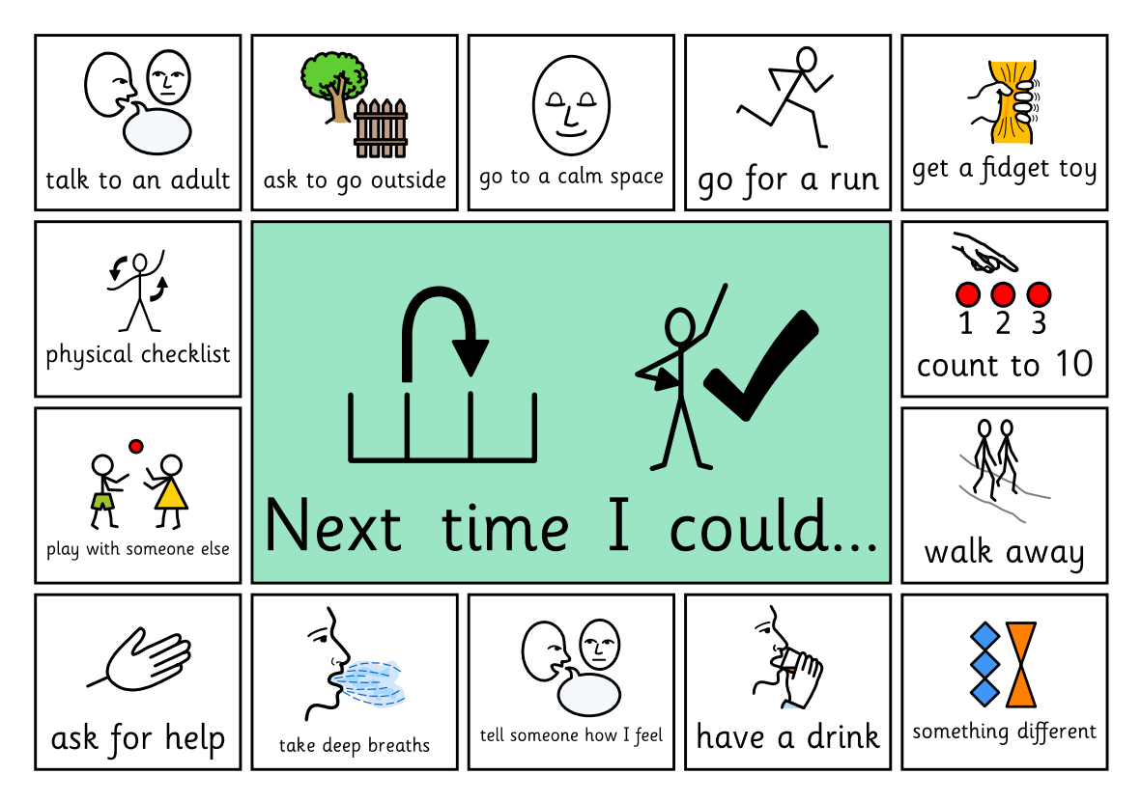

To support children in EYFS (Early Years and Foundation Stage) and who find verbal communication difficult with Restorative dialogue, staff may choose to use WIN STEM sentences.

- I wonder what happened?
- I imagine that was…
- I noticed you are … can you tell me how you are feeling?

Positive Behaviour Plans

The school acknowledges its legal duty under the Equality Act 2010 to prevent pupils with protected characteristics from being disadvantaged. As a result, our approach to challenging behaviour may be adapted to meet individual needs. The special educational needs coordinator (SENDCo) will assess pupils displaying challenging behaviour to identify any unmet needs. When necessary, we will seek support from specialist teachers, educational psychologists, medical practitioners, or other professionals. For pupils with acute needs, we will collaborate with external agencies to develop and regularly review support programmes in partnership with parents.

Some children may require additional support and reasonable adjustments to manage their behaviour, leading to the implementation of a positive behaviour plan. This plan, agreed upon by the child, parents, class teacher, and SENDCo, outlines specific behaviour targets, triggers, displayed behaviours, effective regulation strategies, ineffective approaches, and appropriate rewards and sanctions to ensure consistent support and progress.

Extreme, Unsafe Behaviour

Extreme behaviours that are unsafe to members of the school community and surrounding public may result in suspension or exclusion. These will fall into four main categories:
1. Deliberate, targeted, physical assault or intimidation and threat of violence
2. Hate speech, involving homophobic, ableist, transphobic or racist language
3. Actions or behaviours that put themselves or others at significant risk of harm
4. Serious challenge to authority and / or significant damage to school property

Please refer to Exclusion Policy for more information.

Bullying

Bullying can take many forms including verbal abuse, exclusion from a group, threatening behaviour and physical violence. It is characterised by persistent and repeated incidents where one-person targets another. Bullies are not always older or physically bigger than their victims but this is often the case.

At Grove Road Community Primary School, no form of bullying is ever to be tolerated, whether children to children, adults to children or adults to adults. We acknowledge that bullying may happen at any time, although staff may not be aware of it. We aim to make ourselves and children more aware of bullying by addressing the issue in assemblies and through the curriculum. Children are encouraged to confide in any member of staff, parents or friends.

All incidents are treated seriously and the appropriate action taken to deal with the bully and help the victim. All incidents classified as bullying must be recorded accurately on CPOMS. The role of parents is important in reducing any incidents of bullying and they should watch out for signs of distress such as repeated illness, damaged clothing etc. Parents should always encourage their children to tell a member of staff.

The school has a clear Anti-Bullying Policy.

Racism and Homophobia

At Grove Road Community Primary School, our wish is to develop in every individual a sense of self-worth and respect for others.

Racism is behaviour which upsets a person by making a connection with a person’s ethnic group, skin colour, religious beliefs, language / dialect or cultural background or nationality in a negative way. Homophobia is behaviour which upsets a person by making a connection with their perceived sexual orientation. It can take many forms including verbal abuse, threatening behaviour to the person or their property or exclusion from activities. We intend that all possible racial or homophobic incidents are followed up immediately to ensure that it is obvious such behaviour is not condoned under any circumstances. A log on CPOMs and to the local authority must be completed for all incidents by a member of SLT, in addition to being reported to the governing body.

It may be dealt with in a number of ways depending on the seriousness of the incident and the understanding of the children involved. It may take the form of a discussion to improve understanding, the child may have a consequence, parents brought into school, or in very serious incidents a child may be excluded from school following appropriate investigations by the Headteacher.

We oppose all forms of racism and homophobia by both adults and children, in the firm belief that everyone has the right to the best possible education through equal opportunity and access in a healthy, safe, caring and stimulating environment. Children will be encouraged to respond to racism appropriately.

Appeals

The staff, Headteacher and governors expect the support of parents in implementing the behaviour policy. On all matters of behaviour, the Headteacher will, after due investigation, make the final decision which is non-negotiable. Only in the case of exclusion is there a right to appeal, of which parents will be notified should the need arise.
Searching without consent
The law states that knives or weapons, alcohol, illegal drugs and stolen items (referred to in Section 550ZA of the Education Act 1996 as ‘prohibited items’) may be searched for and confiscated by school staff to ensure the safety and wellbeing of all students.
Establishing Grounds for a Search
- Teachers can only undertake a search without consent if they have reasonable grounds for suspecting that a pupil may have in his or her possession a prohibited item. The teacher must decide in each particular case what constitutes reasonable grounds for suspicion. For example, they may have heard other pupils taking about the item or they might notice a pupil behaving in a way that causes them to be suspicious.
- The powers allow school staff to search regardless of whether the pupil is found after the search to have that item. This includes circumstances where staff suspect a pupil of having items such as illegal drugs or stolen property which are later found not to be illegal or stolen.
- School staff can view CCTV footage in order to investigate an incident or to make a decision as to whether to conduct a search for an item and act in accordance with the Data Protection Act 2018.

Grove Road Community Primary School follows the DfE statutory guidance (2025) on the use of reasonable force and other restrictive interventions. This replaces the previous 2011 advice.

1. Definitions
- Reasonable force: using no more force than is necessary in the circumstances to prevent harm.
- Restrictive intervention: any action that restricts a pupil’s movement, liberty or freedom to act.
- Significant incident: any incident where force or restrictive intervention is used that goes beyond light physical guidance.

2. Core Principles
- Restrictive interventions are always a last resort.
- Staff must prioritise de-escalation and preventative strategies.
- Reasonable adjustments will be made for pupils with SEND or vulnerabilities.
- Staff must use approaches that minimise risk of harm.

3. When can reasonable force be used?
Reasonable force may be used to prevent a pupil from:
- Hurting themselves or others
- Causing significant damage to property
- Committing an offence
- Seriously disrupting learning or school order

4. Recording and Reporting
- All significant incidents must be recorded in detail on CPOMS.
- Records must include: context, de-escalation used, what intervention took place, staff involved, injuries, and follow-up.
- Parents/carers must be informed as soon as practicable, normally the same day.
- Governors will receive anonymised termly reports.

5. Post-incident Support
- Pupils offered debrief and chance to share their perspective.
- Staff offered support/wellbeing check.
- Injuries checked and recorded.
- Behaviour and risk plans reviewed after the incident.

6. Training
- Key staff will receive accredited positive handling training.
- Training will include de-escalation, safe holds, SEND awareness, trauma-informed practice.

7. Unacceptable Practices
Not permitted under any circumstances:
- Prone restraint (face down)
- Pain compliance techniques
- Seclusion in locked rooms
- Deprivation of food, drink, or basic needs
- Any action likely to cause injury or humiliation

8. Other Physical Contact
Appropriate, non-restrictive contact may be used when:
- Comforting a distressed pupil
- Giving first aid
- Congratulating or praising a pupil
- Guiding a child safely
- Demonstrating PE or musical techniques

Appendix 1

Flow chart of responses, rewards and consequences.

(Note: Not all parts to a step must be completed before moving to next step)

 | Positive Rewards
 |  |  | Star of the Week
 |  |  | Gold Award
 |  |  | Share success with Class / Parents
 |  |  | Dojo points
 |  |  | Verbal praise for specific actions
 |  |  | Head Teacher’s Award
 |  |  | Head Teacher visit
 | Look
 |  |  | Non-verbal reminder of expectations
 |  |  | Dojos used
 | Verbal Warning
 |  |  | Re-state expectations and reminders
 |  |  | Proximal praise
 |  |  | Dojos used
 |  |  | Consistency
 |  |  | Planned ignore – we don’t give attention for the wrong reasons
 | Pay Back
 |  |  | Payback time – 5 minutes of next breaktime
 |  |  | Learning time made up for in playtime – with teacher / HLTA if PPA time
 | Step Out, ELT Removal and SLT Removal Logged on CPOMS
 | Step Out |  | Behaviour is logged on CPOMS  Pupil will be moved to another class within phase – minimum 5 minutes  Pupil should have time to reset and return to class  Class teacher / HLTA to speak to parents at the end of the day
 | ELT Removal |  | Behaviour is logged on CPOMS  Pupil will be moved to work in an ELT Phase Leader’s Class or with Learning Mentor – minimum 20 minutes  Pupil to have time to have a restorative dialogue, reset and return to class  Pay Back time – 5 minutes of next break  Class teacher / HLTA to speak to parents at the end of the day
 | SLT Removal |  | Behaviour is logged on CPOMS  - Go to a member of SLT (HT/DHT) minimum 30 minutes – can be in free time (playtimes)  Pupil to have time to have restorative dialogue, reset and return to class  Pay Back time – 5 minutes of next break  SLT / Class teacher to speak to parents via phone call home at earliest possible opportunity
 | SLT Removal Following Investigation |  | Pupil will be referred to SLT – HT / DHT – who will contact parents  Pupil may receive a fixed term suspension  Permanent exclusion may be considered

