Spring 2 2023 Animals
Possible Themes & Interests  (Based on interests the children have had in past years) |  | SPRING PANCAKE DAY POETRY DAY WORLD BOOK DAY MOTHERS DAY HOLI RAMADAN EASTER ANIMALS  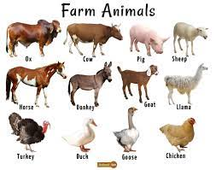
Suggested Texts | Books following possible themes. | 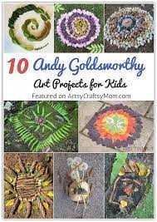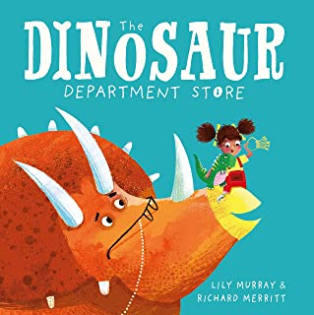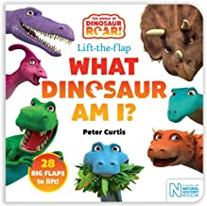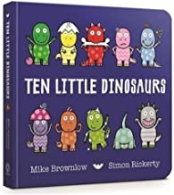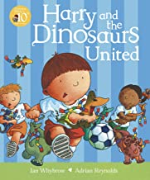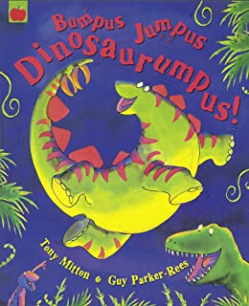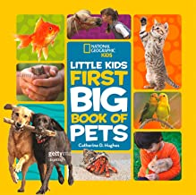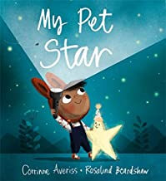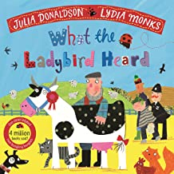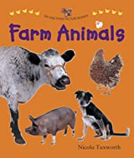  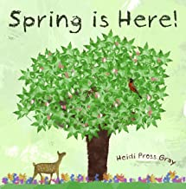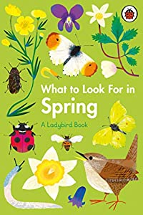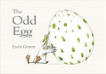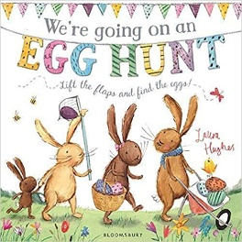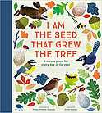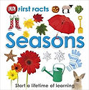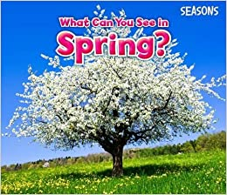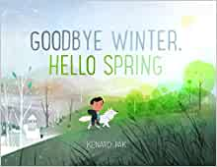  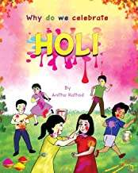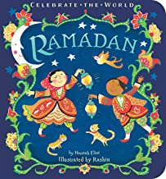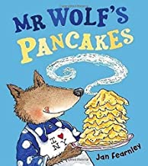
 |  | + Makaton songs, poetry basket, Concept cat stories, nursery rhymes and school/class songs.
Child led interests covered during the half term:

Prime Areas

Area of learning | Objectives/skills
Communication and Language | Listening, Attention & Understanding:  Enjoy listening to longer stories and can remember much of what happens.  Can find it difficult to pay attention to more than one thing at a time  Speaking:  Use a wider range of vocabulary.  Understand a question or instruction that has two parts, such as “Get your coat and wait at the door.”  Use longer sentences of four to six words.  Communication and Language group x3 weekly
Personal, Social  and Emotional Development | Self Regulation:  Increasingly follow rules, understanding why they are important.  Do not always need an adult to remind them of a rule.  Managing Self:  Develop appropriate ways of being assertive.  Talk with others to solve conflicts.  Talk about their feelings using words like ‘happy’, ‘sad’, ‘angry’ or ‘worried’.  Can put their coat on independently.  Begin to talk about the importance of oral health.  Building relationships:  Play with one or more other children, extending and elaborating play ideas.  Help to find solutions to conflicts and rivalries. For example, accepting that not everyone can be Spider-Man in the game, and suggesting other ideas  Jigsaw Theme – Healthy Me  Intentions include:  I know the names for some parts of my body and am starting to understand that I need to be active to be healthy  I can tell you some of the things I need to do to be healthy  I know what the word ‘healthy’ means and that some foods are heathier than others  I know how to help myself go to sleep and that sleep is good for me  I can wash my hands and know it is important to do this before I eat and after I go to the toilet  I know what to do if I get lost and how to say NO to strangers  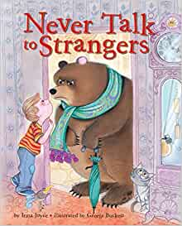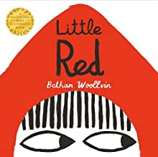  Discovery RE –  Coverage – Holi, Ramadan, Shrove Tuesday, Easter
Physical  Development | Start taking part in some group activities which they make up for themselves, or in teams.  Are increasingly able to use and remember sequences and patterns of movements which are related to music and rhythm.  Start to eat independently and learning how to use a knife and fork.  Show a preference for a dominant hand.
Be increasingly independent as they get dressed and undressed, for example, putting coats on and doing up zips.

Be increasingly independent in meeting their own care needs, e.g. brushing teeth, using the toilet, washing and drying their hands thoroughly.
Literacy | COMPREHENSION  Understand the five key concepts about print: - print has meaning - the names of the different parts of a book - print can have different purposes - page sequencing - we read English text from left to right and from top to bottom  Listen to a story and comment on the events.  Continue Concept Cat stories
WORD READING
Develop their phonological awareness, so that they can: - spot and suggest rhymes - count or clap syllables in a word - recognise words with the same initial sound, such as money and mother

WRITING
Use some of their print and letter knowledge in their early writing. For example: writing a pretend shopping list that starts at the top of the page; write ‘m’ for mummy.
Write some or all of their name.
Daily Poetry Basket and weekly Story Basket
Weekly Core Books
Phonics | Phase 1  - See Phonics LTP- Monster Phonics  - Focus on Rhyme and rhythm, voice sounds, initial sound
Mathematics | 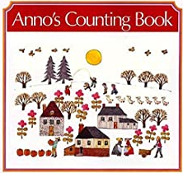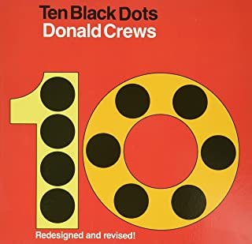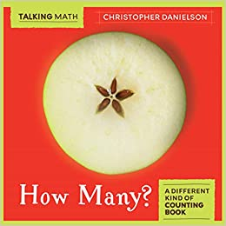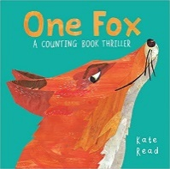  Maths group focus- x2 weekly
 | Coverage | Guidance (subject knowledge)
 | Exploring and understanding Number 4 | When teaching 1-6 the counting principles should be considered at all times. Ensure children are counting real life objects. Start by counting identical objects before moving onto objects that have a slight difference (eg, different colours, different sizes, but ,ake sure the objects are the same type. Encourage children to put objects in a line so they have a clear start and end point. 5 Frames can be used to support children lining up objects to count. This will also support children to subitise within 5. Numerals may be introduced but they are not expected to write them at this stage. They could use drawings to represent numbers*  Focus on composition of 4 (2 is part of me, 2 is part of me and the whole of me is 4; 3 is part of me and 1 is part of me and the whole of me is 4)  Explore: Numberblocks Episode 4, Counting to 4, Finding 4 objects, 4 being the fourth number, its position on a number line, ordinal numbers, Numicon 4, Dice 4, Subitising 4, Representing 4 on a 5 frame, squares and rectangles in the environment, 4 actions, numeral and formation of 4, number 4 in the environment, representing 4 using marks, pictures and fingers, matching numeral to quantity
 | Exploring and understanding Number 5 | Focus on composition of 5 (3 is part of me, 2 is part of me and the whole of me is 5; 4 is part of me and 1 is part of me and the whole of me is 5)  Explore: Numberblocks Episode 5, Counting to 5, Finding 5 objects, 5 being the fifth number, its position on a number line, ordinal numbers, Numicon 5, Dice 5, Subitising 5, Representing 5 on a 5 frame, penatgons in the environment, 5 actions, numeral and formation of 5, number 5 in the environment, representing 5 using marks, pictures and fingers, matching numeral to quantity
 | Exploring and understanding Number 6 | Focus on composition of 6 (3 is part of me, 3 is part of me and the whole of me is 6; 4 is part of me and 2 is part of me and the whole of me is 6 etc) Explain 6 as being 5 and 1 more.  Explore: Numberblocks Episode 6, Counting to 6, Finding 6 objects, 6 being the sixth number, its position on a number line, ordinal numbers, Numicon 6, Dice 6, Subitising 6, Representing 6 on a 10 frame, hexagons in the environment, 6 actions, numeral and formation of 6, number 6 in the environment, representing 6 using marks, pictures and fingers, matching numeral to quantity
Understanding the World | Past & Present  Begin to make sense of their own life-story and family’s history  Show interest in different occupations.  People, culture and communities  Show interest in different occupations  Know that there are different countries in the world and talk about the differences they have experienced or seen in photos  The Natural World  Explore how things work.  Plant seeds and care for growing plants. Understand the key features of the life cycle of a plant and an animal.  Begin to understand the need to respect and care for the natural environment and all living things.
Expressive Arts and Design | Creating with Materials:  Create closed shapes with continuous lines, and begin to use these shapes to represent objects.  Draw with increasing complexity and detail, such as representing a face with a circle and including details.  Use drawing to represent ideas like movement or loud noises.  Being imaginative and expressive:  Develop storylines through small-world or role-play. .  Sing the pitch of a tone sung by another person (‘pitch match’).  Sing the melodic shape (moving melody, such as up and down, down and up) of familiar songs.  Begin to develop complex stories using small world equipment like animal sets, dolls and dolls houses etc.  Artist Study- Andy Goldsworthy –  Sculpture, clay, salt tough, textures, natural and transitional art

