Talk for Teaching:
Personal Professional Development to maximise the impact of all staff through collective teacher efficacy

Aims

- To assist school leaders in developing a culture of collective teacher efficacy which impacts positively on teacher wellbeing and Personal Professional Development.
- To maximise the impact of Teaching & Learning and raising attainment, particularly for disadvantaged learners.
- To assist school leaders in embedding metacognitive strategies as outlined in the EEF Guidance Report and the ReflectED approach by Rosendale Research School.

Research Theory

Paul Garvey: Talk for Teaching

On Talk for Teaching: “ Changing the language is critical… designed to separate Talk for Teaching from what happens in lesson observations, which have a very different, more judgemental purpose. Formal observations can put good teachers under a great deal of unnecessary pressure. Talk for Teaching doesn’t.
Talk for Teaching can also save schools lots of money in sending teachers on conferences, or bringing in expensive speakers and pots of time, with senior leaders not having to spend as much time preparing INSET days. It is a fact that almost all teachers love the chance to visit each other’s lessons… Teachers also love learning… and I believe they learn best about how to improve their teaching via talking to others.
Talk for Teaching results in a very regular sharing of ideas and practice across a school or larger collaborative structure. What it does to employ the collective intelligence of the school community to drive forward innovation and improvement.
Such an enterprise requires a larger degree of trust, on all sorts of levels, than some schools have had in the past. However, Talk for Teaching is an excellent vehicle for generating that trust.”
On formal observations: “telling teachers how to improve seldom works. I know that I had an inbuilt defence mechanism to feedback points. That defensiveness centred on the trust that I had in the observer/assessor/coach. Talk for Teaching removes that completely, by putting professional development in the hands of the staff.”

John Hattie: Visible Learning & Effect Sizes Study: 250+ Influences on Student Achievement

Effect Sizes
Hattie provides effect sizes- measures of the impact of educational initiatives on achievement.
Effect sizes typically range in size from -0.2 to 1.2, with an average effect size of 0.4. It would also appear that nearly everything tried in classrooms works, with about 95% of factors leading to positive effect sizes:

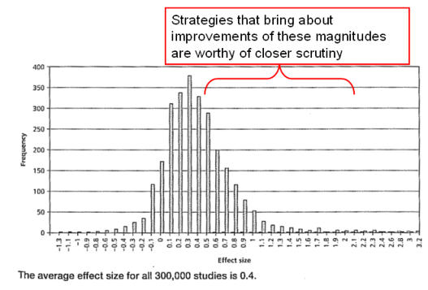
Hattie states that an effect size of 0.2 may be judged to have a small effect, 0.4 a medium effect and 0.6 a large effect on outcomes. He defines 0.4 to be the hinge point, an effect size at which an initiative can be said to be having a ‘greater than average influence’ on achievement. Of all 250+ Visible Learning ‘strategies’ analysed, ‘Collective teacher efficacy’ has the greatest impact on student achievement.
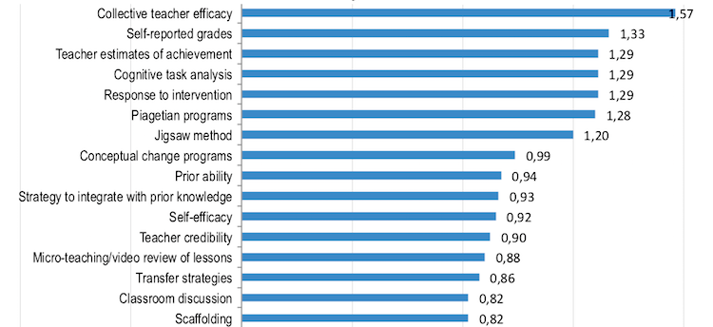

Collective teacher efficacy & self-efficacy

Teaching self-efficacy refers to the beliefs that teachers hold about their capabilities. Different researchers have provided evidence that teachers with a high sense of efficacy tend to be more psychologically healthy and effective than teachers who doubt their capabilities.
Our model of staff development aims to promote self-efficacy amongst our staff, where there is a collective ‘buy in’ to Personal Professional Development, supported by a culture of high challenge and low threat (Mary Myatt ‘High Challenge, Low Threat’) . Our desire is for staff to be invested in the vision of the school and for the key priorities to be owned by all, not just senior leaders. We believe that the phases of PPD, as outlined below, result in staff being highly reflective practitioners who feel professionally supported by school leaders.

ReflectED & Metacognition

For the past year, we have been a ‘hub’ school for ReflectED, which is a metacognitive approach to learning developed by Rosendale Research School. The approach, which is used throughout our curriculum, teaches and develops our children’s metacognition skills (learning about how they learn). It supports and improves attainment, especially amongst disadvantaged pupils, and aims to help learners of all backgrounds develop the tools to make excellent progress in their learning and fulfil their potential.
ReflectED teaches children the skills of reflection and how to record their learning moments and strategies. Teachers can also look across these reflections to understand what pupils are enjoying or struggling with, and identify specific pupil needs.
Evidence suggests the metacognitive skills children develop through ReflectED will significantly enhance their learning.

How it works

Each class in school receives a weekly ‘metacognition’ lesson. The children learn new skills, such as how to juggle, how to use chopsticks, how to tie shoelaces etc. The purpose of these skills lessons is to teach children a new skill which they will most likely find difficult and challenging. We purposefully put the children in a position in which they feel ‘stuck’. Subsequent lessons deliver key messages around ‘having a growth mind-set’, what makes a successful learner, cognition and metacognition, being in ‘The Learning Pit’ and possessing skills of resilience, grit and determination in order to succeed.

Throughout the school day, staff support children to make ‘reflections’ about their learning. They discuss what has helped them to be successful with a specific learning task and use colour tags to represent how confident they are feeling. Red means they feel stuck , and need to be resilient and find strategies to help them. Yellow means they are getting there, but need to continue to be determined in order to become more confident. Green means they feel confident, and with a little more hard work will become masters of a particular task. Blue means that the children feel so confident about a task that they can ‘coach’ and support a partner to learn. Blue learners are ready to seek additional challenge so that they are stretching themselves to achieve more.

All staff incorporate the language learned in the metacognition skills lessons across all subject areas, so that the strategies learnt through embracing the ‘struggle’ of learning a new skill creates a crucial learning point for children and equips them with values of resilience, determination and grit that help them succeed across the curriculum.
The culture of metacognitive language for learning, modelled by staff, is what supports our children’s own ‘growth-mindsets’, giving them the determination and belief required to be successful.

On a daily basis, children and staff use Seesaw to share new learning. Children’s learning is shared on Seesaw so that parents can see, ‘like’ and ‘comment’ on their child’s work. Seesaw is also used by children to make reflections; they share ‘marvellous mistakes’ which they’ve learned from and they discuss how they have found an activity/lesson.

Across the Grove Road Curriculum, we promote and explicitly praise our children for making and learning from ‘marvellous mistakes’. We embrace a culture where making mistakes is part of life; we are accepting of and positive about each other’s mistakes because we realise that mistakes and being ‘stuck’ are the best opportunities we have to learn. By creating a school environment where ‘feeling red’ and learning from mistakes is embraced, we aim for Grove Road children to intrepid and bold, undaunted by failure; instilling life-long skills and values that we see as fundamental to their futures.

ReflectED and Talk for Teaching

After introducing ReflectED to our school, embracing metacognition and embedding it across our curriculum, as senior leaders we realised that, as Paul Garvey discusses, our staff model for CPD was not, in any way, supporting Hattie’s ‘collective teacher efficacy’ or ReflectED’s ‘metacognitive’ approach to learning. We wanted our children to be metacognitive thinkers, but we were not creating a culture where our staff could be, therefore limiting the impact ReflectED could have.
Paul Garvey: “Another important change of language comes here. Instead of talking about traditional CPD ( Continuous Professional Development ), I’d rather use my new term PPD ( Personal Professional Development ). Again, it frees education professionals from the concept of professional development being provided – effectively owned – by someone else.”

So, in order for ReflectED to have an impact across our school community, we created a model for PPD that, in essence, provided a metacognitive environment for our staff; a model that empowers teachers to regularly reflect on their own practice, and that of their colleagues, therefore developing a true ‘mind-set for success’ which directly influences the learning behaviours of the children in our classrooms. Talk for Teaching, alongside ReflectED, has created a metacognitive culture where collective teacher efficacy and self-regulated learning can thrive.

Talk for Teaching: 5 phases of PPD

- Phase 1: Teacher-led Learning Walks and Self Evaluation Reflection Forms

For each part of the curriculum, SERFs are created. These forms are put together by subject leaders/senior leaders, with the aim of incorporating key Teaching & Learning priorities for the school and key metacognitive strategies (with reference to the EEF metacognition guidance report). On a three weekly rota, Learning Walks are carried out by subject leaders or senior leaders to enable them to monitor their subject in a ‘low threat’ way; a move away from a higher level of observation and judgement, but still allowing for rigorous and accurate evaluation (high challenge) of a specific aspect of the curriculum.
Self Evaluation Reflection Forms/SERFS provide teachers with opportunity to reflect upon their own practice prior to a learning walk. Subject leaders will aim to give teachers a week to complete a SERF. All Learning Walks are recorded on Perspective – our online platform for tracking PPD. (Example SERF form attached below). The aim is for teachers to reflect upon their impact within a specific area of the curriculum, which ideally should take 5-10 minutes, and for subject leaders and senior leaders to support their professional development. The SERFs also provide an opportunity to improve the implementation and consistency of key strategies and language across the curriculum.

- Phase 2: Twenty20 Teaching –

Every week, a senior leader or HLTA covers two classes for 20 minutes each to release a teacher to observe a colleague for 20 minutes. After school, the senior leader will lead a 20 minute coaching discussion group with both teachers together. These coaching questions are based on key metacognitive strategies and current teaching priorities across school. (Please see attached 20/20 questions). The aim is to cultivate purposeful professional dialogue between colleagues that causes reflective practice and refocuses their impact in the classroom towards quality first teaching, in line with the whole school vision.

- Phase 3: IRIS Champions & Film Club

Using IRIS Connect technology to record teaching practice.
Film Club is a half termly staff meeting for all teaching staff where teachers are given opportunity to reflect on their practice and collaborate with colleagues for Personal Professional Development.
Iris Champions – a lead Iris teacher from each phase of school – will lead their team in reflective practice. Each half term has a different teaching focus, and during Film Club each teacher is encouraged to share a brief clip of their practice with phase colleagues. Phase teams will then have opportunity to reflect and support each other’s practice, and to set next goals for themselves and a focus for the next Film Club. Senior leaders will not be present at Film Club unless invited by staff. An example of a half-termly theme for Film Club might be ‘Kagan Cooperative Learning Structures within Maths’ or ‘the use of feedback through Seesaw’.
The aim is to encourage teachers to celebrate each other’s successes, boost confidence and refine their reflective practice, supporting each other in developing as teachers.

- Phase 4: Teach Meets

Termly Teach Meet PPD events as a school staff/collaborating with other local schools consist of teachers volunteering to do a 3 minute sharing presentation about a strategy or element of teaching practice that has proven successful in their classroom. The aim of the Teach Meets, as well as building team spirit and morale, is to share ‘moments of magic’ in the classroom – strategies that teachers deliver most days, but their colleagues may never have seen! Teach Meets provide a further opportunity to develop the school’s reflective culture, and can be key to collaborating with other schools.

- Phase 5: Pupil Voice Councils

Termly pupil voice surveys are carried out in order to measure and evaluate key methods of learning. The statements within a survey are mostly linked to metacognition and the children’s attitudes towards learning. The surveys can be carried out whilst their teacher is visiting another class for a Twenty20 session.
The aim is for teachers to then be able to effectively use the surveys to better understand what helps their children to learn and how they can be more successful learners, as well as which key teaching strategies are causing the most effective learning in their classroom. (Please see attached pupil voice example).

