Dear Parents/Carers,

I hope that you are all well and keeping safe.

I am sure that after the Prime Minister’s statement last night, there are lots of questions that you have. We have lots of questions that need clarification too, and await further guidance from the Department of Education and the Local Authority.

At this moment in time, there is no change to the current guidance. We will continue to provide childcare for children of key workers, as well as daily online learning opportunities via Seesaw. We will also continue to send learning packs to support our children at home, if required. The message is still clear that it is safer to stay at home.

Since the very beginning of the coronavirus pandemic, I have only received information via the public announcements at the same time as you at home. Last night’s update was no different and, as I am sure you can understand, it makes it exceptionally challenging to plan and prepare for further change. We will need clear guidance to plan how to open school and socially distance to keep our pupils, teachers and families safe. We will then consider how we might start to phase groups of children into returning and what this will look like with clear policies and plans.
Closing our school at short notice was a challenge and reopening school (whenever/however this happens) will be no less of one, however, please rest assured that we will be working tirelessly to ensure that the health and safety of the children is the central focus of what we do and we can promise you that we will call on our best efforts to do so.

As always, we will keep you informed, but for now, please try not to worry. We will continue to do everything we possibly can to support our wonderful school community in these difficult and uncertain times.

Kindest regards,

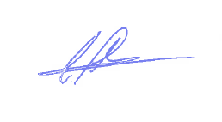
Chris Parkhouse
Headteacher

