Grove Vale Primary School

Behaviour policy

Date: September 2023

Review: September 2024

C.Dubidat

**RATIONAL**

Grove Vale is committed to providing the maximum educational opportunities for all it’s pupils, and to providing the kind of responsible, caring community, which is essential to the fulfilment of these opportunities. Every aspect of our school is affected by the behaviour of both the children and the adults who come together for this purpose. Attitudes towards acceptable and unacceptable behaviour therefore play a fundamental part in the overall ethos of the school.

When developing this behaviour policy for the whole school it was important to ensure that all the relevant people were consulted; those who have a vested interest in Grove Vale being a happy, considerate and effective place in which to work.

**BEHAVIOUR PRINCIPLES**

* Our school’s behaviour principles were agreed by all stakeholders.
* All members of the school community behave in a polite and considerate manner showing respect for themselves, each other and to the school itself.
* Our 9 Core Values (see appendix C) also impact and underpin children’s and adult’s attitudes.
* Pupils behave in a manner which supports their own learning, and that of other pupils, and does not jeopardise the health and safety of any member of the school community.
* It is expected that all adults – staff, volunteers and governors – will set excellent examples to the children at all times.
* Grove Vale Primary School is an inclusive school; all members of the school community should be free from discrimination, harassment, victimisation and any other conduct that is prohibited by or under the Equality Act 2010.
* That the school’s Behaviour Policy and Anti-Bullying Policy will be applied with consistency and fairness, with regard to each individual situation.
* That the emphasis will be on encouraging positive behaviour through high expectations; the modelling of good behaviour; a focus on learning; and praise and rewards.
* That sanctions, when necessary, will enable the pupil to reflect on, and learn from their behaviour and to make reparation wherever possible.
* That each pupil receives behavioural support according to their need.
* The school will seek advice and support from appropriate outside agencies where concerns arise over a child’s behaviour.
* That the focus on positive behaviour, forgiveness and reconciliation will significantly reduce the need for exclusion. However, when making decisions, the Headteacher must balance the needs of the individual with those of the wider school community and where a pupil’s behaviour places others at risk, the safety of the pupil body as a whole is paramount. Considering this, the Governing Body support the right of the Headteacher to exclude for a single offence, permanently if necessary, where it is considered that allowing the pupil to remain in school would seriously harm the education or welfare of that pupil or others in the school.
* That given, the overriding need is to keep the pupils and staff safe. The Headteacher, or representative(s), will utilise their powers to search or use reasonable force in order to keep individuals from harming, or further harming, themselves or others.
* This written statement and the policies that are influenced by it apply to all pupils when in school, when engaged in extra-curricular activities such as educational trips and visits (residential and non-residential), when travelling to and from school and when being educated as a member of Grove Vale Primary School.

**Code of Conduct:**

1. Treat each other with care, good manners and respect
   1. Using please, thank you, good morning/afternoon.
   2. Using kind words and no bad language.
   3. Show tolerance, kindness, understanding and respect to others at all times regardless of background, beliefs and race.
   4. To share and take turns
   5. To show kind hands and feet
2. Listen when an adult and other children are talking
3. Put your hand up if you want to speak- do not shout out or interrupt someone.
4. Move around our school in a sensible manner
   1. walk around our school at all times in a sensible and quiet manner
   2. walk on the left
   3. move around in single file as a class
   4. line up in an agreed order
   5. open doors for adults and other pupils and wait for them to pass through
   6. We will line-up sensibly at the end of playtimes and assemblies.
   7. We will enter and exit the classrooms sensibly and silently
   8. Knock before going into a class
5. Look after our property and the school environment.
   1. Put your litter in the bin.
   2. Keep the classroom tidy, put equipment in it’s proper place.
   3. Remember to push your chair in at all times.
6. Try our best in everything we do
7. Do not talk when you should be working.
8. Do not disturb other people when they are working
9. Be honest

**Home School Agreement**

At the beginning of each year, we send Home School Agreements home with children. (see appendix A)

There is an assumption that parents will support both staff and children in the maintenance of good behavioural standards, and there will be occasions when both school and parents need to work closely together.

Occasionally there may be instances where parents disagree with something that has happened in school. We would expect parents to approach the class teacher in the first instance and then the Phase Leader. If the problem persists or is of a serious nature, then the Head teacher/Deputy Head teacher will be informed.

The school office should be contacted to arrange a convenient day and time to discuss any concern.

*\* NOTE – Children should be kept unaware of any grievance a parent may have and it should appear that school and home are working in co-operation. It is extremely harmful for a child to be present whilst parent and teacher are voicing a disagreement.*

**REWARDS AND SANCTIONS**

In any behaviour system the emphasis should always be positive with encouragement and praise, rather than the more negative approach of criticism and punishment. Criticism should always include advice on how to improve and should be constructive in its approach.

Here at Grove Vale we aim to praise and reward those children who follow our rules consistently as well as those who have shown great behavioural improvement.

Praise is given in many ways, and may include the following:

- a quiet word or encouraging smile

- written comment on child's work

- a public word of praise (in group, class or whole school situation)

- stickers

- stickers, assistant/deputy/head teacher stickers for good work

- showing work to another teacher, phase leader or senior leader.

- certificate presented in assembly

- use of school reports

- post card sent home

- phone call home

**Behaviour System:**

A zone board is displayed in every classroom across the whole school to support the management of behaviour for all of our pupils (see appendix D).

Each classroom has a display with three clear sections:

Thank you for always – This section of the display is a visual reminder for the children. Its presence reminds the children of the expectations with regard to their behaviour in class and around school. Each class teacher will refer to this segment of the chart regularly to highlight those children who are doing what is expected and displaying good behaviour. Class teachers will use phrases such as ‘Well done (child’s name), I can see that you are using equipment

sensibly’ or ‘Thank you (child’s name) for sitting sensibly and concentrating whilst I explained today’s task’. Teachers praising regularly and consistently in this manner will enthuse other children to have their good behaviour recognised and praised.

Stars – Each day, the class teacher will choose a child whose behaviour has stood out or who has gone above and beyond the school expectations for behaviour. For example, someone who has put in extra effort all day into all of their tasks or someone who has been exceedingly polite and courteous. This child will then be placed on the star and will be the star of the day. When a child is placed on the star, their name (which has been displayed on a golden star) will be placed onto the star section of the board and this will be communicated home. This will be in the form of a certificate. Each child’s name will remain on the star for the remainder of the week. By the end of the week, each class will have five stars. The class teacher will choose one of these children to be the shining star for the week and they will be presented with a shining star certificate in assembly on the following Monday. This child will also get a phone call home as well as 5 minutes extra ‘Golden Time’ on Friday.

Lost learning reminder – Children will be reminded that their behaviour is their responsibility and misbehaviour is ultimately a time where they are doing something that they shouldn’t be doing and therefore missing out on learning time. In any instance where a child is breaking the code of conduct, a verbal warning will be given. Teachers will aim to ‘reprimand in private’ through non-verbal gestures or a quiet reminder about their conduct.

If more than one warning is given for breaking the same rule or the behaviour is severe, the child will then be required to make up lost learning time. Lost learning time means the child has reflection time during play time and is required to either reflect on their behaviour at the pit stop (infant children on the pit stop; junior pupils on the jnr pitstop) or complete any unfinished tasks during their own time. It is up to the teacher whether they miss 5, 10 or 15 minutes of their play.

Lost learning time is documented on a class record which is collected and monitored weekly by CD.

Golden Time – At the end of each week, each class will take part in golden time. Golden Time is a whole school session to celebrate those who have adhered to the school code of conduct all week. This will last for 15 minutes and all staff will be out with their children. Any child who has had lost learning time that week, will take part in a reflection session with CD. During this time, CD will remind the children of the school code of conduct and will encourage the children to reflect on their behaviour. Together, they will discuss ways in which they can make sure that they do not miss Golden time again.

Red Sky: Persistent lost learning time (three or more instances in a half term) - If a child has 3 lost learning entries over a period of time, the pupil needs to be referred to the phase leader and the pupil will have Red sky. The pupil would also automatically have red sky for any physical, bullying or severe incidents.

The pupil will spend a lesson with the phase leader and miss their playtimes for that day. They fill in a reflection sheet (adult may need to do this for/with younger children (see appendix E) Parents will also be informed with a letter and a copy of the reflection (see appendix F), parents are asked to respond and send an acknowledgement slip back to school.

Grey sky If a pupil has been involved in a serious incident or has displayed continuous poor behaviour they will have grey sky. This involves the pupil spending a whole morning or afternoon with DHT, HT or AHT. They will be doing work in isolation from their classmates and missing playtimes. The pupil will fill in a reflection sheet (adult may need to do this for/with younger children (see appendix E) Parents will also be informed with a letter and a copy of the reflection, parents are asked to respond and send an acknowledgement slip back to school.

**CPOMS** – all red incidents, red sky and grey sky incidents need to be logged on CPOMs. Any other staff who have witnessed or dealt with the incident need to be tagged in, alongside all senior leaders (head, deputy and assistant head and pastoral lead).

**Team Points:**

If a pupil displays an excellent example of following our code of conduct the pupil will be given a team point and mark this on the team point chart.

Each week, the child with the most team points will be rewarded by their class teacher with a team point prize. Teachers can choose what prizes will be given out weekly in class.

Team points will also be collected in by a team of year 6 children on a weekly basis. These children will count up the number of points scored across school for each team and the winning team will be celebrated in celebration assembly on a Friday. Each week, these children will also make a note of the class with the most team points and they will also be celebrated in celebration assembly and presented with a certificate.

**Exclusion**:

*Please see Grove Vale Exclusion policy*

**SEND**

* When persistent problems occur with a pupil’s behaviour the SENCO will become involved. A meeting with the class teacher, phase leader and parents will be arranged. At this meeting the pupil will be set targets and a behaviour chart introduced to monitor and track their behaviour at different times in the school day.
* Further advice may be sought from Sandwell Inclusion Support Service, the Special Education Needs Advisory teacher (SENAT) for social, emotion and mental health. Following an initial consultation and observations of the child’s behavior they will help support with targets, behavior trackers and advice regarding provision and intervention to help improve the child’s behaviour.
* For children will social, emotional, mental health and behavior difficulties, staff use the emotion coaching approach when de-escalating a situation, back-chaining and identifying a trigger and problem solving so it does not happen again.

**Online Safety**

As a school we follow the Smart rules in school, regarding on-line safety. These can be found in the online safety policy. We expect children to follow these rules when online inside and outside school, our school’s behaviour policy applies to pupil’s behaviour online. School may also consult the online safety advisor for Sandwell for support, when dealing with pupil’s behaviour online.

The school’s behaviour policy also applies to when children are remote learning and taking part in virtual lessons. Further guidance about this can be found on the remote learning policy.

**Appendix A**

**Grove Vale Primary School Home/School Agreement**

At Grove Vale Primary, we recognise each child as an individual, and aim to give all children every opportunity to realise their full potential. We believe that a close partnership between the school, parents and the child is essential if we are to achieve this aim. We therefore ask all parents and children to sign up to our Home/School Agreement.

**The Responsibilities of the School**

At Grove Vale Primary we will:

* Provide a secure, happy and stimulating learning environment where children’s experiences and interests shape our ethos and curriculum.
* Provide a broad and balanced curriculum which challenges your child to reach their potential and fulfils the requirements of the National Curriculum.
* Encourage your child to show friendship and respect for others and to abide by the school behaviour policy, ensuring a safe, caring environment for all.
* Keep you informed about your child’s progress and behaviour, as well as their termly curriculum. We do this through termly meetings and termly reports.
* Set regular and appropriate homework for your child that encourages creative and independent learning.
* Make you feel welcome whenever you visit the school and respond to your questions or concerns as quickly as possible.
* Allow children safe and secure use of the Internet through a combination of site filtering, supervision and by fostering a responsible attitude in all pupils, in partnership with parents.
* Provide interesting and exciting clubs, trip and other activities.

**The Responsibilities of the Parents/Carers**

All parents/guardians will:

* Having chosen Grove Vale Primary School for your child, accept the school’s aims and ethos, positively supporting the school.
* Ensure that your child attends school punctually every day during term time, unless there is a good reason for absence (e.g. illness).
* Notify the school by letter or telephone in the event of absence.
* Ensure that your child is collected on time by an adult known to the child and school
* Support the school’s policies and guidelines on learning, behaviour and uniform, both in School and at home and ensure that your child reflects this.
* Attend parent/teacher meetings to discuss your child’s progress.
* Support your child with homework that is set, including reading.
* Keep us informed of where to contact you in case of emergency.
* Promptly inform the school of any concerns or problems that may affect your child’s learning, behaviour or happiness at school in a calm, supportive manner.
* Support school in the teaching of safe and secure Internet use at home.
* Be respectful to other adults and children

**The Responsibility of the Child**

I will try my best to :

* Treat each other with care, good manners and respect
* Listen to others
* Move around our school in a sensible manner
* Look after our property and the school environment
* Try our best in everything we do
* Be honest
* Use the Internet safely as I have been taught in class

Appendix B

**Red Sky Sanction**

[](http://www.google.co.uk/url?sa=i&source=images&cd=&cad=rja&docid=lvOmlTkMKfohkM&tbnid=r03nW0J6O6MwzM:&ved=0CAgQjRwwAA&url=http://dailyinspires.com/red-sky-wallpapers/&ei=7Ln_UZDmOsne7Aah3oCQCQ&psig=AFQjCNHiSbWv3hODjokgapz8e4-x65Yk7g&ust=1375800173061932)

**Have you lost learning time 3 times?**

* Miss all your playtimes for the day.
* Work in another classroom for 1 lesson, away from your classmates.
* Fill in a reflection form
* Miss Golden Time on Friday
* Parents will be contacted about your behaviour.

**Grey Sky Sanction**

[](http://www.google.co.uk/url?sa=i&source=images&cd=&cad=rja&docid=2UC6Caa4HuPaEM&tbnid=lOxI8C-mdaSHHM:&ved=0CAgQjRwwAA&url=http://www.fimfiction.net/story/20949/grey-sky-goes-to-ponyville&ei=Lb3_UcPNKYiX7QbT3IDABg&psig=AFQjCNEZH0FoTuQpcPUaGPp_AeQtPVfAiw&ust=1375801005761696)

**Have you been involved in a serious incident?**

* Playtimes will be missed
* Work for 1 morning or afternoon in the senior leadership office, away from your classmates.
* Your parents will be contacted about your behaviour.
* You will miss Golden Time on Friday

**Appendix C**

**Grove Vale Teaching and Learning Framework Core Values**

|  |  |  |  |  |
| --- | --- | --- | --- | --- |
| **Key Features** | **Brief Outline** | **What does this look like at Grove Vale?** | **Core Value** | **Lead member of staff/**  **Term of focus** |
| **G**  Greater Depth Thinking | Using effective question to consolidate knowledge and then to ensure a deeper level of understanding. Moving towards enabling learning to develop their critical thinking skills. |  | Growth |  |
| **R**  Relationships for Collaboration | Supporting learners to learn in a variety of ways with others. Peer work and collaboration are highly effective strategies. ***“Children learn better from their peers than a teacher or a books” (John Hattie)*** |  | Relationships |  |
| **O**  Outstanding opportunities to make progress | Ensuring that pupils make outstanding progress within lessons as well as over time. This includes knowledge of learners’ starting points to be able to effectively move them on as well as ensuring impactful & effective feedback. |  | Originality |  |
| **V**  Valuing Ourselves and Each Other | . Role modelling and demonstration of learning processes and learning behaviours. Also modelling expected behaviours and values of being a ‘good person’ |  | Valuing ourselves and each other |  |
| **E**  Engaging Learning | Actively enthusing and exciting learners with a range of teaching and learning strategies which fully engage. Stimulating and purposeful learning environment. Effective and impactful resources |  | Enthusiasm |  |
| **V**  Visually Stimulating | A highly stimulating environment and exceptional organisation of the curriculum provides rich, varied and imaginative experiences. |  | Vitality |  |
| **A**  Attitudes to learning | Encouraging development of learning behaviours for all children. Creating a climate where learners can actively explore, make mistakes, adapt and be flexible etc |  | Ambition |  |
| **L**  Love of Learning for everyone, everyday | An inclusive approach ensuring that every learner, whatever their individual needs, are catered for appropriate and effectively. |  | Love of learning |  |
| **E**  Empowering All Learners | Having high expectations about what learners can achieve. Ensuring that all learners are suitably challenged through appropriate levels of differentiation. |  | Empower |  |

**Appendix D**

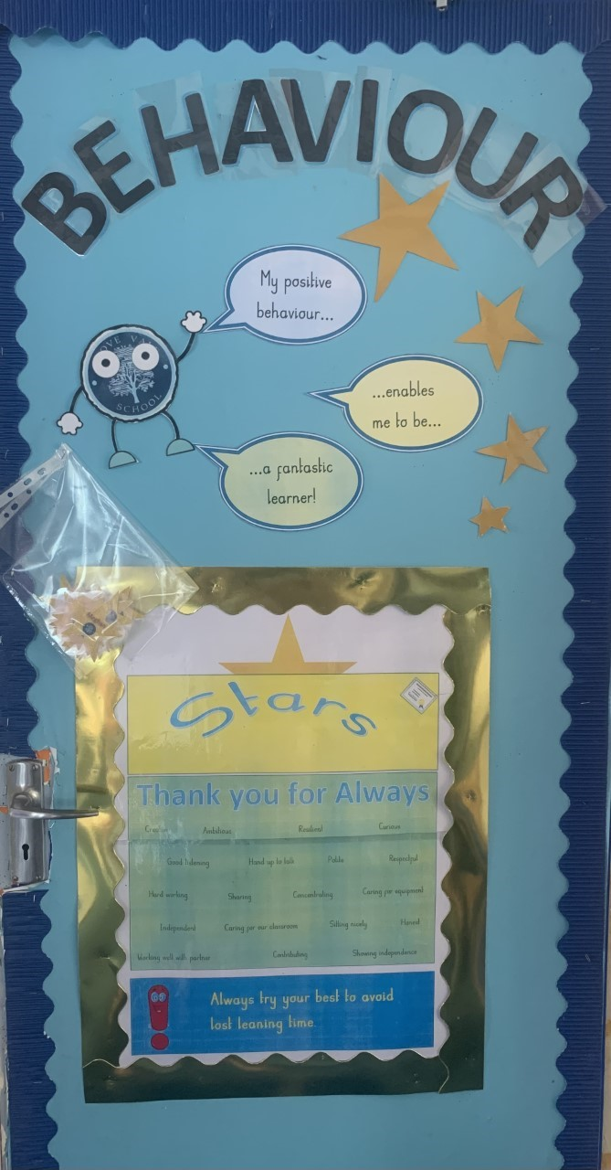

Appendix E

Appendix E

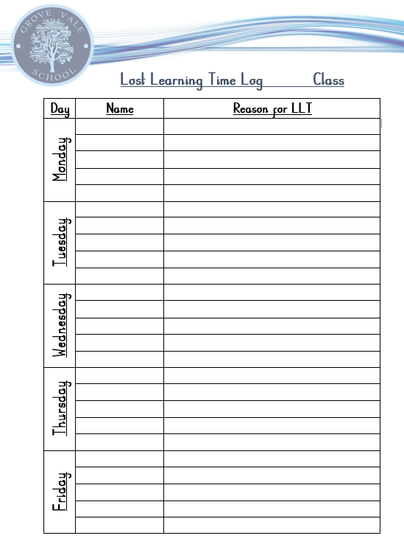

Appendix F

**Grove Vale Behaviour Reflection 2022/23**

Often, we rush through life without thinking about what has happened. Take time to think and **reflect** on your behaviour while answering the questions below.

|  |  |
| --- | --- |
| What happened? | _____________________________________________  _______________________________________________  _______________________________________________ |
| What did I do? | _______________________________________________  _______________________________________________  _______________________________________________ |
| What did other people do? | _______________________________________________  ______________________________________________  _______________________________________________ |
| How did I feel? | _______________________________________________  _______________________________________________  _______________________________________________ |
| What could I have done differently? | _______________________________________________  _______________________________________________  _______________________________________________ |
| What did I achieve? | _______________________________________________  _______________________________________________  _______________________________________________ |
| What could have gone better? | _______________________________________________  _______________________________________________  _______________________________________________ |
| What have I learnt? | _______________________________________________  _______________________________________________  _______________________________________________ |

Signed by Teacher:__________________________________________

Signed by Pupil:_________________________________________________

Sent home to Parent:____________________________________________

**REFLECTION**

**Grove Vale Behaviour Reflection KS1**

With an adult, take time to think and **reflect** on your behaviour while discussing the questions below.

Pupil name: __________________________ Date: ____________

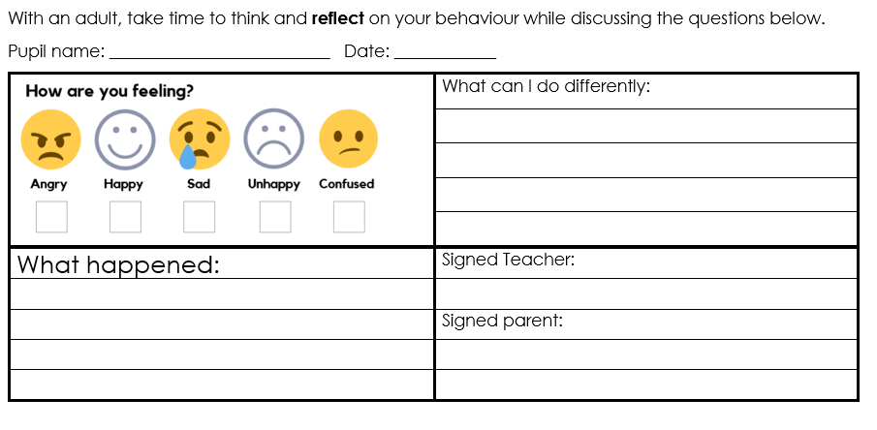

**APPENDIX G**

Dear Parent,

Date: _________________________

________________________________________________ has had red sky for

Your child spent a lesson with the phase leader and missed their playtimes for that day. They completed a reflection sheet, which is enclosed.

We would appreciate it if you would talk to your child about this matter and reinforce our School Rules and school code of conduct (overleaf).

Please return the slip below to indicate that you have received this letter and followed up the incident with your child.

If you would like to discuss the matter further please do not hesitate to contact your child’s class teacher.

Yours sincerely

Mrs A Connop

**--------------------------------------------------------------------------------------------------------------------------**

**RED SKY**

Name of child: _______________________________

Date:_______________________________________

I can confirm I have received the letter regarding my child’s behaviour.

Signed: _____________________________________

Relationship to child: __________________________