**Grove vale’s PE Journey – outdoor and adventurous activvtiies**

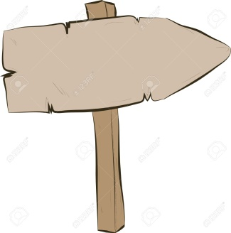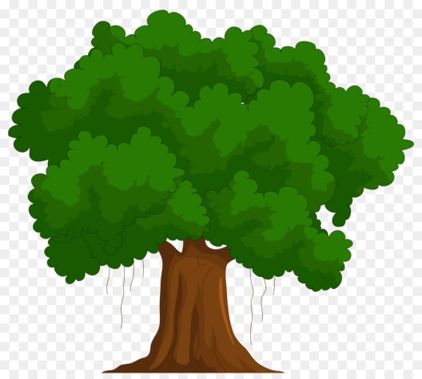

Reflect on being successful in problem solving tasks

Navigate around a course using a map

Use reflection to alter methods in order to improve

Able to share ideas and work on a team strategy

Use critical thinking to approach a task

Share ideas and select the best method to solve problems

Confidently follow and give instructions

Identify key symbols on a map and navigate around using a key

Work with a partner/group effectively

Plan and apply strategies to solve problems

Confidently communicate ideas and listen to others

Accurately give and follow instructions

Understand basic map reading

Attempt to reflect on when and why a challenge was successful or not

Work with a partner and small group

Plan and apply strategies to attempt to solve problems

Communicate ideas and listen to others

Follow and give instructions

Recognise a map and its key features

Solve simple problems

Work with a partner

Attempt to solve simple problems

Listen to others

Follow simple instructions

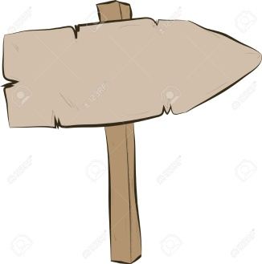

**Reception**

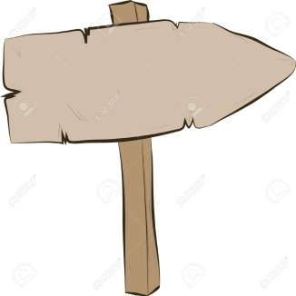

**Year 2**

**Year 6**

**Creative**

**Resilient**

**Curious**

**Ambitious**