**Grove vale’s PE Journey – Yoga**

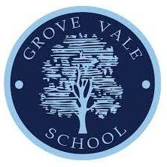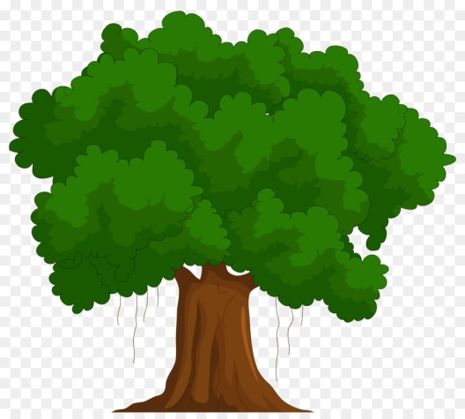

Showing flexibility

Showing balance

Controlled breathing techniques

Coordinating body movements

Showing confidence in movement

Adding flow to poses and movement

Working independently

Creating movement patterns

Selecting and applying actions through movement/poses

Observing and providing feedback

Showing physical strength

Providing feedback to peers

Using focus

Selecting actions

Creating poses

Emotional understanding

Showing patience

Showing leadership

Listen to others – sharing ideas

Emotional calmness

Working safely



**Year 2**



**Year 3**

**Year 5**

**Creative**

**Resilient**

**Curious**

**Ambitious**