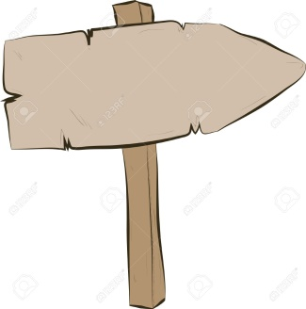

Jump from standing

Throw an object with one hand

Recognise changes to body during exercise

Throw a variety of objects with one hand

Recognise a difference in temperature and heart rate

Run at speed appropriate to distance

Complete a running jump

Demonstrate a range of throwing actions using a variety of objects

Recognise a change in temperature, heart rate and breathing

Improve andsustain running technique at different speeds

Demonstrate accuracy and technique in a range of throwing and jumping actions

Identify and explain good athletic performance

Describe changes in my body when running, jumping and throwing

Jump accurately from standing

Running at different speeds

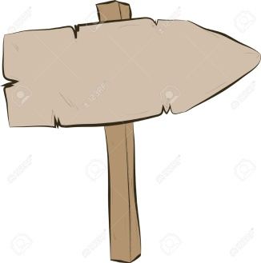

**Reception**

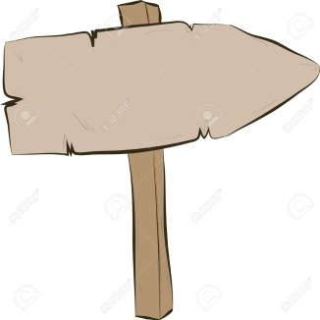

**Year 2**

Change speed and direction when running

**Year 6**

**Grove vale’s PE Journey - Athletics**

**Creative**

**Resilient**

**Curious**

**Ambitious**