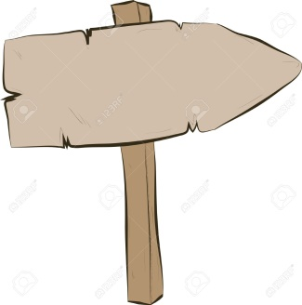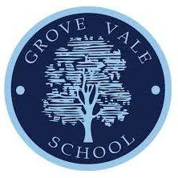

Vary dynamics and develop actions as part of a group or with partner

Continually demonstrate rhythm and spatial awareness

Modify own and others performance using observation and basic understanding of the structure of the body

Use dance vocabulary to compare and improve work

Demonstrate precision, control and fluency in response to stimuli

Compare, develop and adapt movement and motifs to create longer dances

Translate ideas from a range of stimuli into movement

Improvise freely, alone, or with partners

Discuss own and others performance using simple vocabulary

Understand the need for warm up and cool down

Vary dynamics, levels, speed and direction

Respond imaginatively to a range of stimuli

Follow a teacher led warm up and cool down

Describe and discuss others work

Perform with control and coordination

Choose actions and link with sounds and music

Remember simple dance steps and perform in in a controlled manner

Copy and explore basic body patterns and movements

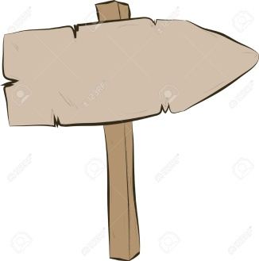

**Reception**

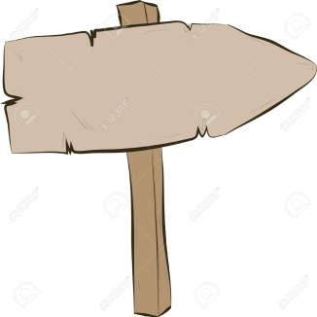

**Year 2**

**Year 6**

**Grove vale’s PE Journey - dance**

**Creative**

**Resilient**

**Curious**

**Ambitious**