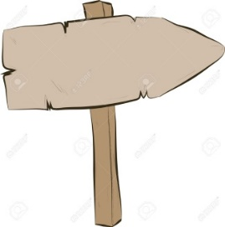

**Year 6**

Dribble a ball in and out of a set of obstacles

Hit a ball with a bat/racket with some accuracy

Control and catch a ball & accurately pass whilst moving

Take part in conditioned game with understanding of tactics & rules

Move with a ball in opposed situations

Develop simple tactics for attacking and defending

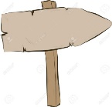

**Reception**



**Year 2**

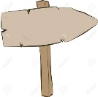

**Year3/4**

Accurately pass to someone in a team game

Control and catch a ball with movement

Begin to influence an opposed conditioned game

Kick a ball with a degree of accuracy

Throw a ball at a given target

Stop and catch a ball with control

Throw a ball to someone using overarm or underarm throw

Take part in team games

Hit a ball with a racket

Send and receive a ball

Travel with a ball

Pass a ball to someone

Stop or catch a ball with basic control

**Grove vale’s PE Journey - games**

**Creative**

**Resilient**

**Curious**

**Ambitious**