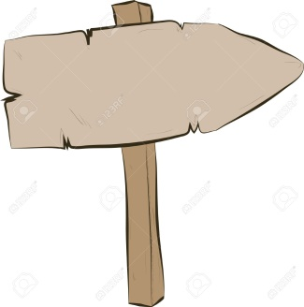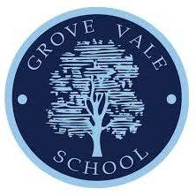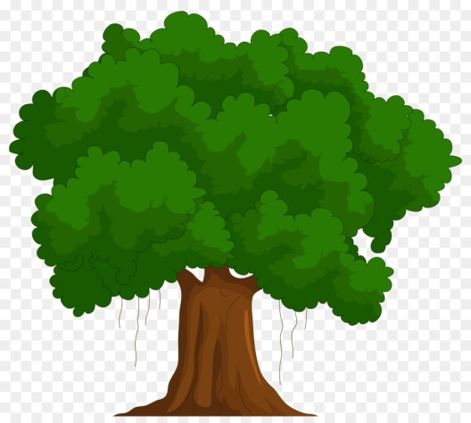

Copy, remember, explore & repeat simple actions, and link & vary ideas with control & co-ordination

Apply compositional ideas to sequences alone and with others

Describe own and others work noting similarities and differences

Make suggestions to improve performance

Understand how to work safely

Link ideas, skills & techniques with control, precision & fluency when performing basic skills

Understand composition, performing more complex sequences

Describe how to modify, improve and refine performances

Copy, remember, explore and repeat simple actions varying speed and levels

Choose and link basic actions

Recognise and use space appropriately

Discuss own and others performance

Begin to identify the difference between own performance and that of others

Begin to select simple actions to construct simple sequences

Copy and explore basic movements with some control and coordination

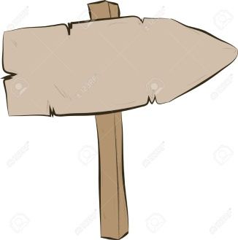

**Reception**

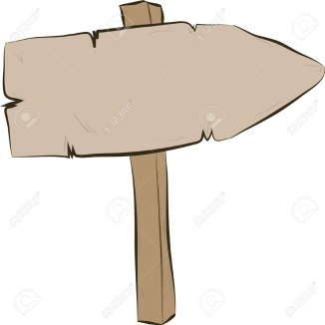

**Year 2**

**Year 6**

**Grove vale’s PE Journey - gymnastics**

**Creative**

**Resilient**

**Curious**

**Ambitious**