LONG TERM FORECAST Key Stage 1 PE 2023/24
Pupils should develop fundamental movement skills, become increasingly competent and confident and access a broad range of opportunities to extend their agility, balance and coordination, individually and with others. They should be able to engage in competitive (both against self and against others) and co-operative physical activities, in a range of increasingly challenging situations. Children should be encouraged to lead healthy, active lifestyles for life.
Pupils should be taught to:
- Master basic movements including running, jumping, throwing and catching, as well as developing balance, agility and co- ordination, and begin to apply these in a range of activities
- Participate in team games, developing simple tactics for attacking and defending
- Perform dances using simple movement patterns.
Swimming and water safety
At Grove Vale we provide swimming instruction for all children from Reception up to Year 6 each week.
Pupils should be taught to:
- swim competently, confidently and proficiently over a distance of at least 25 metres
- use a range of strokes effectively [for example, front crawl, backstroke and breaststroke]
- perform safe self-rescue in different water-based situations.
Children in Early Years are taught PD through continuous provision every day. Explicit targets are worked towards and planned for, during the weekly taught sessions as part of FGF, and we use ‘Get Set for PE’ to deliver these. EYFS follow the curriculum map shown below;
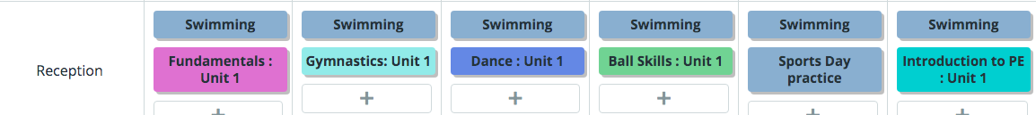
Children will be taught PE through the ‘Get Set 4 PE’ scheme using the long term overview below;
