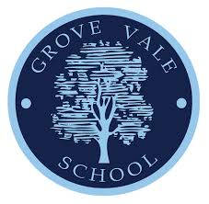 |  |  |  | Packed Lunch Guide
What a packed lunch should include?
To keep children’s lunches as healthy as possible, we would like the following items not to be included in packed lunches:
• Sweets
• Chocolate or chocolate items.

What drinks should be included?
At Grove Vale we encourage children to drink water. We do not allow fizzy drinks in lunch boxes. Fresh drinking water is provided for all children who bring a packed lunch therefore you do not need to pack a separate water bottle for lunchtime.

Why eat a healthy packed lunch?
New School Food Standards were introduced in January 2015 to ensure that all pupils are getting balanced and healthy food in school. We have used these standards to create our packed lunch guide and help families with ideas. A healthy packed lunch can help children to:
• Have enough energy to concentrate and learn in the afternoon
• Keep calm and be prepared to do their best
• Get important nutrients to keep their bodies healthy

 |  | Grove Vale Primary School, B43 6AL.
 |  | 0121 357 4319
 |  | sarah.hopcroft@grovevale.sandwell.sch.uk
 |  | www.grovevale.co.uk

What should a packed lunch include?
Use the following ideas to help plan a healthy lunch for your child.
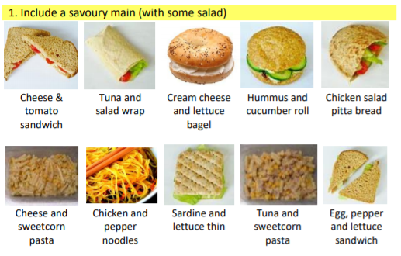

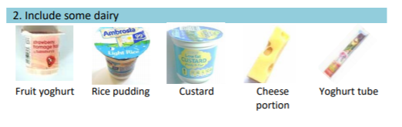
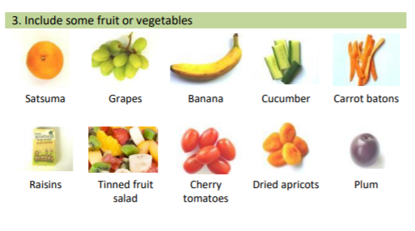
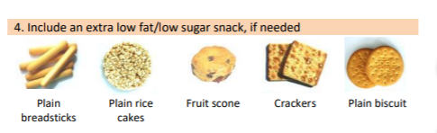

Please remember we are a nut free school so anything containing nuts should not be packed in lunchboxes. This includes Nutella.

Snack Time
Please remember if you send a snack in to school it must be healthy, ideally fruit. All the children in KS1 are entitled to a free piece of fruit which school provide.

