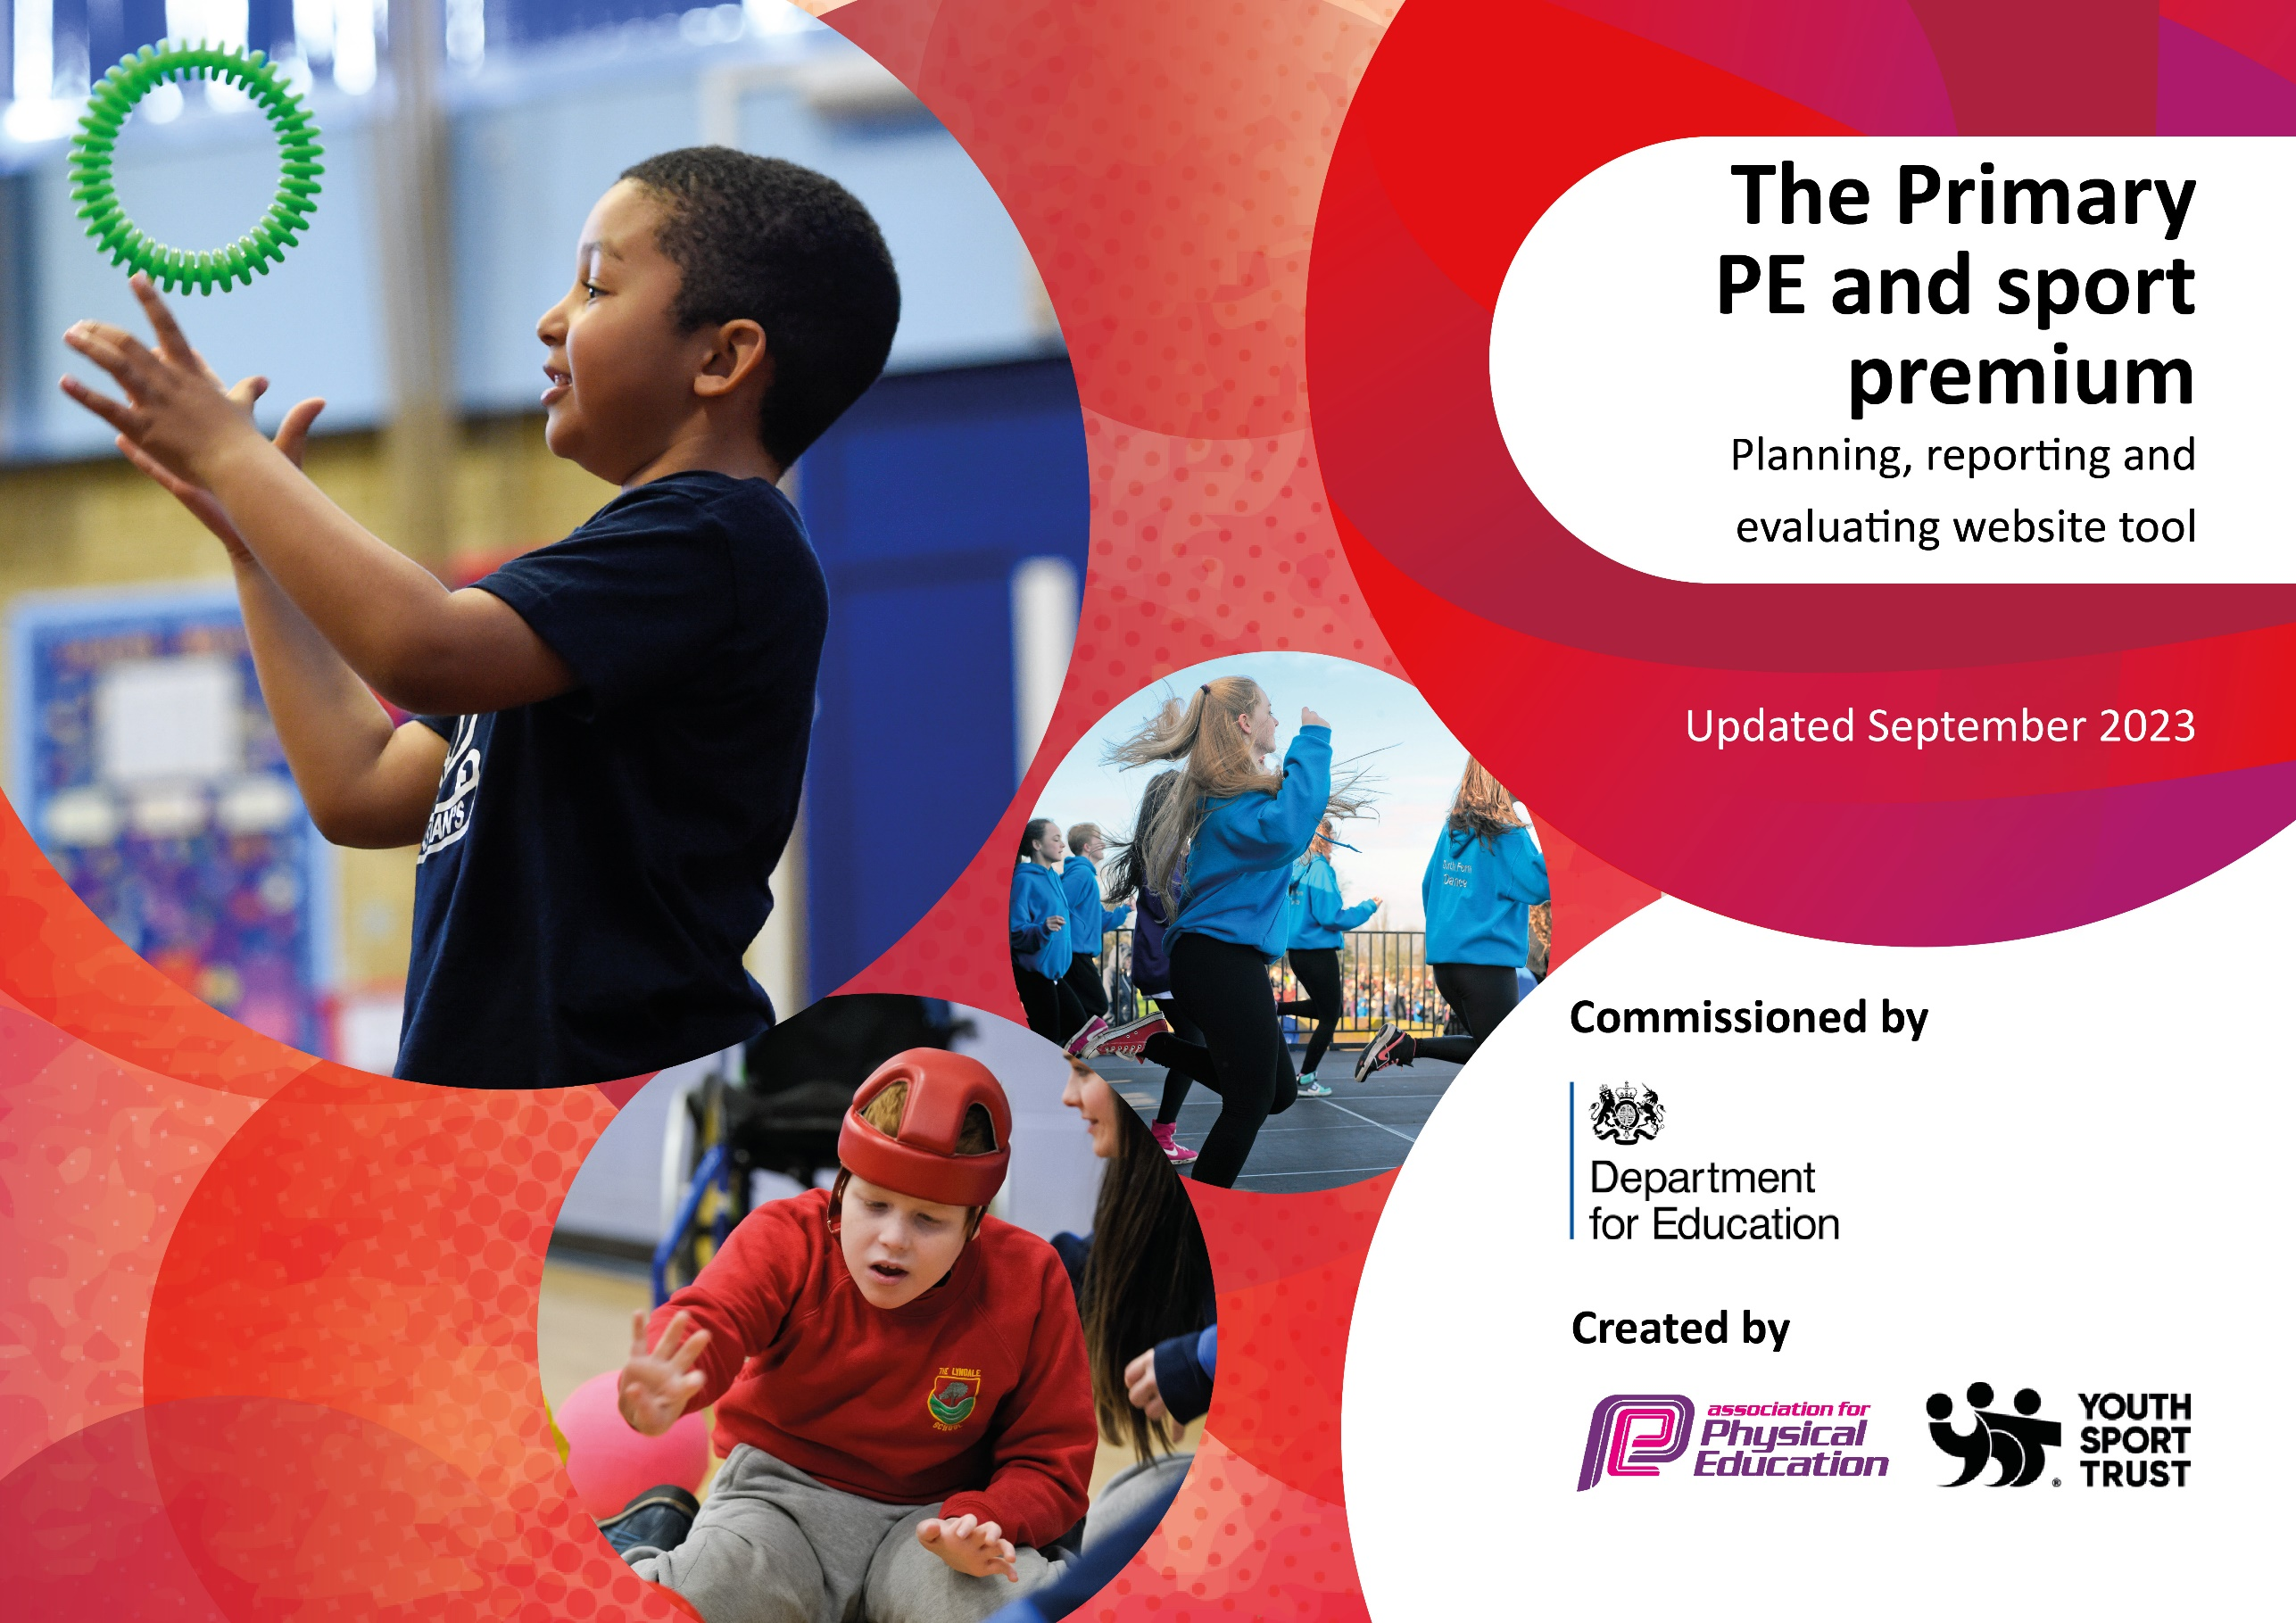

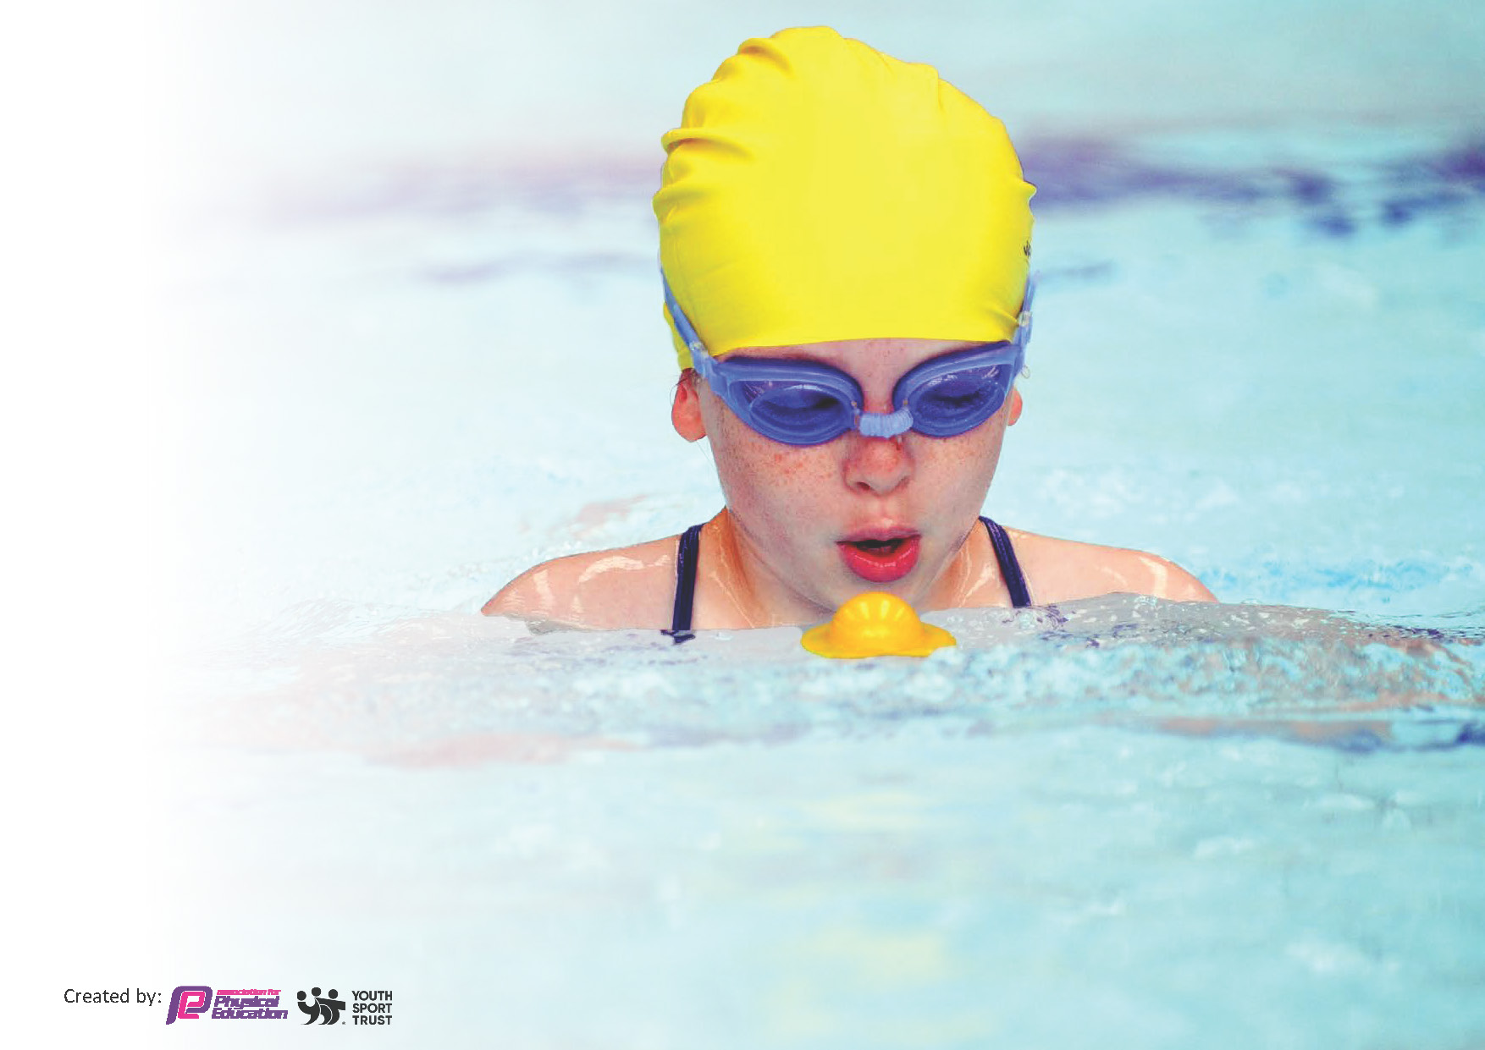
This template can be used for multiple purposes:
by:
- It enables schools to effectively plan their use of the Primary PE and sport premium
- It helps schools to meet the requirements (as set out in guidance) to publish information on their Primary PE and sport premium
- It will be an effective document to support Ofsted inspections enabling schools to evidence progress in Physical Education (PE) and evidence swimming attainment, which forms part of the PE National Curriculum. We would recommend schools consider
the Intent, Implementation and Impact of any spend, as examined within the Education Inspection Framework.

It is important that your grant is used effectively and based on school need.

Schools must use the funding to make additional and sustainable
improvements to the quality of the PE, School Sport and Physical Activity (PESSPA)
they offer. This means that you should use the Primary PE and sport premium to:

- Build capacity and capability within the school to ensure that improvements made now will benefit pupils joining the school in future years
- Develop or add to the PESSPA activities that your school already offers.

The Primary PE and sport premium should not be used to fund capital spend projects; the school’s core budget should fund these. Further detail on capital expenditure can be found in the updated Primary PE and sport premium guidance.

The Primary PE and sport premium guidance, outlines 5 key priorities that funding should be used towards. It is not

necessary that spending has to meet all the key priorities, you should select the priorities that you aim to use any funding towards.

Although completing this template is not a requirement for schools, schools are required to publish details of how they spend this funding. Schools must also outline what the impact this funding has had on pupils’ PE and sport participation and attainment and how any spending will be sustainable in the future. All funding must be spent by 31st July 2024.

The Department for Education has worked closely with the Association for Physical Education (afPE) and the Youth Sport Trust (YST) to develop this template and encourages schools to use it. This template is an effective way of meeting the reporting requirements of the Primary PE and sport premium.
Review of last year’s spend and key achievements (2022/2023)

We recommend you start by reflecting on the impact of current provision and reviewing your previous spend.

Activity/Action | Impact | Comments
School Games mark achieved – Gold standard  Premier Ed delivered a range od lunchtime and after school clubs to all children.  S  kip to be fit introduced with training for staff and equipment purchased for all children across the school.  WOW walk to school still ongoing and children rewarded for achievements.  Daily mile/Supermovers continues to be used across the school to encourage daily physical activity.  Swimming teacher delivers lesson across the school from EYFS to Yr6.  Staff training on Dance delivered to all staff - June 2023  PE lead continues to be part of PE network  Certificates awarded to children for good practice across PE sessions. Chd encouraged to show and tell their sporting achievements during assemblies. | Lots of competition experience for all pupils  Access for a lot of children to a good range of clubs, delivered by trained coaches.  Daily physical activity for all children across the school.  Physical activity encouraged away from school for future healthy lifestyles.  Physical activity encouraged away from school for future healthy lifestyles.  Up skilling staff knowledge and delivery of dance sessions.  PE lead able to pass on vital information to staff with regards to PE.  Half termly awards, presented in assemblies. | School games award was very pleasing and children gained a lot from attending a variety of competitions across the academic year. School will apply again next year and go for Platinum award.  Lunchtime and after school clubs were a success, offering all children a wide range of activities to take part in.  Skip to be fit was a great success, children really enjoyed the activity day and enjoy the competitive element to the program. Each class will continue to do this alongside the daily mile, twice a week and will try to beat their own scores.

Key priorities and Planning
This planning template will allow schools to accurately plan their spending.

Action – what are you planning to do | Who does this action impact? | Key indicator to meet | Impacts and how sustainability will be achieved? | Cost linked to the action  SPEND: £19597
Continue to have high expectations and focus on the daily mile, ‘Skip to be Fit’ and supermovers to get all pupils undertaking at least 30 minutes of additional activity per day.  Swimming teacher employed to teach extra SEN swimming sessions and swimming catch up sessions.  Embedding physical activity into the school day through active playgrounds, playtimes, clubs and active teaching  Table tennis table purchase for use at break and lunch times, but also possibility for an after school club.  Lunchtime and after school clubs provision.  Staff training to increase knowledge and performance in the delivery of PE.  Dancedesk subscription  Sports Assembly ran half termly – profile of PE, School Sport & Physical Activity and children’s achievements are shared with all children/staff and parents are invited to join us to celebrate in school/outside of school achievements.  Raise the profile of PE in the school community  Active mats to be purchased to raise the profile of warm up and cardio fitness for use during PE sessions and FGF.  Sports Assembly ran termly – profile of PE, School Sport & Physical Activity and children’s achievements are shared with all children/staff and parents are invited to join us to celebrate in school/outside of school achievements.  Lunchtime and after school clubs provision. Ensure disadvantaged children have equality of opportunity.  To continue to provide additional competitive sports identified by pupils survey in order to engage more pupils.  To continue to provide regular, competitive games with local schools.  Continue to be part of the School Games and enter regular competitions across all Key stages. | Children will have at least 30 minutes of physical activity per day. Children each have a skipping rope and are recording and improving their scores.  All staff  Qualified swimming teacher employed to teach across year groups, to ensure catch up from COVID and a range of SEN groups. DR  Attitudes to learning improved with better concentration in lessons -More children walk to school - Children bring healthier Children in both key stages will access to a wider range of equipment and use the playground marking effectively and independently to be active. Building a greater understanding of the benefits of exercise and a healthy lifestyle with more children walking to school and eating healthier including school lunchboxes. Feel good Friday will support this initiative. Children will be motivated by a wide range of opportunities in addition to PE. – All staff  A wider range of extra-curricular clubs on offer. E.g. Rugby, hockey, tennis, gymnastics, couch to 5K and basketball, cricket lead by school staff. More staff involved and feel confident teaching a wider range of sports PE lead to share expertise by running after school clubs Increased % of children attending clubs and the creation of new clubs to give children wider opportunities. Targeted pupils especially least active to attend extracurricular classes. Children will have regular access to equipment at lunch and break times and are able to play games using the playground markings to be active. Children will have a range of after school clubs to take part in and increase their own personal fitness/participation. – Prem Ed - SH  External agencies in to deliver staff training to enhance professional development of staff. Staff knowledge and confidence will improve and quality of lessons will therefore increase. EW  Increased staff knowledge and ability to pass on key information regarding Sport and PE. EW  The children feel pride representing their school and as a result it improves performance  Assemblies run by EW  Children take part in Schools games comps and part of local network of Football league. AD  Purchasing of the active mats and then implemented into school through training given by the PE lead. EW  Photographs & Certificates. Using the core values of the school children are awarded trophies in each class. EW  Children will have regular access to equipment at lunch and break times and are able to play games using the playground markings to be active. Children will have a range of after school clubs to take part in and increase their own personal fitness/participation. Premier Education to be employed to deliver staff training on delivery of lunchtime clubs/activities.  Prem Ed to deliver a range of after school clubs.  Number of children participating in clubs increased especially targeted children. WIDER IMPACT AS A RESULT OF ABOVE Improved standards in invasion games in curriculum time More girls are keen to take part in after school sports clubs. Greater interest in a wider range of sports to engage pupils Achievement of the School games mark to compliment PE Quality mark achievement – EW/AD/RP | Key indicator 1: The engagement of all pupils in regular physical activity – Chief Medical Officers guidelines recommend that primary school pupils undertake at least 30 minutes of physical activity a day in school  Key indicator 1: The engagement of all pupils in regular physical activity – Chief Medical Officers guidelines recommend that primary school pupils undertake at least 30 minutes of physical activity a day in school  Key indicator 1: The engagement of all pupils in regular physical activity – Chief Medical Officers guidelines recommend that primary school pupils undertake at least 30 minutes of physical activity a day in school  Key indicator 2: The profile of PESSPA being raised across the school as a tool for whole school improvement  Key indicator 3: Increased confidence, knowledge and skills of all staff in teaching PE and sport  Key indicator 4: Broader experience of a range of sports and activities offered to all pupils  Key indicator 5: Increased participation in competitive sport | Skip to be fit further embedded into school life. Profile continuing to be raised. Programme will continue to prove beneficial to pupils for the following reasons: - Calming influence upon pupils that prepares for subsequent class work by way of enhanced concentration and application - Improved self-esteem - Enhanced enjoyment of physical activity.  Children will be motivated by a wide range of opportunities in addition to PE.  Children will be motivated by a wide range of opportunities in addition to PE.  A sustainable legacy which will impact on children and young people. Sustainable professional development. Addresses high standards of teaching and learning, and will create additional positive impact upon our school development plan outcomes  Encourages and inspires children to be more active and to take part in events in and out of school.  Encourages and inspires children to be more active and to take part in events in and out of school  Encourage and inspire chd to part of a team and local community groups.  Encourages and inspires children to be more active and to take part in events in and out of school  Encourages and inspires children to be more active and to take part in events in and out of school.  Staff will work together and share practice which will lead to better confidence and more staff keen to get involved to ensure the extracurricular clubs will continue and thrive.  Member of staff to take charge of the competition teams with the help of parents for lifts etc. | £250  £6000  £1000  £1000  £500  £1000  £895  £1000

Key achievements 2023-2024
This template will be completed at the end of the academic year and will showcase the key achievements schools have made with their Primary PE and sport premium spending.

Activity/Action | Impact | Comments

Swimming Data
Meeting National Curriculum requirements for swimming and water safety.
Priority should always be given to ensuring that pupils can perform safe self-rescue even if they do not fully meet the first two requirements of the National Curriculum programme of study

Question | Stats: | Further context  Relative to local challenges
What percentage of your current Year 6 cohort can swim competently, confidently and proficiently over a distance of at least 25 metres? | 66.10% | Use this text box to give further context behind the percentage.  e.g., 30% - we are struggling to get pool space due to our local pool closing so we have had to use a much smaller local school pool. We have had to limit the number of pupils attending swimming lessons during one term which means some pupils have attended fewer swimming lessons than others.
What percentage of your current Year 6 cohort can use a range of strokes effectively [for example, front crawl, backstroke, and breaststroke]? | 59.32% | Use this text box to give further context behind the percentage.  e.g., Even though your pupils may swim in another year please report on their attainment on leaving primary school at the end of the summer term 2024

What percentage of your current Year 6 cohort are able to perform safe self-rescue in different water-based situations? | 91.52% | Use this text box to give further context behind the percentage.
If your schools swimming data is below national expectation, you can choose to use the Primary PE and sport premium to provide additional top-up sessions for those pupils that did not meet National Curriculum  requirements after the completion of core lessons. Have you done this? | Yes/No | Swimming data is low due to covid restrictions and swimming pool repairs to school pool.
Have you provided CPD to improve the knowledge and confidence of staff to be able to teach swimming and water safety? | No | Due to qualified swimming teacher delivering sessions.

Signed off by:

Head Teacher: | Alison Connop
Subject Leader or the individual responsible for the Primary PE and sport premium: | Emma Wetherall PE Lead and Yr4 Teacher
Governor: | Lisa Rashid
Date: | July 2023

