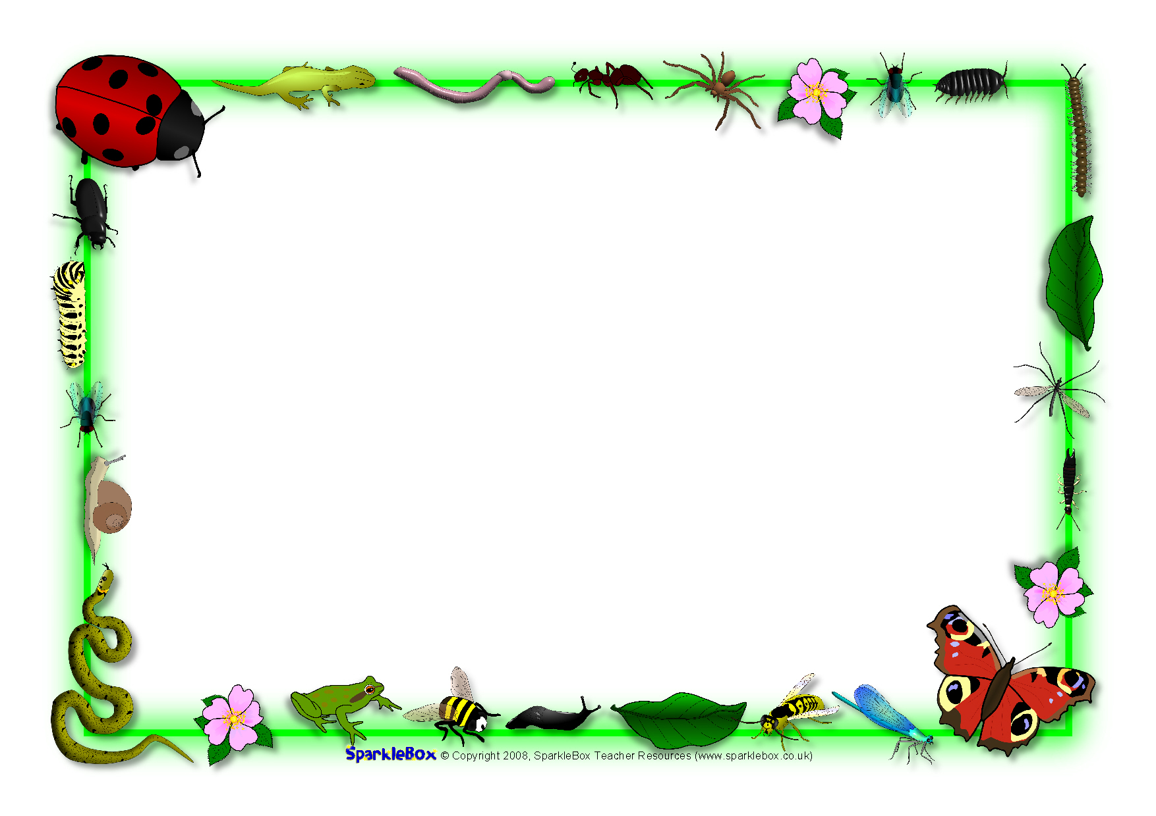

Expressive Arts & Design (EAD)
I will create art work in the style of Van Gogh (Sunflowers)
I will create observational drawings of minibeasts
I will use pastels to draw pictures of plants
I will develop my joining skills to create imaginary creatures/plants and animal homes
I will sing songs, create music and learn to recognise and copy different rhythms and beat
I will continue to develop my role play skills, making up new stories
I will use collage materials to create pictures using the different techniques

Communication and Language (CL)
I will listen carefully to stories and fact files about animals and plants and respond with relevant comments, questions or actions
I will follow a story without pictures or props
I will join in refrains in stories
I will use vocabulary linked to learning (word of the day, topic words)
I will talk confidently in front of the class, sharing tapestry projects and talking about things I have found out
I will follow instructions to make bread

Understanding the World (UW)
I will find, describe and compare different minibeasts I will look at life cycles (frog, butterfly, chick, plants) and use correct terms I will go on a seasons walk to Red House Park and identify change
I will grow and plant seeds
I will answer open ended questions – How can we? What would happen if? I will record findings by drawing, writing, making a model, photographs, ICT (selecting and using technology to help me)
I will programme beebots and be able to compare with a living bee
I will know about the needs of living things

Literacy (L)
- I will be retelling stories using vocab: once upon a time, first, then. Next. But, so, finally …happily ever after
- I will begin to read and write cvcc and ccvc
- I will use and, but, because (oral sentences)
- I will attempt to spell unfamiliar words using phonics knowledge (phase 3)
- I will write sentence(s) independently that can be read by others
- I will use a full stop and begin to use a capital letter
- I will write phase 3 tricky words
- I will use an adjective
- I will write for a purpose (recount, instructions, story)

- Physical Development (PD)
- I will be learning about eating healthily.
- I will be learning about exercise.
- I will take part in races and learn to wait for ‘ready, steady, go’
- I will begin to develop my athletic skills of running, throwing and jumping
- I will cut with greater accuracy
- I will hold my pencil with my ‘three friends hold’
- I will be able to form my numbers and letters.

Personal Social Emotional Development (PSED)
- I will have the opportunity to be creative.
- I will be able to try out my own ideas.
- I will be able to take turns.
- I will be able to play board games.
- I will invent my own games.
- I will be able to make compromises.

Reception Summer 1 2025/2026
The Circle of Life

Mathematics (M)
- I will recite numbers to 100
- I will count up to 20 objects
- I will learn to order numbers to 20
- I will be able to write all numerals to at least 10
- I will use the vocab involved in adding
- I will add 2 single digit numbers counting on
- I will solve problems including doubling,
- I will count in 2s and 10s
- I will sort and compare minibeasts
- I will name and describe a wider range of 2D shapes

