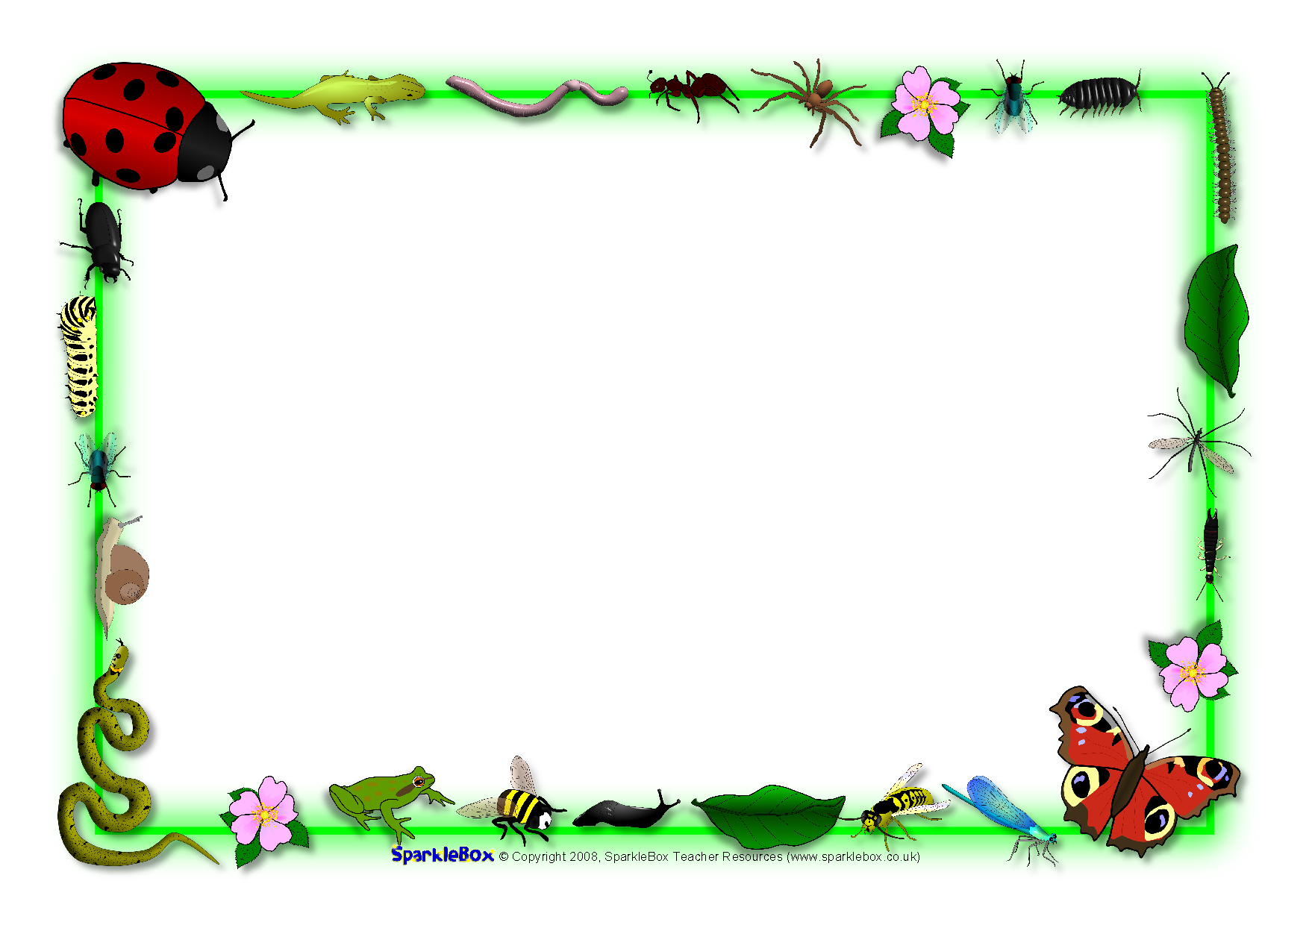

## Expressive Arts & Design (EAD)

I will create art work in the style of Van Gogh (Sunflowers)

I will create observational drawings of minibeasts

I will use pastels to draw pictures of plants

I will develop my joining skills to create imaginary creatures/plants and animal homes

I will sing songs, create music and learn to recognise and copy different rhythms and beat

I will continue to develop my role play skills, making up new stories

I will use collage materials to create pictures using the different techniques

## Communication and Language (CL)

I will listen carefully to stories and fact files about animals and plants and respond with relevant comments, questions or actions

I will follow a story without pictures or props

I will join in refrains in stories

I will use vocabulary linked to learning (word of the day, topic words)

I will talk confidently in front of the class, sharing tapestry projects and talking about things I have found out

I will follow instructions

## Understanding the World (UW)

I will find, describe and compare different minibeasts I will look at life cycles (frog, butterfly, chick, plants) and use correct terms I will go on a seasons walk to Red House Park and identify change

I will grow and plant seeds

I will answer open ended questions – How can we? What would happen if? I will record findings by drawing, writing, making a model, photographs, ICT (selecting and using technology to help me)

I will programme beebots and be able to compare with a living bee

I will know about the needs of living things

I will find out about Easter and how it is celebrated

## Literacy (L)

* I will be able to answer simple questions about stories.
* I will be able to read simple sentences.
* Begin to hold a sentence independently.
* I will learn the names of the letters of the alphabet.
* Write phase 2 and some Phase 3 tricky words.
* Use an adjective to describe a character.
* Physical Development (PD)
* I will be learning about eating healthily.
* I will be learning about exercise.
* I will be able to throw and catch a large ball.
* I will be able to roll a ball to a target.
* I will be able to kick a large ball.
* I will be able to form my numbers and letters.

**Personal Social Emotional Development (PSED)**

* I will have the opportunity to be creative.
* I will be able to try out my own ideas.
* I will be able to take turns.
* I will be able to play board games.
* I will invent my own games.
* I will be able to make compromises.

Reception Spring 2 2024/2025

The Circle of Life

## Mathematics (M)

* Count to 50.
* Consolidate numbers to 20.
* Order numbers to 10.
* Combine two groups and find a whole.
* Know number bonds to 10.
* Begin to record.
* Estimates amounts (to 10).
* Name and describe 2d shapes.
* Use positional language (treasure hunt).
* Know the days of the week in order.
* Know the months of the year in order.
* I will sort and compare minibeasts