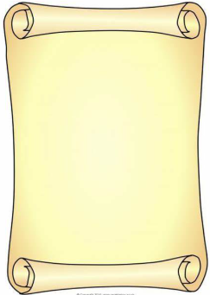

Literacy (L)
- I will be able to answer simple questions about stories.
- I will sequence events from a story
- I will be able to read simple sentences.
- Begin to hold a sentence independently.
- I will learn the names of the letters of the alphabet.
- Write phase 2 and some Phase 3 tricky words.
- Use an adjective to describe a character.

Physical Development (PD)
- I will be learning about eating healthily.
- I will be learning about exercise.
- I will be able to throw and catch a large ball.
- I will be able to roll a ball to a target.
- I will be able to kick a large ball.
- I will be able to form my numbers and letters.
- I will hold my pencil with my ‘three friends hold’

Mathematics (M)
- Count to 50.
- Consolidate numbers to 20.
- Order numbers to 10.
- Combine two groups and find a whole.
- Know number bonds to 10.
- Begin to record.
- Estimates amounts (to 10).
- Name and describe 2d and 3d shapes.
- Use positional language (treasure hunt).
- Know the days of the week in order.
- Know the months of the year in order.

Personal Social Emotional Development (PSED)
- I will be learning how to be a good friend
- I will explore different ways to respond to the feelings of others
- I will learn to follow rules in games (board games/team games)
- I will organise my own activities saying when I need help
- I will learn not to give up when I have a problem
- I will be able to say what I do well and link with COEL

Understanding the World (UW)
- I will learn about how things change over time
- I will talk about changes within my lifetime
- I will compare things from the past with things today eg. Toys and games
- I will learn about how holidays have changed over time
- I will learn where Egypt is and what it is like there
- I will explore how we can learn from items from the past
- I will draw simple maps with symbols
- I will learn that dinosaurs used to roam the Earth a very long time ago
- I will learn the Easter Story and why it is important to Christians

Communication and Language (CL)
- I will follow a story with pictures or props
- I will join in refrains in stories
- I will begin to ask questions about a topic
- I will use vocabulary linked to learning (word of the day, topic words)
- I will talk confidently in front of the class, sharing tapestry projects and talking about things I have found out
- I will follow instructions

Expressive Arts & Design (EAD)
- I will use different paint techniques to create an effect
- I will develop my cutting and collaging skills to create an Egyptian mask
- I will learn a song as a group and accompany this with instruments, keeping a rhythm
- I will continue to develop my role play skills, making up new stories

Reception Spring 2 2025/2026
Time Travellers

