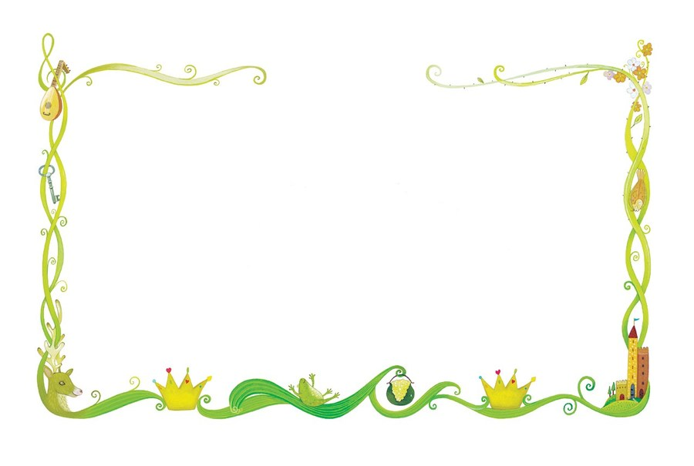

**Personal Social Emotional Development (PSED)**

I will continue to develop my confidence and share what I have done with the class

I will learn about feelings and being kind to others

I will be recognise feelings from facial expressions

I will begin to respond to the feelings of others

I will begin to compromise to sort disagreements

I will tidy away all resources after use and make sure I look after them

I will learn not to give up when I have a problem

I will understand about stranger danger

I will take turns and share

I will be able to say what I have done well and link to the COEL characters

## Expressive Arts & Design (EAD)

I will learn what happens when we add white and black to different colours

I will be learning new songs to help me in my learning.

I will learn simple dance sequences

I will learn the difference between quiet/loud sounds and fast/slow music

I will be acting out stories

I will learn new collage techniques (fringe and layer)

I will plan and make a house to keep the 3 pigs safe

I will make masks and puppets of fairytale characters

I will make a chair for baby bear

## Literacy (L)

I will talk about the story setting (where it takes place)

I will talk about the characters in a story, what they do and how they are feeling

I will be able to say what happens at the beginning, middle and end of a story (story mountain)

I will begin to read words, captions and sentences

I will write cvc words and phase 2 tricky words

I will write for different purposes (invitation, menu, recipe, stories)

I will learn that I need to put a finger space between words

I will begin to learn that there is a full stop at the end of a sentence

## Communication and Language (CL)

I will listen carefully to stories and to other people and respond with relevant questions or actions

I will talk about the events and characters in a story

I will learn to listen and respond with relevant comments questions or actions

I will make predictions about what might happen next

I will use appropriate story language to re-enact familiar stories

I will learn new vocabulary linked to stories and our topic.

I will play listening games

I will identify patterns to stories – what often happens to the good and wicked characters

## Understanding the World (UW)

I will learn to slow things down when they are falling (parachutes)

I will learn that plants need water and light to grow

I will investigate different materials and their properties (eg rough, smooth, hard, soft, bendy, waterproof)

I will find which material is best for building a house

I will learn how houses have changed through time

I will talk about what I see on my walk around the local area (park, hill, busy road, house, library, shop, trees, pond, busy, quiet)

I will know that Red House Park is next to our school

I will find out about Summer and talk about the changes from Spring

## Mathematics (M)

I will recite numbers to 30

I will count up to 10 objects and above

I will be learning to recognise numbers to 20

I will count out a specific amount of objects

I will write numbers to 10

I will be able to sort objects into groups (materials)

I will be learning number bonds to 5

I will be able to find one more/1 less than a number to 5 then 10

I will learn the names of some 3D shapes (weekly shape)

I will learn that some shapes can be stacked and some can be rolled.

Reception Summer 2 2023/2024

Once upon a time

## Physical Development (PD)

I will learn to balance on one foot and on apparatus

I will be able to hop

I will handle tools safely (saw)

I will know the importance of hygiene when

handling food

I will develop my fine motor skills

I will learn to colour inside the lines

I will continue to practise holding a pencil correctly (tripod grip)

I will practise forming my letters and numbers correctly

I will hold scissors correctly and cut carefully along a line