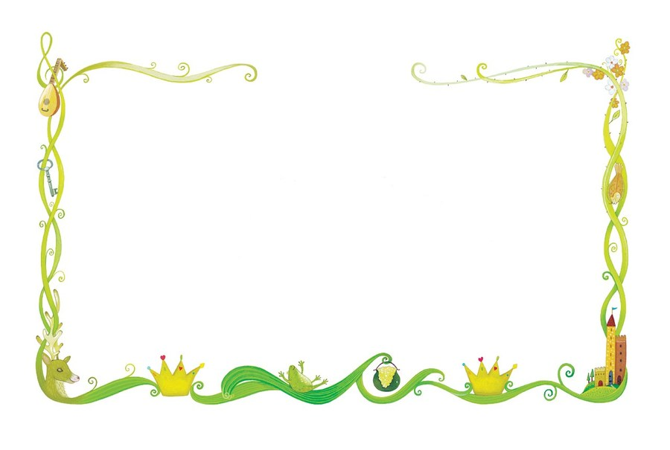

**Personal Social Emotional Development (PSED)**

I will continue to develop my confidence and share what I have done with the class.

I will learn about feelings and being kind to others.

I will be able to recognise feelings from facial expressions.

I will begin to respond to the feelings of others.

I will begin to compromise to sort disagreements.

I will tidy away all resources after use and make sure I look after them.

I will learn not to give up when I have a problem.

I will understand about stranger danger.

I will take turns and share.

I will be able to say what I have done well and link to the COEL characters.

## Expressive Arts & Design (EAD)

I will be learning new songs to help me in my learning.

I will learn simple dance sequences.

I will be acting out stories.

I will develop my drawing skills.

I will learn how to combine items to making an object with a moving part e.g. lever for Jack to climb the beanstalk, van for the Jolly Postman.

I will make masks and puppets of fairytale characters.

I will design and make a chair for baby bear.

I will make houses from different materials to keep the 3 pigs safe.

I will learn what happens when we add white and black to different colours.

## Literacy (L)

I will talk about the story setting (where it takes place).

I will talk about the characters in a story, what they do and how they are feeling.

I will be able to say what happens at the beginning, middle and end of a story (story mountain).

I will begin to read words, captions and sentences.

I will write cvc words and phase 2 tricky words.

I will write for different purposes (letter, poster, story).

I will learn that I need to put a finger space between words.

I will begin to learn that there is a full stop at the end of a sentence.

## Communication and Language (CL)

I will listen carefully to stories and to other people and respond with relevant questions or actions.

I will talk about the events and characters in a story.

I will learn to listen and respond with relevant comments questions or actions.

I will make predictions about what might happen next.

I will use appropriate story language to re-enact familiar stories.

I will learn new vocabulary linked to stories and our topic.

I will play listening games.

I will identify patterns to stories – what often happens to the good and wicked characters

## Understanding the World (UW)

I will learn about different types of bears and their habitats.

I will investigate different materials and their properties (e.g. rough, smooth, hard, soft, bendy, waterproof).

I will find which material is best for building a house.

I will learn what castles are and why they were important in the past.

I will compare locations – cities and countryside.

I will talk about what I see on my walk around the local area (park, hill, busy road, house, library, shop, trees, pond, busy, quiet).

I will know that Red House Park is next to our school.

I will find out about Summer and talk about the changes from Spring.

## Mathematics (M)

I will recite numbers to 30.

I will count up to 10 objects and above.

I will be learning to recognise numbers to 20.

I will count out a specific amount of objects.

I will write numbers to 10.

I will be able to sort objects into groups (materials).

I will be learning number bonds to 5.

I will be able to find one more/1 less than a number to 5, then 10.

I will learn the names of some 2D and 3D shapes

I will learn that some 3D shapes can be stacked and some can be rolled.

## Physical Development (PD)

I will learn to balance on one foot and on apparatus

I will be able to hop.

I will handle tools safely (saw).

I will know the importance of hygiene when handling food.

I will develop my fine motor skills.

I will learn to colour inside the lines.

I will continue to practise holding a pencil correctly (tripod grip).

I will practise forming my letters and numbers correctly.

I will hold scissors correctly and cut carefully along a line.

Reception Summer 2 2024/2025

Once upon a time