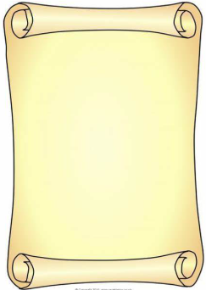

**Physical Development (PD)**

* I will be learning about eating healthily.
* I will be learning about exercise.
* I will take part in races and learn to wait for ‘ready, steady, go’
* I will begin to develop my athletic skills of running, throwing and jumping
* I will cut with greater accuracy
* I will hold my pencil with my ‘three friends hold’
* I will be able to form my numbers and letters.

## Mathematics (M)

* I will recite numbers to 100
* I will count up to 20 objects
* I will learn to order numbers to 20
* I will be able to write all numerals to at least 10
* I will use the vocab involved in adding
* I will add 2 single digit numbers counting on
* I will solve problems including doubling,
* I will count in 2s and 10s
* I will explore faces found on 3d nets and shapes

## Literacy (L)

* I will be retelling stories using vocab: once upon a time, first, then. Next. But, so, finally …happily ever after
* I will begin to read and write cvcc and ccvc
* I will use and, but, because (oral sentences)
* I will attempt to spell unfamiliar words using phonics knowledge (phase 3)
* I will write sentence(s) independently that can be read by others
* I will use a full stop and begin to use a capital letter
* I will write phase 3 tricky words
* I will use an adjective
* I will write for a purpose (recount, instructions, story)

**Personal Social Emotional Development (PSED)**

* I will be learning how to be a good friend
* I will explore different ways to respond to the feelings of others
* I will learn to follow rules in games (board games/team games)
* I will organise my own activities saying when I need help
* I will learn not to give up when I have a problem
* I will be able to say what I do well and link with COEL

## Understanding the World (UW)

* I will learn about how things change over time
* I will talk about changes within my lifetime
* I will compare things from the past with things today eg. Toys and games
* I will learn about how holidays have changed over time
* I will learn where Egypt is and what it is like there
* I will explore how we can learn from items from the past
* I will draw simple maps with symbols
* I will learn that dinosaurs used to roam the Earth a very long time ago
* I will learn about how some places are special to people and that people may believe different things

## Communication and Language (CL)

* I will listen carefully to stories and fact files about animals and plants and respond with relevant comments, questions or actions
* I will follow a story without pictures or props
* I will join in refrains in stories
* I will use vocabulary linked to learning (word of the day, topic words)
* I will talk confidently in front of the class, sharing tapestry projects and talking about things I have found out
* I will follow instructions

## Expressive Arts & Design (EAD)

* I will use different paint techniques to create an effect
* I will develop my cutting and collaging skills to create an Egyptian mask
* I will learn a song as a group and accompany this with instruments, keeping a rhythm
* I will continue to develop my role play skills, making up new stories

Reception Summer 1 2024/2025

Time Travellers