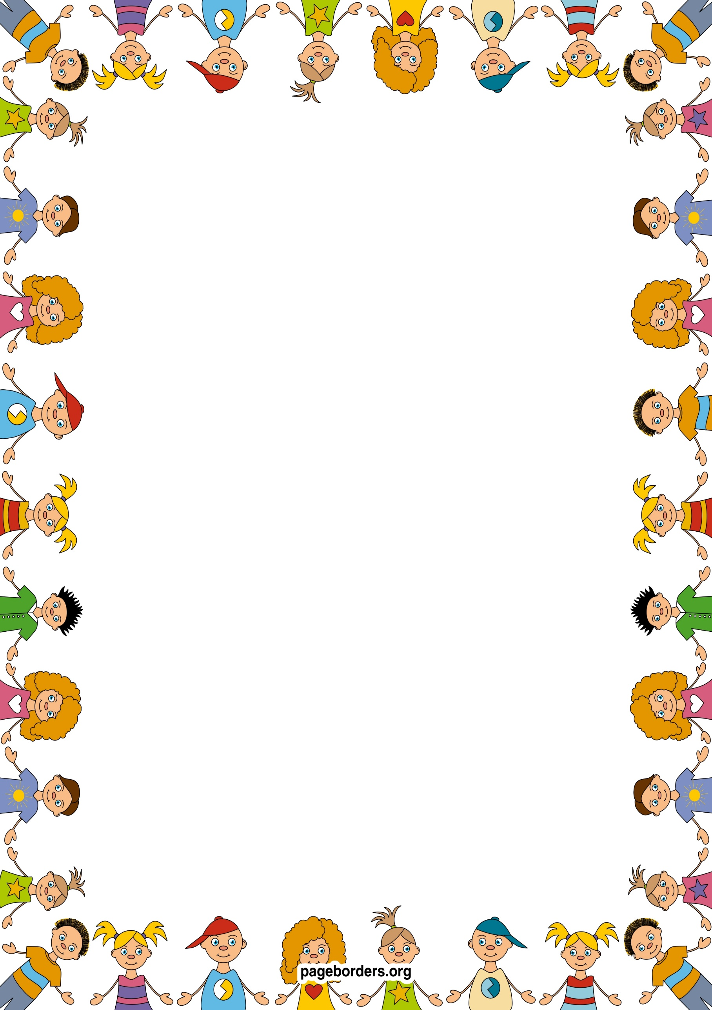

**Personal Social Emotional Development (PSED)**

* I will be creating class rules with my friends.
* I will be participating in turn taking games
* I will be trying out new activities independently
* I will select resources independently.
* I will be dressing and undressing independently
* I will be learning routines of the school day
* I will be learning to think about the feelings of others
* I will be learning the names of other children
* I will take turns and share
* I will learn where resources are kept
* I will learn ways that we are all the same and ways that we are different

Reception Autumn 1 2025

Marvellous Me

## Mathematics (M)

* I will be learning to recite numbers to 10 and back
* I will be able to count at least 5 objects
* I will be able to recognise numerals to at least 5
* I will be learning number facts to 5
* I will compare height to see who is taller
* I will be ordering the events in my day (visual timetable)
* I will learn that the year is split into months
* I will be playing games to use words to describe position – in, under, next to, between,
* I will make shape pictures and begin to learn to name and describe simple 2D shapes.

## Literacy (L)

* I will be learning to recognise my name
* I will listen and learn rhymes through stories and songs
* I will discuss stories and predict endings
* I will be retelling stories, looking for clues in the pictures
* I will talk about the characters, setting and plot
* I will have a library book and learn to handle books carefully
* I will learn what the title and blurb is
* I will learn sounds that letters make and begin to recognise the sound at the beginning of words
* I will be learning to read and write tricky words – I, to, the, to, go, into
* I will do shared writing for a purpose (lists, labels) and begin to have a go at writing/mark making myself, saying what I have written

## Expressive Arts & Design (EAD)

* I will be drawing pictures of myself using mirrors.
* I will be drawing pictures of my family
* I will be thinking about colours and using them appropriately in my pictures.
* I will be using a range of objects to print with e.g. leaves
* I will do leaf rubbings
* I will be learning new songs to help me in my learning.
* I will be roleplaying in the home corner.
* I will be acting out stories with puppets.
* I will be using a range of materials to make collages and models.

## Understanding the World (UW)

* I will be using digital cameras to take photos of my friends
* I will be using a computer to help me in my learning.
* I will be using all five senses to investigate areas around me
* I will be recognising similarities and differences between my friends and I
* I will be going on an autumn walk around the park.
* I will be learning about different parts of the body.
* I will investigate how things change
* I will find out about Diwali

## Physical Development (PD)

* I will be playing ring games
* I will be using tools safely
* I will be learning about how to be healthy
* I will be describing the changes in my body after being active.
* I will be moving with control and co-ordination over, under, through various small apparatus.
* I will be using a range of small and large equipment.
* I will be using a range of malleable materials in my play
* I will learn to copy a dance, linking 2 movements
* I will be learning how to swim

## Communication and Language (CL)

* I will be learning to talk about myself using describing words such as tall, short.
* I will be imagining and recreating roles in real life, family situations and fictional stories.
* I will be asking questions to get to know my friends in my new class.
* I will be talking about my family, where I live and what I find out
* I will be thinking about sequence of events in stories and saying what happened in the beginning, middle and end.
* I will play listening games