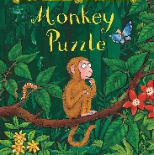
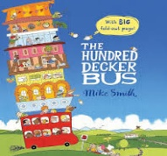

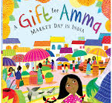
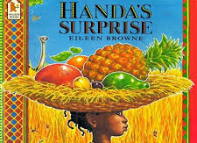
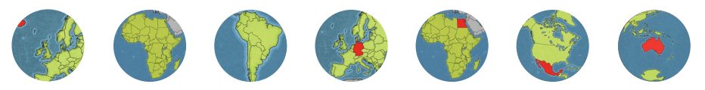
Physical Development (PD)
- I will be playing parachute and playground games.
- I will handle tools safely.
- I will learn how to handle food safely.
- I will move in a variety of ways in and out of cones and obstacles.
- I will learn to jump with both feet leaving the ground.
- I will be able to hop, run and sprint (stopping on command).
- I will develop my fine motor skills.
- I will learn how to hold a pencil correctly and form some letters correctly.

Literacy (L)
- I will be retelling stories, looking for clues in the pictures.
- I will sequence pictures from familiar stories.
- I will learn what the author and illustrator do.
- I will learn the difference between fiction and non- fiction.
- I will learn sounds that letters make.
- I will learn that words have more than one sound and try to blend them.
- I will be learning to read and write VC and CVC words.
- I will learn to write my name,
- I will do shared writing for a purpose (names, lists labels, signs, captions, lists).

Mathematics (M)
- I will recite numbers to 20 and back.
- I will count up to 10 objects.
- I will be able to order numbers to 10.
- I will be learning to recognise numbers to 10.
- I will be able to sort objects into groups.
- I will be able to compare objects.
- I will be learning to find one more/less by counting (to at least 5).
- I will be learning number facts to 5.
- I will be learning to name and describe simple 2D shapes.
- I will use words to describe time.

Understanding the World (UW)
- I will learn there are many countries in the world.
- I will learn how other countries are different to the UK.
- I will use an ipad to create pictures.
- I will find out about different forms of transport.
- I will find out about Winter and talk about the changes from Autumn.
- I will learn about Christmas.

Personal Social Emotional Development (PSED)
- I will be learning about feelings and being kind to others.
- I will be thinking about what I can do if I feel cross or sad.
- I will be learning how to share with others.
- I will become more confident and perform in a Nativity play.
- I will learn to put all resources away after use and to look after them.
- I will learn about how we can look after our world.
- I will learn not to give up when I have a problem.
Expressive Arts & Design (EAD)
- I will learn to mix prime colours to make new colours.
- I will be learning to add more detail to my drawings.
- I will continue to learn about colours and use them appropriately in my paintings.
- I will be learning new songs to help me in my learning.
- I will dance in different ways, responding to the music.
- I will explore different sounds instruments make.
- I will be acting out stories and making up new stories.
- I will be using a range of materials to make collages and models.
- I will use collage materials to create jewellery.

Reception Autumn 2 2026/2027
Globe Trotters

Communication and Language (CL)
- I will listen carefully to stories.
- I will be learning to talk about the events and characters in a story.
- I will learn to listen and respond with relevant comments, questions or actions.
- I will be answering how and why questions.
- I will talk to the class about what I have found out.
- I will use appropriate story language to re-enact familiar stories.
- I will learn new vocabulary linked to stories and our topic.
- I will play listening games.

