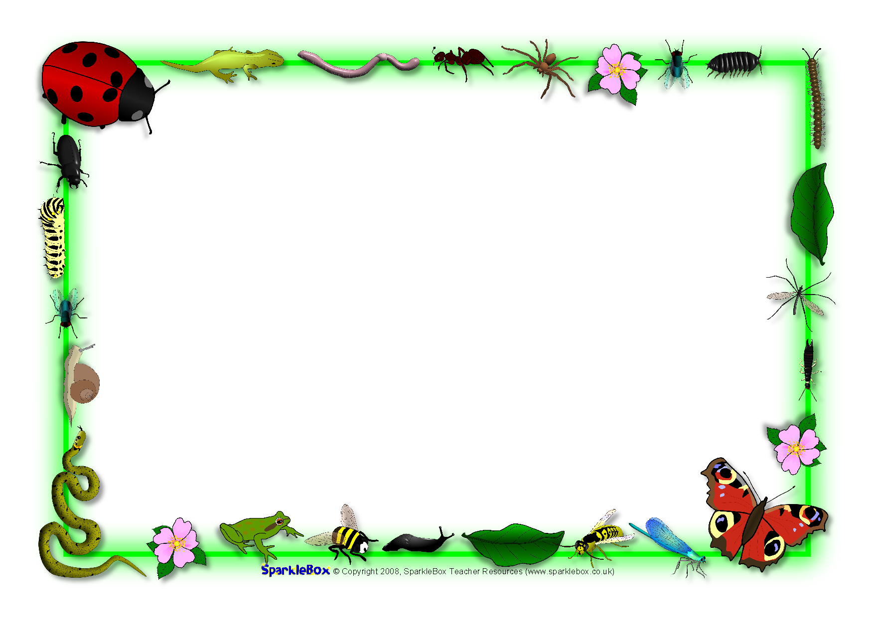

## Expressive Arts & Design (EAD)

I will create paintings in the style of Kandinsky (patterns and colour mixing)

I will create observational drawings of minibeasts

I will use pastels to draw pictures of plants

I will develop my woodwork skills to create imaginary creatures/plants and animal homes

I will sing songs, create music and learn to recognise and copy different rhythms and beat

I will continue to develop my role play skills, making up new stories

I will use collage materials to create pictures using the different techniques I have learnt

I will learn to weave

## Communication and Language (CL)

I will listen carefully to stories and fact files about animals and plants and respond with relevant comments, questions or actions

I will follow a story without pictures or props

I will join in refrains in stories

I will use vocabulary linked to learning (word of the day, topic words)

I will talk confidently in front of the class, sharing tapestry projects and talking about things I have found out

I will follow instructions

## Understanding the World (UW)

I will find, describe and compare different minibeasts I will look at life cycles (frog, butterfly, chick, plants) and use correct terms I will go on a seasons walk to Red House Park and identify change

I will grow cress and plant other seeds

I will answer open ended questions – How can we? What would happen if? I will record findings by drawing, writing, making a model, photographs, ICT (selecting and using technology to help me)

I will programme beebots and be able to compare with a living bee

I will know about the needs of living things

I will find out about Eid and how it is celebrated

## Literacy (L)

I will be retelling stories using vocab: once upon a time, first, then. Next. But, so, finally …happily ever after

I will begin to read and write cvcc and ccvc

I will use and, but, because (oral sentences)

I will attempt to spell unfamiliar words using phonics knowledge (phase 3)

I will write sentence(s) independently that can be read by others

I will use a full stop and begin to use a capital letter

I will write phase 3 tricky words

I will use an adjective

I will write for a purpose (recount, instructions, story)

* Physical Development (PD)

I will learn why exercise, eating, sleeping and hygiene are good for us

I will play team games (catch the balloon, balloon volleyball)

I will control a ball within a game setting

I will be able to use my hands to stop, catch, bounce and

throw a ball

I will use a tripod grip

I will form my letters correctly

I will colour inside lines

**Personal Social Emotional Development (PSED)**

I will be learning how to be a good friend

I will explore different ways to respond to the feelings of others

I will play team building games – keep the balloon in the air, parachute games

I will learn to follow rules in games (board games/team games)

I will organise my own activities saying when I need help

I will learn about how we can look after our world

I will learn not to give up when I have a problem

I will be able to say what I do well and link with COEL

Reception Summer 1 2023/2024

The Circle of Life

## Mathematics (M)

I will recite numbers to 100

I will count up to 20 objects

I will learn to order numbers to 20

I will be able to write all numerals to at least 10

I will use the vocab involved in adding and subtracting

I will add and subtract 2 single digit numbers counting on or back

I will solve problems including doubling,

I will count in 2s and 10s

I will explore patterns

I will recognise coins

I will measure height and distance

I will sort and compare minibeasts