

**Autumn –**

Who is an inspiring person? What stories inspire Christian, Muslim and Sikh people?

What is the ‘good news’ Christians believe Jesus brings?

**Summer –**

Beginning to learn Islam: What can we learn from Muslims in Sandwell?

Beginning to learn Sikhi: Stories about the Sikh Gurus.

**Year 1 - RE**

**Autumn –**

The Christian Nativity

Why it is the Diwali story special?

**Fast-forward to Year 2**

**Rewind to Reception**

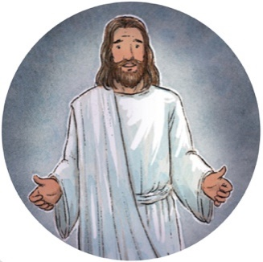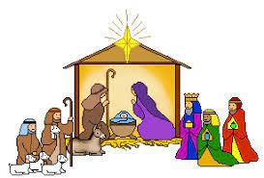

**Autumn –**

What do Christians believe God is like?

Why does Christmas matter?

How and why do we celebrate special times?

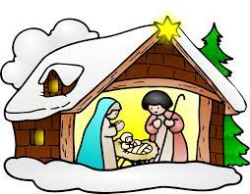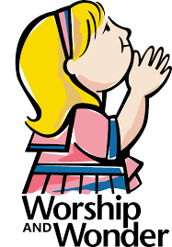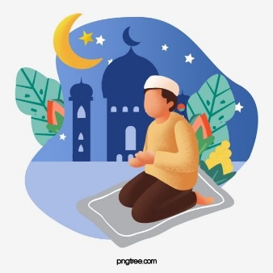

**Spring –**

How and why are some booksholy? Sacred wordsfor Sikhs, Muslims and Christians.

Why does Easter matter to Christians?

**Summer –**

Who celebrates what? How and Where? Celebrations that matter in Sandwell (Christians, Muslim, Sikh)/

Beginning to learn Islam: What can we learning from stories of the Prophet?

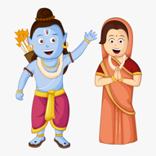

**Spring –**

Holy places: where and how do Christians, Sikhs and Muslims worship?

Beginning to learn Sikhi.. The Gurdwara, a place to belong.

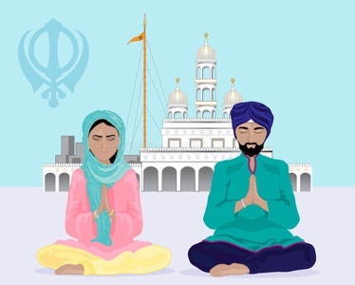

**Spring –**

Why do Christians celebrate Easter?

Who celebrates Eid, what is it about and why it is special?

What was Noah’s ark and why is it a special story?



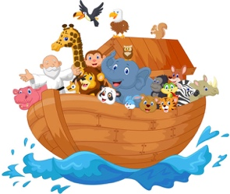

**Summer –**

Places and stories that are special to different people.

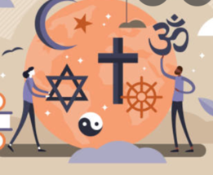



**We are ambitious.**

**We are curious.**

**We are creative.**

**We are resilient.**

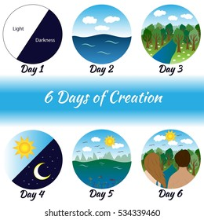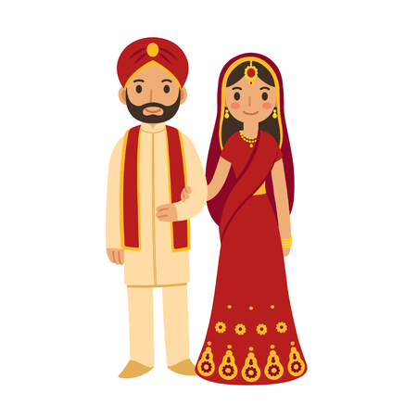

**Autumn –**

Who is an inspiring person? What stories inspire Christian, Muslim and Sikh people?

 What is the ‘good news’ Christians believe Jesus brings?

**Summer –**

Who celebrates what? How and Where? Celebrations that matter in Sandwell (Christians, Muslim, Sikh)/

Beginning to learn Islam: What can we learning from stories of the Prophet?

**Autumn –**

What do Christians believe God is like?

Why does Christmas matter?

How and why do we celebrate special times?

**Spring –**

How and why are some booksholy? Sacred wordsfor Sikhs, Muslims and Christians.

Why does Easter matter to Christians?

**Rewind to Year 1**

**Summer –**

Beginning to learn Islam: What can we learn from Muslims in Sandwell?

Beginning to learn Sikhi: Stories about the Sikh Gurus.

**Spring –**

Holy places: where and how do Christians, Sikhs and Muslims worship?

Beginning to learn Sikhi.. The Gurdwara, a place to belong.

**Autumn –**

What are the deeper meanings of festivals?/ What do Christians learn from the Creation story?

**Fast-forward to Year 3**

**Year 2 - RE**

**Spring –**

What is it like to be a Hindu? Community worship, Celebration (Hindus) Why do Christians call the day Jesus died ‘Good Friday’?

**Summer –**

What is it like to be a Sikh in Sandwell? Sikh beliefs and ways of living (Sikh) What is it like to be Jewish? Family, Synagogue and Torah (Judaism)



**We are resilient.**

**We are ambitious.**

**We are curious.**

**We are creative.**

**We are creative.**

**We are curious.**

**We are ambitious.**

**We are resilient.**

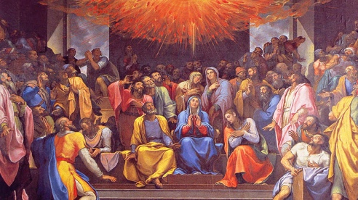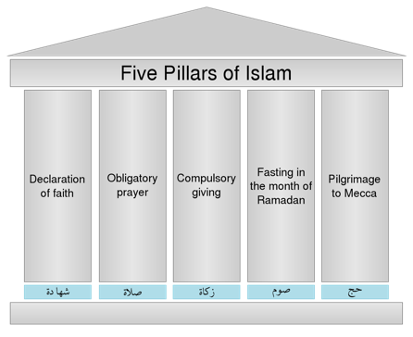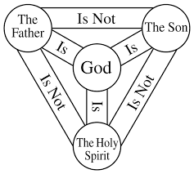

**Autumn –**

Who is an inspiring person? What stories inspire Christian, Muslim and Sikh people?

 What is the ‘good news’ Christians believe Jesus brings?

**Summer –**

For Christians, when Jesus left, what was the impact of Pentecost? Values: What matters most? Christians and Humanists.

**Summer –**

What is it like to be a Sikh in Sandwell? Sikh beliefs and ways of living (Sikh) What is it like to be Jewish? Family, Synagogue and Torah (Judaism)

**Spring –**

What is it like to be a Hindu? Community worship, Celebration (Hindus) Why do Christians call the day Jesus died ‘Good Friday’?

**Autumn –**

What are the deeper meanings of festivals?/ What do Christians learn from the Creation story?

**Fast-forward to Year 4**

**Rewind to Year 2**

**Year 3 - RE**

**Summer –**

Beginning to learn Islam: What can we learn from Muslims in Sandwell?

Beginning to learn Sikhi: Stories about the Sikh Gurus.

**Spring –**

Holy places: where and how do Christians, Sikhs and Muslims worship?

Beginning to learn Sikhi.. The Gurdwara, a place to belong.

**Autumn –**

What kind of world did Jesus want? What is the ‘Trinity’ and why is it important for Christians?

**Spring –**

Keeping the 5 Pillars of Islam (Islam) Why does the Prophet matter to Muslims? (Islam)



**We are creative.**

**We are curious.**

**We are ambitious.**

**We are resilient.**

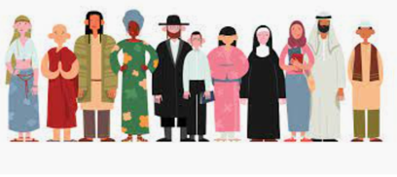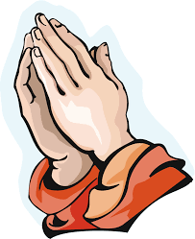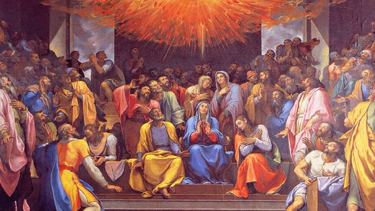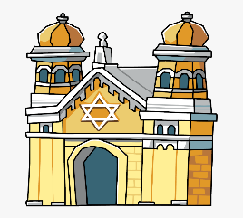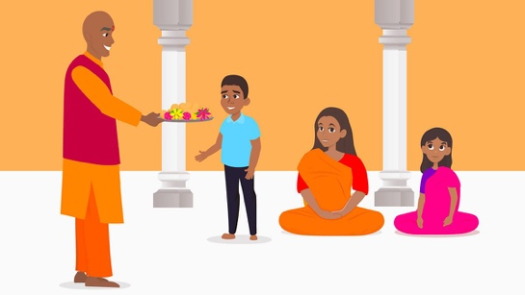

**Summer –**

Can religions help people when times get hard? (Christians, Hindu, non-religious)

Why do Hindus want to be good?

**Autumn –**

What kind of world did Jesus want? What is the ‘Trinity’ and why is it important for Christians?

**Spring –**

Keeping the 5 Pillars of Islam (Islam) Why does the Prophet matter to Muslims? (Islam)

**Summer –**

For Christians, when Jesus left, what was the impact of Pentecost? Values: What matters most? Christians and Humanists.

**Autumn –**

What does it mean if Christians believe God is Holy and loving? Hindu, Jewish and Islamic Prayer: What? When? How? Where? Why? (Muslims, Jews)

**Year 4 - RE**

**Rewind to Year 3**

**Fast-forward to Year 5**

**Summer –**

What is it like to be a Sikh in Sandwell? Sikh beliefs and ways of living (Sikh) What is it like to be Jewish? Family, Synagogue and Torah (Judaism)

**Spring –**

What is it like to be a Hindu? Community worship, Celebration (Hindus) Why do Christians call the day Jesus died ‘Good Friday’?

**Autumn –**

What are the deeper meanings of festivals?/ What do Christians learn from the Creation story?

**Spring –**

An Enquiry into visiting places of worship (Synagogue)

What do Christians believe Jesus did to save human beings?

**We are creative.**

**We are curious.**

**We are ambitious.**

**We are resilient.**

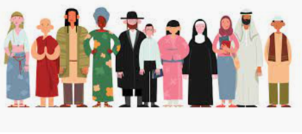

**Spring –**

Christians and how to live: ‘What would Jesus do?’

What will make Sandwell a more respectful community? (Many religions)

**Summer –**

For Christians, when Jesus left, what was the impact of Pentecost? Values: What matters most? Christians and Humanists.

**Spring –**

Keeping the 5 Pillars of Islam (Islam) Why does the Prophet matter to Muslims? (Islam)

**Autumn –**

What kind of world did Jesus want? What is the ‘Trinity’ and why is it important for Christians?

**Year 5 - RE**

**Rewind to Year 4**

**Fast-forward to Year 6**

**We are creative.**

**We are curious.**

**We are ambitious.**

**We are resilient.**

**Autumn –**

What does it mean if Christians believe God is Holy and loving? Hindu, Jewish and Islamic Prayer: What? When? How? Where? Why? (Muslims, Jews)

**Spring –**

An Enquiry into visiting places of worship (Synagogue)

What do Christians believe Jesus did to save human beings?

**Summer –**

Can religions help people when times get hard? (Christians, Hindu, non-religious)

Why do Hindus want to be good?

**Summer –**

Christian Aid and Islamic Relief: can they change the world? (Christians, Muslims)/ What impact do people’s beliefs have in their lives?

**Autumn –**

What can we learn from religion about temptation? (Christians, Muslims). Atheists and believers in God: What are the arguments?



**If you go to a Sandwell secondary School, you will study a range of the following units.**

**You will continue to learn about Christians, Muslims, Buddhists, Sikhs and non-religious views (Atheism).**

**Year 6 - RE**

**Rewind to Year 5**

**Fast-forward to Year 7**

**We are creative.**

**We are curious.**

**We are ambitious.**

**We are resilient.**

**Autumn –**

What does it mean if Christians believe God is Holy and loving? Hindu, Jewish and Islamic Prayer: What? When? How? Where? Why? (Muslims, Jews)

**Spring –**

An Enquiry into visiting places of worship (Synagogue)

What do Christians believe Jesus did to save human beings?

**Summer –**

Can religions help people when times get hard? (Christians, Hindu, non-religious)

Why do Hindus want to be good?

**Summer –**

Christian Aid and Islamic Relief: can they change the world? (Christians, Muslims)/ What impact do people’s beliefs have in their lives?

**Spring –**

Christians and how to live: ‘What would Jesus do?’

What will make Sandwell a more respectful community? (Many religions)

**Autumn –**

What can we learn from religion about temptation? (Christians, Muslims). Atheists and believers in God: What are the arguments?

Some of the key questions included are:

Why do Christians believe Jesus is God on earth?

How do we express our spiritual ideas?

What difference does it make to be atheist or agnostic in Britain today?

What makes a person inspiring to others?

What makes some scientists believe in religion, and others reject it?

Does religion make peace or cause wars?

